AURORATM Electric Market Model
EPIS, Inc

Electric Power Solutions for the Dawn of a New Era
Technical and Background Information
EPIS, Inc. is the developer of the pace-setting information product AURORA for the electric-energy industry.
AURORATM Electric Market Model offers to power marketers, resource planners, industry analysts, and consultants a market-based software package for forecasting prices, valuing supply and demand resources, reviewing risk, and analyzing contracts and portfolios.
Information on electric energy prices and market value by applying fundamental economic principles is critical to making profitable decisions in the emerging competitive energy market.

EPIS, Inc
1800 Blankenship Rd.
Suite 350
West Linn, OR 97068
www.epis.com
info@epis.com
503-722-2023
503-722-7130 Fax

Leading Edge Software 1
What is AURORA? 1
Highlights of AURORA: 1
Information You Get from AURORA 4
Methodology 5
Drivers and Inputs to an AURORA Forecast 6
Unique Features 7
Operating Platform 7
Minimum Requirements 8
Recommended Requirements 8
Who developed AURORA? 9
EPIS and its Principals 9
Licensing 11
Significant Features of AURORA Software 12
Resource Forecasting……………………………………………………….12

Sample Output of AURORA 14

AURORA Electric Market Model

Leading Edge Software
AURORA sets a new pace in software for the competitive electric market. AURORA is responsive to the real-world needs of power marketers, resource developers and industry leaders. To help you understand the power of AURORA, we provide the following information:

- What is AURORA?
- Highlights, Methodology, Drivers and Inputs, and Results
- Unique Features and Operating Platform
- Who developed AURORA?
- What are the significant features?

What is AURORA?
AURORA is an economic model of the competitive electric-energy marketplace. AURORA forecasts:
- Electric energy prices.
- The market value of electric generating units.
- The market value of contracts and portfolios, and

AURORA analyzes the effect of market uncertainty.

AURORA applies economic principles, dispatch simulation and bidding strategies to model the relationships of supply, transportation and demand for electric energy.

Highlights of AURORA:
AURORA is accurate. AURORA is proving to be a reliable tool for forecasting market prices and operation, given knowledge of key fundamental drivers of demand, fuel prices and hydro conditions.

AURORA is fast. Point estimates are analyzed in seconds, stochastic analyses in minutes.

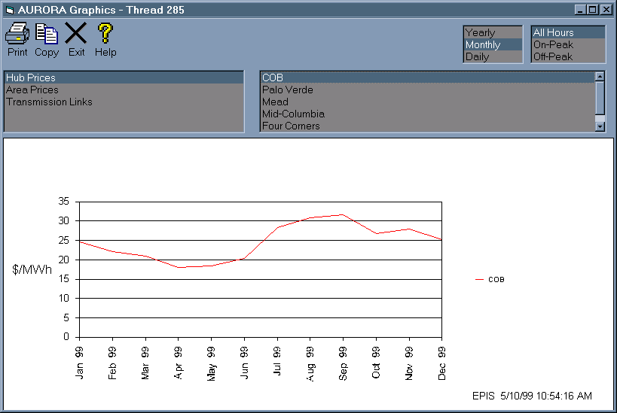
AURORA is comprehensive. In addition to market prices, AURORA provides information on resource value, portfolio value, net power cost, risk and uncertainty analysis and resource planning. With appropriate inputs, AURORA can be used for near-term analysis (next day/week) to very long-term analysis of 20 plus years.
- AURORA Graphical Output Screen with GUI tool bar. This is an example of Average Monthly prices of the trading hub at the California Oregon Border (COB).
AURORA is delivered complete. To install AURORA and its three North American databases, simply run the set-up program from a CD-ROM or via the Internet. AURORA is ready to run.

AURORA is flexible. The user can make changes to data (using spreadsheet-like grids) in the database and run scenarios and what-if cases.

AURORA is transparent to the user. Unlike large "black box" models, you can easily view all assumptions and results. By stepping through the model, you can follow the progress of results on an hourly basis. Results are presented in straightforward graphical and spreadsheet-like grids.

EPIS provides support for AURORA. Periodic model and data updates are provided via the Internet. Model upgrades for user-specified needs are performed rapidly and (if they are of general interest and not proprietary) for no charge.

AURORA clients. AURORA is in use at companies that include national marketers, regional marketers, utilities, and consulting and planning organizations.

AURORA is easy to use. AURORA uses the latest in Windows 95/NT graphical user interfaces (GUI's). It integrates well with Microsoft Office 95/97/2000 products, for example, MS Excel. AURORA documentation and help context are sensitive.

AURORA is affordable. There are three competitively priced licenses: single user, limited-use, and site. You can license AURORA for one-year as a single-user, limited-users, or as a site.
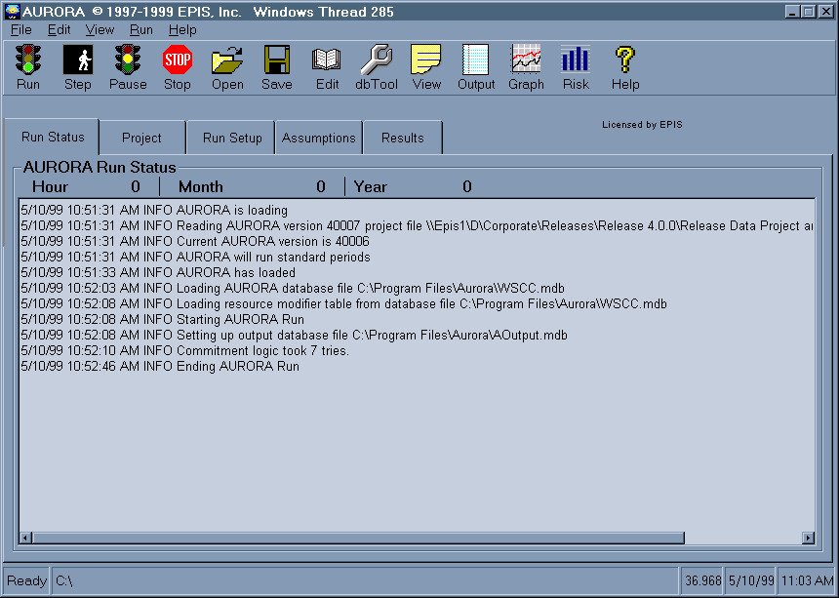
- Main AURORA Screen with GUI tool bar and AURORA Run Status box.

You can find additional information at www.epis.com.

Information You Get from AURORA
AURORA has considerable breadth in its forecast capabilities. With its standard forecasting, AURORA produces month-by-month and annual forecasts. With its daily forecast capabilities, it can be used for next day or next 30-120 day forecasts. The long-term optimization mode develops an optimum resource portfolio for medium- to long-range projections.

AURORA provides the following information:

Electric price forecasts:
- Geographic areas and trading hubs
- User-specified time periods--Hourly, daily, monthly and annual
- On-peak, off-peak or other defined sets of hours

Resource value forecasts:
- All existing generating units
- Future generating-unit alternatives
- Demand-side resources
- Hourly, daily, monthly and annual time periods

Resource strategy forecasts:
- Uses NPV of resource market profitability
- Optimal resource strategies for long-term runs

Portfolio analysis:
- User-defined sets of contracts and resources
- Monthly and annual time periods

Uncertainty analysis:
- Price, value and defined portfolios
- Input sampling of key fundamental drivers
- Transmission usage and congestion

Information from AURORA is readily and easily transferred to Excel or virtually any other MS Windows program. In addition, AURORA provides the above information in MS Access database files. AURORA comes with built-in standard database reports written in Crystal Reports (Seagate). You have the option of writing output to Internet HTML formats.

Methodology
Modeling Framework for Market Prices. AURORA is specifically designed to model wholesale electricity prices in a deregulated generation market.

In a deregulated generation market, at any given time, prices should be based on the marginal cost of production. In a competitive electricity market, prices will rise to the point of the variable cost of the last generating unit needed to meet demand.

One of the principal functions of AURORA is to estimate this hourly market-clearing price at various locations in the national electric market. AURORA uses a fundamentals approach in estimating prices, reflecting the economics and physical characteristics of demand and supply.

AURORA estimates prices by using hourly demands and individual resource-operating characteristics in a transmission-constrained, chronological dispatch algorithm.

The operation of resources within the electric market is modeled to determine which resources are on the margin for each area in any given hour. Databases are provided for all the NERC reliability areas in the North American national electric market. There are data bases for the Eastern Interconnection (EAST and Central Database), for the Texas market area (ERCOT), and for the Western Systems Coordinating Council (WSCC).

For all AURORA databases, long-term average demand and hourly demand shapes for these areas are input. These demand areas are connected by transmission links with specified transfer capabilities, losses and wheeling costs.

Existing supply-side generating units are defined and modeled individually with specification of a number of cost components and physical characteristics and operating constraints. Hydro generation for each area, with instantaneous maximums, off-peak minimums and sustained peaking constraints are also input. Demand-side resources and price-induced curtailment functions are defined, allowing the model to balance use of generation against alternatives to reducing customer demand.

AURORA uses this information to build a least-cost dispatch for the markets. Units are dispatched according to variable cost, subject to non-cycling and minimum run constraints until hourly demand is met in each area. Transmission constraints, losses, wheeling costs and unit start-up costs are reflected in the dispatch. The market-clearing price is then determined by observing the cost of meeting an incremental increase in demand in each area. All operating units in an area receive the hourly market clearing price for the power they generate.

AURORA also has the capability to simulate the addition of new-generation resources and the economic retirement of existing units. New units are chosen from a set of available supply alternatives with technology and cost characteristics that can be specified through time. New resources are built only when the combination of hourly prices and frequency of operation for a resource generate enough revenue to make construction profitable; that is, when investors can recover fixed and variable costs with an acceptable return on investment. AURORA uses an iterative technique in these long-term planning studies to solve the interdependencies between prices and changes in resource schedules.

Existing units that cannot generate enough revenue to cover their variable and fixed operating costs over time are identified and become candidates for economic retirement. To reflect the timing of transition to competition across all areas, the rate at which existing units can be retired for economic reasons is constrained in these studies for a number of years.

In summary, AURORA simulates the economic dispatch of resources to meet demand requirements. AURORA:
- Solves the whole system dispatch simultaneously.
- Dispatches hourly, with sampling capabilities, where appropriate.
- Determines the market-clearing prices from marginal costs.
- Values all the resources in the system.
These price and value forecasts are provided for each time period being studied.

Drivers and Inputs to an AURORA Forecast
AURORA uses the fundamental economic drivers of the electric market to make its forecast. That information includes:

- Electricity demand by geographic area, annually and monthly including hourly shapes.
- Supply-side resources (all major generating units) in the system. Resource heat rates, fuel types, resource-commitment data and other resource information. Future resource alternatives are used in long-term optimization studies.
- Demand-side resources including an interruptible price curve.
- Fuel prices by fuel type and location.
- Hydro information for AURORA’s hydro-optimization logic.
- Transmission costs and constraints.
- Statistical distributions for demand, fuel prices, hydro conditions and other drivers for uncertainty analysis.
You can manage the cases and analyze the drivers to electricity-market forecasts by selecting the underlying assumptions of the analysis. The projections are created using assumptions for the chosen inputs, such as electricity demand growth, fuel prices, and gas-fired combined-cycle generation efficiency and cost. For example, the low electricity market scenario could include low-demand growth, low fuel prices and optimistic assumptions about combined-cycle combustion turbines. The combination of assumptions may consist of outcomes that the decision maker believes are plausible. A user can model the conditions, cases and options a decision maker wants to evaluate. Without any programming, you determine the assumptions used in each forecast or study.

Unique Features
Unique features of AURORA include the following:

Hydro optimization logic. The hydro logic was developed in conjunction with the Northwest Power Planning Council (NWPPC), a four-state regional planning group. AURORA optimizes the use of hydro energies over a weekly period. It uses hydro constraints such as instantaneous maximums and minimums and sustained peaking maximums. Within shaping constraints, AURORA shapes hydro to flatten load (net of hydro) as much as possible. It accounts for regional hydro imports and exports, too.

Unit Commitment logic. The unit commitment logic simulates operation of generating units that can not cycle hourly. These units commit to operate based upon the value they create over an operating period. Once committed, units will run at either maximum available capacity or at minimum capacity depending on the value created in each hour of operation. To make the determination on unit commitment, AURORA will iterate to a solution of consistent prices and resource operation for a forecasted period.

Operating Reserves. To provide system reliability, a portion of resource capacity can be reserved to provide stability in the integrated electrical supply system in the event of unexpected outage conditions. The portion of resources that are reserved for system reliability cannot be dispatched into the system based upon dispatch for economic profitability. Hence this leads to higher prices during periods where generation supplies are near full utilization.

Long-term optimization logic. The long-term logic uses market economics to determine the long-term resource position. This optimization process simulates what happens in a competitive marketplace and produces a set of future resources which have the most value in the marketplace.

Uncertainty Analysis. Prices and values of resources and portfolios may be forecast and understood under conditions of uncertainty. AURORA’s speed makes it possible to get results in a matter of hours, not days. To see the effects of uncertainty, AURORA samples from statistical distributions of key drivers. AURORA can be run in Monte-Carlo or Latin Hypercube mode, results are tabulated, and a full set of statistical results can be analyzed. For instance, the effects of summer-peaking situations may be understood or the effects of hydro uncertainties can be examined. Because the basic economics of the system are not linear, this kind of analysis can lead to insights that would not otherwise be available.

Operating Platform
Software. AURORA uses the latest software technologies from Microsoft and other leading software vendors. The model is Written in MS Visual Basic 6.0 (SP4) and MS C++ 6.0.

Ease of use and analysis of multiple scenarios are facilitated by Visual Basic Scripting (VB Scripting) capability in the AURORA software. VB Scripting is used to place results directly in MS Excel.

AURORA can use MS Worksheets for input by linking the worksheets to database tables.
Requires MS DAO and VB Scripting engines (installations are included with AURORA installation)
AURORA input and output are stored in standard Jet databases--MS Jet (Access 97) databases (Excel worksheets are also supported). Input databases are about 3-8 MB each.
We are using the latest MS software and all DLL's etc. included with the installation are the latest MS available.
AURORA is year 2K compliant and as far as we can tell, the MS software included is also year 2K compliant.

Hardware and Operating System AURORA is optimized to run on Pentium Pro or Pentium II and III 32 bit processors.

Minimum Requirements
The computer must meet the following minimum requirements. The processing will be slow for long-term capacity expansion runs. And, the minimum configuration is not recommended for performing risk analysis.

Hardware:
- Fast Pentium PC (at least 400 MHz)
- 128 MB and should have at least 256 MB of memory for long-term capacity expansion and for risk studies.
- 150 MB of free hard disk space for the install and enough free hard disk space for the virtual memory settings. Uses up to 20-80 MB of disk space for data and results depending on what (database capabilities) is currently installed on your computer.
Operating System:
- Windows 2000, NT4.0 (SP5) or 98 or later
- Internet Explorer 5.5 or later is needed to use the HTML Help system

Recommended Requirements
This configuration will handle long term and risk analysis runs.
Hardware:
- Pentium III (at least 500 MHz)
- 256 MB of RAM (384 MB for 20 year studies with at least 400 MB of virtual memory)
- 150 MB of free hard disk space for the install and enough free hard disk space for the virtual memory settings
- Uses up to 40-120 MB of disk space for data and results (long term results databases are 3-6 MB unless you are writing resource operations or hourly information)
Operating System:
- Windows NT4.0 (SP5) or 2000 or later (98 may not be stable for long term runs)
- Internet Explorer 5.5 or later for help system

Who developed AURORA?

EPIS and its Principals
EPIS was formed in 1997 with the vision of becoming the premier provider of electric price forecast information. EPIS developed the AURORA model explicitly to forecast electric prices in the competitive electric marketplace. Using the latest in software technology and input from clients, the AURORA model is continuously improving to meet real needs for electric-market price forecasts, resource valuation and market-risk analysis.

EPIS principals bring a combined industry experience of over 100 years in the electric-energy marketplace. They have strong backgrounds in technical studies and managing industry issues. EPIS principals are as follows:

Warren H. Winter
Warren, President, co-founded EPIS after 26 years of experience at Portland General Electric (PGE), where he was Manager of Resource Planning, Power Cost Forecasting and Demand Forecasting. His responsibilities included analytical support for the newly formed trading floor (the first for an electric utility). Earlier responsibilities included Manager of Engineering Systems, Manager of Financial Planning, and Director of Corporate Development and Manager of Revenue Requirements. Warren has been the principal developer of the AURORA model for EPIS. Education: BS in Electrical Engineering, registered professional engineer.

Dave G. LeVee
Dave co-founded EPIS after 26 years of experience at Portland General Electric. Dave was a senior analyst at PGE and an expert in financial analysis. At PGE, he provided economic and business review for strategic corporate decisions. The scope of his review included both regulated and non-regulated proposals, risk analysis and rate-of-return requirements. His recommendations were presented to the Board of Directors. His expertise included understanding and evaluating the financial implications of major resource decisions. Dave is instrumental in applying the economic framework used in AURORA to forecast pricing in the competitive market. Education: BS in Electrical Engineering, registered professional engineer.

Lee A. Barney
Lee, Vice President, joined EPIS with 24 years of experience in the energy business at Portland General Electric, Enron and ConneXt. At EPIS, Lee is focusing on enhancing AURORA databases. At ConneXt, a software development company for the energy industry, he was product manager for products targeted to energy service providers. At Enron, Lee managed Customer Choice, a trial program in Oregon to foster a deregulated market. For seven years, he was the Least Cost Planning Manager for PGE. He managed public processes, and was responsible for pulling together the Corporation’s Integrated Resource Plan. In this role, he was involved in forecasting and resource planning, renewable-resource planning, Corporate Financial Modeling and, for five years, managed the application of information technology to business problems. Education: BA in Economics, MBA.

Ronald H. Sumida
Ron, Sr. Research Analyst, joined EPIS with 24 years of utility and electric power experience with General Electric, Portland General Electric, Portland General subsidiaries, and an independent consultant. Ron is experienced in power marketing, power contract administration and electric equipment engineering. He has applied this experience along with computer modeling skills to economic analysis and business decisions in electric power industry. At EPIS, Ron is focusing on research, development and managing AURORA databases. Certification: Microsoft Certified Software Engineer (MCSE). Education: BA, BS in Electrical Engineering, MBA.

Licensing
There are three competitively priced licenses: single user, limited-use, and site.
AURORA License | One Year Term
AURORA License | Single User  License | Limited-Use  License | Site  License
Full Capabilities: Electric Market Pricing, Portfolio Analysis, Resource Planning, Value Analysis, and Uncertainty Analysis | Use by one person of AURORA SOFTWARE installed on one Licensee computer | AURORA Software installed on one Licensee computer and use by more than one person, or Use by one person of Software installed on more than one Licensee computer | Use by any number of people of AURORA SOFTWARE installed on any number of Licensee computers

AURORA Support--Included in Annual License Price | Description
Maintenance | AURORA model and data updates | Included In One Year License
Training | Two Sessions:.  Each session consists of a-day of AURORA training at EPIS offices. On-site training may be arranged. | Included In One Year License  On-site Expenses are paid by the client.
Support Actions | A Support Action is defined to be phone, email, or mail request(s) to EPIS for help on incidental needs related to the use of AURORA | Included In One Year License
In addition, you may take a test drive and get hands-on experience.

Significant Features of AURORA Software
Functional Features
Time frame--next hour to very long term (20+years)

Price Forecasting
Hourly prices
Daily prices
Monthly prices
Annual prices
Area prices
Trading hub prices

Resource Forecasting
Hourly, daily, monthly and annual operation, cost and value
Marginal resources and fuels
Dual fuel modeling
Cycling and commitment resources
Minimum down and up times
Must-run resources (set monthly or annually)
Multiple Segments and Heat Rates
Ramp rates
Bidding factors by resource
All existing resources (thousands)
Emissions dispatch and reporting
Planned resources
New resource additions
Automatic capacity expansion
Resource Stacks displayed graphically
Resource dispatch order information available

Portfolio Value
Hourly, monthly and annual cost, revenue and value
Hundreds of contracts and resources in each portfolio
Many portfolios examined simultaneously
Many contract types, including a variety of option and must-takes

Risk Analysis
Demand, fuel, hydro and resources can be sampled
Normal, log-normal, uniform and binomial distributions
Monte-Carlo and Latin-Hypercube sampling
Detailed sample results
Statistical results (mean and standard deviation)
Histogram results

Analytical Features
Dispatch
Hourly simulation
System-wide dispatch optimization
System-wide capacity expansion optimization

Basic Variables
Resource cost and availability
Hourly demand by area
Transmission costs and constraints
Demand-side cost and availability
Extremely fast, with up to 60 system simulations per second
Thermal Resources including ramp rates
True economic commitment logic
Peaking and long-term unit commitments
Hydro Resources
Annual, monthly and hourly factors
Optimization of hydro on weekly basis
Hydro constraints include maximum and minimum stream lows
Flexible new resource definitions
Unlimited new resource types
Unlimited emission types
Market-value-driven resource decisions
Flexible constraints on new resources and retirements

Input, Reporting and User interface
MS Jet databases used (MS Access or MS Excel for Output)
Input tables can be linked directly from MS Excel sheets
Enhanced VB scripting built-in for automating AURORA runs
Manage all data elements via VB Scripting
AURORA Output can be sent directly to MS Excel sheets
Latest GUI
Toolbars
Tabs
Built in Excel-like viewing and editing grids

Technology
Windows 2000/NT/98 technology
C++ core for extreme speed
Visual Basic interface for extreme flexibility
AURORA runs as an automation server (can run from an Excel macro and on remote computers)
Access 2000 or Access 97
Requires MS Internet Explorer 5.5 or higher.

Sample Output of AURORA
See Figure 1 below for an example of a Resource Stack for Southern California for July 2002 based on Capacity (MW).

- Resource Stacks are available in terms of Capacity (MW) or Capability (De-rated Capacity in MW).
- You may choose one or multiple areas to display (by holding the “Ctrl” key down while clicking).
- By right clicking on the graphical output, you can choose the copy command and copy the graph and its data to the clipboard for pasting into other applications.
- The toolbar gives buttons for printing or copying the data in the graph or for exiting the graphics display.

Figure 1: Graphical Display of Resource Stacks

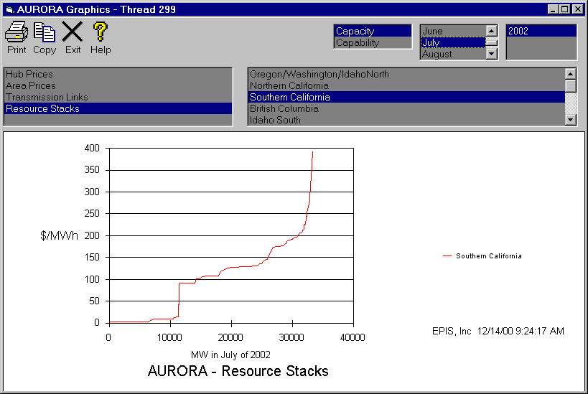
- Resource Stack Information Standard Output. In addition to the graphical display, you can get the lists of resources in the area resource stacks with dispatch costs and dispatch order.
- By left clicking in the upright corner of an output table, you can choose the copy command and copy the data to the clipboard for pasting into other applications, or you can just push the “ToExcel” button and the data will be exported to an MS Excel Workbook.
- The toolbar has buttons for printing or filtering of data in the table display.

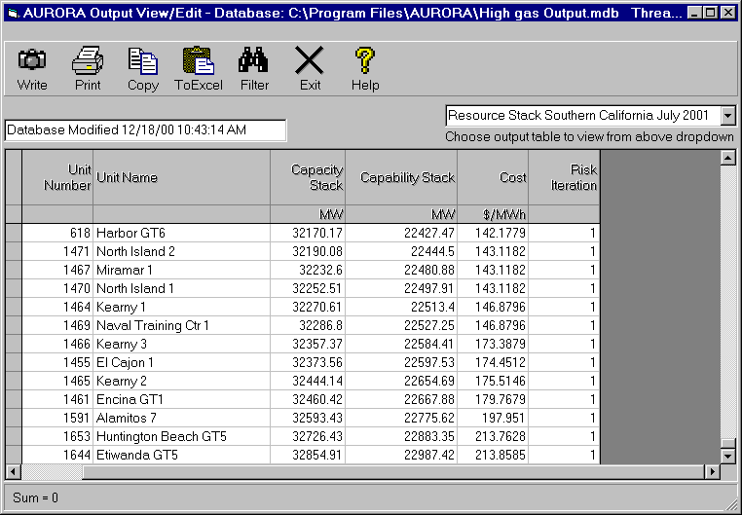
Figure 2: Standard Output of Resource Stack Information.

Marginal reporting for Fuels, Resources and Groups
Fuel Output. A fuel output table is now available as a standard output at the end of each AURORA run. It has monthly and annual fuel cost, fuel usage and percent marginal for each area. Specifically, for each month of the year and annual, the FUEL report displays fuel cost in $/mmBTU, fuel usage in mmBTU and the percent of time in the period the fuel was being used by marginal generation for each area. See Figure 3 for an example.

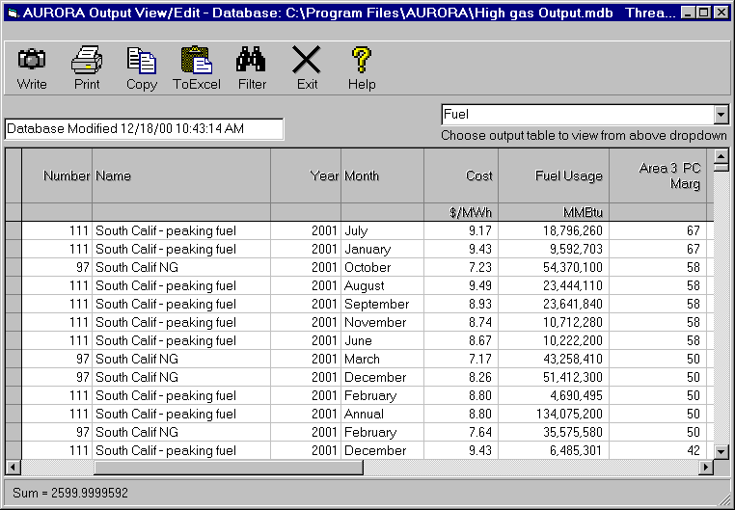
Figure 3: Standard Output of Marginal Fuel Information

