Nuclear Energy and its Impact on Energy Markets – Part 1 (Overview)

By Charlie Weldon

Background - In 1979, the nuclear power industry was thrust into the conversations of Americans everywhere following the March accident at Three Mile Island, Pennsylvania. The movie, ‘The China Syndrome” followed shortly thereafter and further heightened nuclear awareness, albeit coincidentally. The subsequent years were characterized by an even greater awareness of the dangers of nuclear power plants and a general disdain for anything “nuclear.” The 1986 Chernobyl accident in the Ukraine confirmed many people’s worst fear when the main reactor exploded during a faulty test resulting in an uncontrolled release of radiation. Dozens of people were killed while many thousands suffered radiation poison ultimately resulting in their death or extreme illness. Radioactive fallout from the accident covered the Northern Hemisphere, tainting reindeer populations in Norway and salmon worldwide

Despite these negative and unfortunate circumstances, the U.S. nuclear industry has survived and continues to play a major role in providing base load electric power. While the number of nuclear generating units peaked in 1990 at 112 (Figure 1), today’s nuclear power plant base (consisting of only 104 units) generates more power than ever due to an increased focus on plant utility. Figure 2 illustrates the steady rise in capacity factor, seen especially in the last 10 years.

Electricity Generation Mix - The relationship between nuclear power generation and the natural gas market can be investigated by inspecting the mix of generation assets across the U.S. Figure 3 illustrates the generation asset mix by primary fuel across the U.S. for the last 10 years on an annual basis and provides for relative size comparisons. To begin further investigating the relationship and trends between primary fuel types, Figure 4 depicts the last 5 years of national generation mix on a monthly basis. This graph reveals the cyclical pattern that results from seasonal factors affecting power generation from gas, hydro and nuclear. Hydro generation peaks in late spring corresponding with snow melt while gas power peaks in the summer due to peak cooling demand. Nuclear generation peaks in the summer and winter due to the planned maintenance outages that are timed to occur in the spring and fall to correspond with lower overall demand.
The Relationship Between Nuclear Power and Natural Gas - It is clear from Figures 3 and 4 that a relationship must exist between each of the generation types. This relationship is relatively stable and predictable when viewed on average throughout the year as depicted in Figure 3. However, the instantaneous relationship between the different fuel sources is quite dynamic when a perturbation, such as an unplanned nuclear plant outage, occurs at a critical time or location. It is this type of event that can cause significant impact on regional gas flows and prices in which we are most interested.

In order to identify where the most significant impacts can occur, we need to identify those states or regions where there is a large dependence on nuclear base power and relatively high amounts of natural gas fired generation. The Nuclear Regulatory Commission (NRC) releases a daily report on the status of each of the nuclear plants in the U.S. which are seen in Figure 5. Along with monthly EIA generation mix data, this report can be used to estimate the gas demand response due to changes in nuclear plant utility. An accurate estimate can provide gas traders and schedulers the opportunity to better anticipate daily load swings and hence identify profit opportunities. Although experience generally serves these groups very well in dealing with these situations, further analysis can provide additional information on the impact of seasonal factors and regional generation mix trends. Part 2 of this series will describe one method of estimating these impacts in certain states where natural gas and nuclear power are most interrelated.
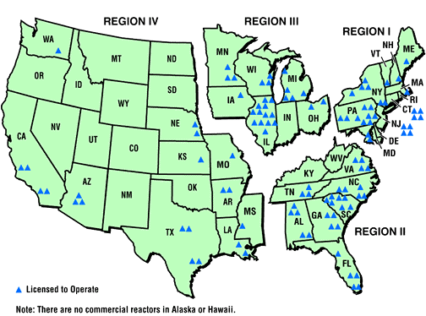

Figure 5 – U.S. Nuclear Plant Locations

