TW N Crawar Site: SVE blower and SVE manifold and liquid knockout box.
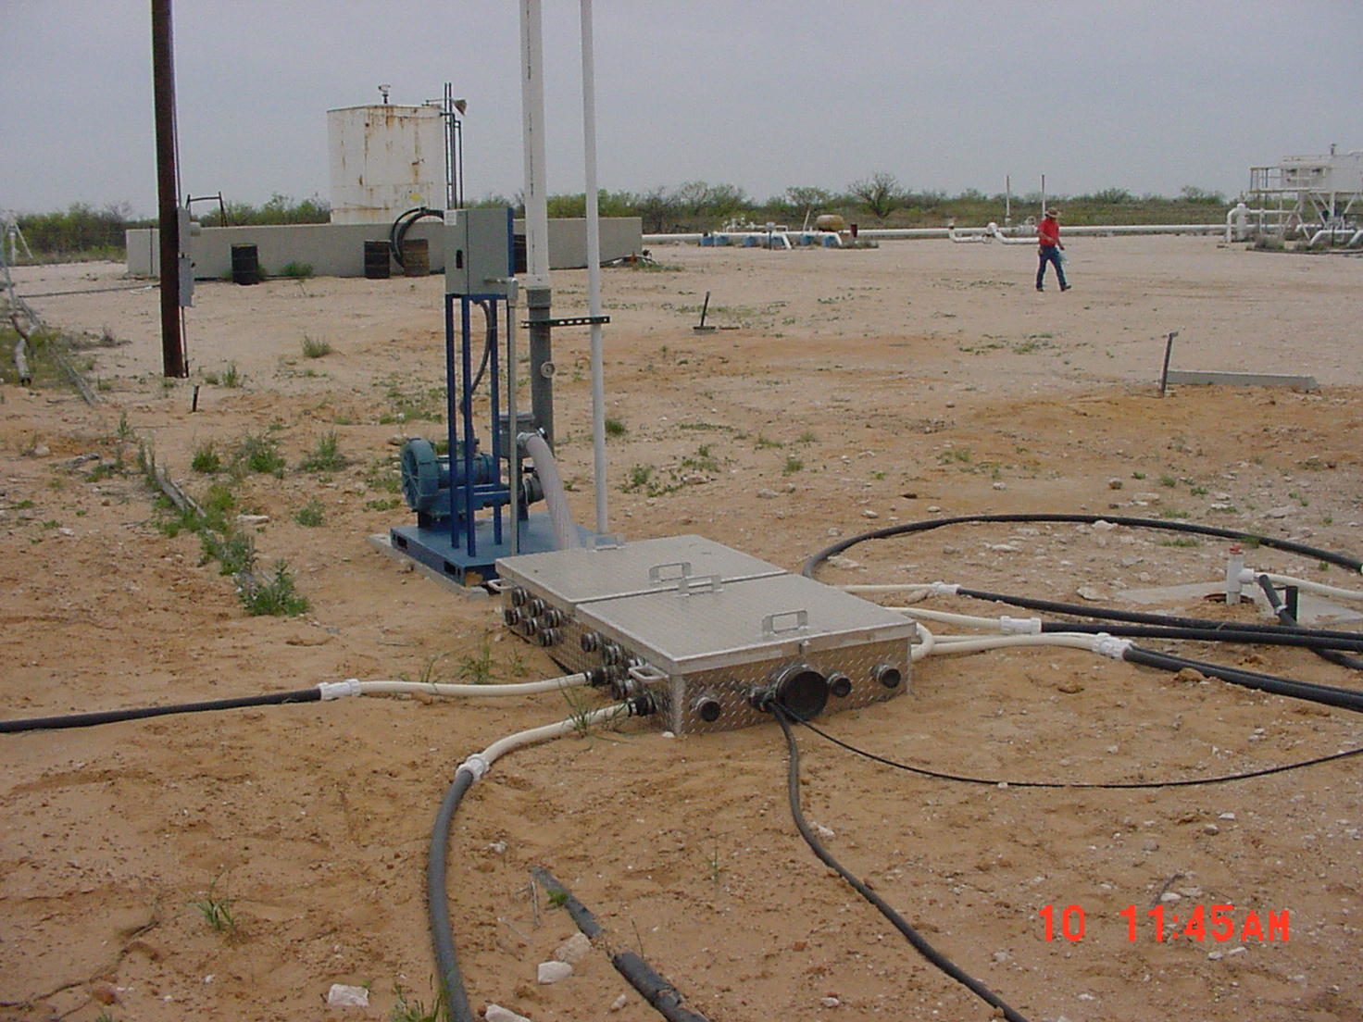

TW N Crawar Site: SVE blower, liquid knockout box, and equipment building.
