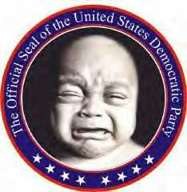

THE NEW OFFICIAL SEAL
FOR THE DEMOCRATIC PARTY

