Storage Allocation
Requirements

Preparation Date: MM/DD/YYYY

Contents
High-Level Details iii
XYZ Change Requirements 4
Introduction 4
Requirements 4
Groups Impacted 5
Time Frame for Implementing the Change Error! Bookmark not defined.
Issues Error! Bookmark not defined.
Risks Error! Bookmark not defined.
Customer Approval Sign-off 5
Glossary Error! Bookmark not defined.
Appendix A⎯NNNNNN Error! Bookmark not defined.

High-Level Details

Date of Request | MM-DD-YYYY
Requested Change
System to be Changed | TMS
Type of Change | Enhancement
Priority | High
Requestor Organization | NNG
Requestor Name | Gerry Medeles | Phone: 713-853-1576
Other Contacts | Mike Bodnar | Phone: 713-853-6486
Technical Support Contact | Joe Hoang | Phone: 713-853-5288
Other Technical Support Contacts |  | Phone: 713-853-0000
Last Updated By | Gerry Medeles

Storage Allocation Requirements

Introduction
In order to provide the maximum value to NNG’s storage services, Marketing and Market Services have requested to automate the storage allocation process. Currently, there is not a storage allocation process within TMS, the method that marketing uses to restrict storage is by not allowing shippers to nominate PNR or to call their shippers to limit their storage activity. The shippers are informed prior to the nomination deadline.
By automating the allocation process Marketing would not have to limit storage nomination prior to actual knowledge of what all the nominations are on the pipeline. This would enable NNG to maximize their storage service.

Requirements

Determining if Storage Allocation is Necessary
For allocation purposes there will be three defined storage allocation groups.
- A Market Area Storage Group
The Market Area Storage Group consists of all storage locations located in the market area, for example, Ogden Deferred, MID 17 Storage Pooling, etc. For Storage Allocation purposes Demarc Deferred is considered to be in the market area.
- Field Area Storage Group
The Field Area Storage Group consists of all storage locations located in the field area, for example, Mid-continent Deferred, MID 1 16A Storage Pooling, etc.
- System Area Storage Group
The System Area Storage Group is the combination of the Market Area Storage Group and the Field Area Storage Group.
In order to determine if the storage capacity is exceeded, the sum of receipts at the storage locations will be compared against the sum of deliveries at these locations, to obtain a net total nominations for the each storage group. This Net Total will then be compared to the capacity established within CAS (Capacity Allocation System) for each storage allocation group.
Receipt Total = Delivery Total | No Allocation Necessary
Receipt Total > Delivery Total | This implies that there will be a net injection into storage. In this instance, the net difference will be compared against the injection capacity for the day. If it exceeds capacity, the excess will be allocated based upon the rules identified below, otherwise no allocation will be necessary.
Receipt Total < Delivery Total | This implies that there will be a net withdrawal from storage. In this instance, the net difference will be compared against the injection capacity for the day. If it exceeds capacity, the excess will be allocated based upon the rules identified below, otherwise no allocation will be necessary.

Storage Allocation Rules.

Timely Process
- Park n Ride and FDD Overrun
Allocation across contracts will be based on price – lowest price to highest price. IF price is the same, gas will be prorated across those contracts.
Previous flowing PNR will have priority over incremental PNR within the rate.
- IDD Packets
Allocation across contracts will be based on price – lowest price to highest price. IF price is the same, gas will be prorated across those contracts.
- FDD
Gas will be allocated on a prorata basis.

Intra-day Process
- Bumping
FDD will have the ability to bump Park n Ride and FDD Overrun.

Storage Allocation Process

PURPOSE AND DESCRIPTION OF REQUEST:
Currently the storage allocation process does not automatically allocate down the a specified capacity level due to the "looping" of storage nominations. We had specifically initiated a halt/stop on the storage allocation process so the storage team can determine whether they need to allocate any further than the specified capacity or if it is at a reasonable level. For example if the storage capacity is set at a net of 950,000 withdrawals, and there are nominations of 50,000 injecting and 1,050,000 withdrawals. During the allocation process because of looping nominations the net scheduled will be reduced down to 1,000,000 and not to the 950,000 capacity quantity, therefore another storage allocation process will need to be initiated.

REQUIREMENTS:
When the allocation process is submitted it will allocate to either the PnR level selected or to the capacity quantity set, the allocation will NOT stop until it reaches either of the selected criteria. Therefore it will continue to allocate until it reaches the capacity quantity or until it removes all PnR transactions whichever it reaches first. This should alleviate the storage team from having to do multiple allocations during the scheduling cycles. This modification will take approximately a couple weeks to implement.
If the allocation process reaches the PnR and Overrun only level or PnR, Overrun, IDD packets level first the application should still provide the user the ability to submit the allocation process again, like it does currently.
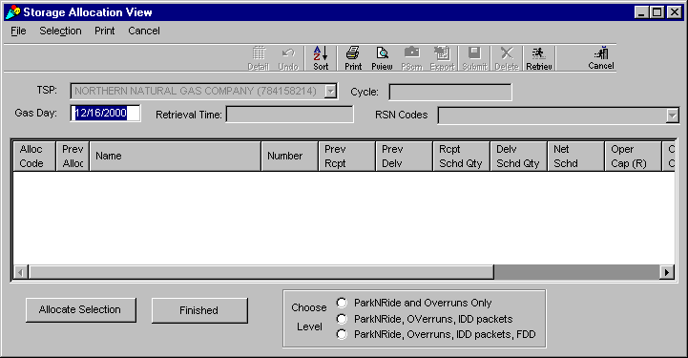

PURPOSE AND DESCRIPTION OF REQUEST:
The request is to change the process sequence during the Evening, Non-Grid, IntraDay 1, and IntraDay2 cycles by placing storage allocations before the confirmation process. In addition, change SBS, during the confirmation process of these changed cycles to allow storage activity in the opposite direction of the allocation (i.e. Allows SBS to schedule storage withdrawals when storage injections are allocated)
The modifications requested provides NNG with a final scheduled quantity to confirm with operators at pipeline interconnects which will serve minimize shipper imbalances.

REQUIREMENTS:
Modify Nomination/Scheduling cycle in TMS to run storage allocations before the confirmation process during the Evening, Non-Grid, IntraDay 1, and IntraDay2 cycles. Note: The Timely cycle will remain unchanged from that currently performed with storage allocations being the final process performed in the Timely cycle.
Modify SBS to automatically schedule storage when transportation/pooling activity is cut due to pipeline balancing and allocations/curtailment processes. SBS coverage during the confirmation process will be limited to storage activity that is directly opposite to the storage allocation (i.e. Allows SBS to schedule storage withdrawals when storage injections are allocated). Note: SBS, as currently programmed, is to continue during the Timely cycle.
- Allocation Rules:
  - If there is an allocation in any of the Storage Groups
 | Injection | Withdrawals
Group 465 – Market | Allocate | SBS
Group 466 – Field | Allocate | SBS
Group 467 - System | Allocate | SBS
SBS will be available for the allocation not performed, for example, if allocating injections, withdrawals for SBS will be available.
  - If allocating 2 Storage Groups (not including System Group)
 | Injection | Withdrawals
Group 465 – Market | Allocate | SBS
Group 466 – Field | Allocate | SBS
Group 465 – Market | Allocate | SBS
Group 466 – Field | SBS | Allocate
………………..and Reverse

 | Injection | Withdrawals |  |  | Injection | Withdrawals
Group 466 – Field | Allocate | SBS |  | Group 465 –Market | SBS | Allocate
Group 467 – System | Allocate | SBS |  | Group 467 – System | SBS | Allocate
 |  |  | OR
Group 466 – Field | Allocate | No SBS |  | Group 465 – Market | No SBS | Allocate
Group 467 – System | No SBS | Allocate |  | Group 467 – System | Allocate | No SBS

Groups Impacted
Table 1 shows all business groups and systems that may be impacted when the change proposed here is implemented.
Group | Impacted Yes/No | Business Contact | Phone | Technical Contact | Phone
Accounting |  |  | 713-853-0000 |  | 713-853-0000
Contracts |  |  | 713-853-0000 |  | 713-853-0000
EDI |  |  | 713-853-0000 |  | 713-853-0000
EDI/Flat File |  |  | 713-853-0000 |  | 713-853-0000
Market Services |  |  | 713-853-0000 |  | 713-853-0000
Marketing |  |  | 713-853-0000 |  | 713-853-0000
Gas Control |  |  | 713-853-0000 |  | 713-853-0000
Legal |  |  | 713-853-0000 |  | 713-853-0000
Customer |  |  | 713-853-0000 |  | 713-853-0000
Internet Communi-cations/  Notices |  |  | 713-853-0000 |  | 713-853-0000
PLE |  |  | 713-853-0000 |  | 713-853-0000
Rates/  Regulatory |  |  | 713-853-0000 |  | 713-853-0000
Table 1. Systems Affected by Business Change

