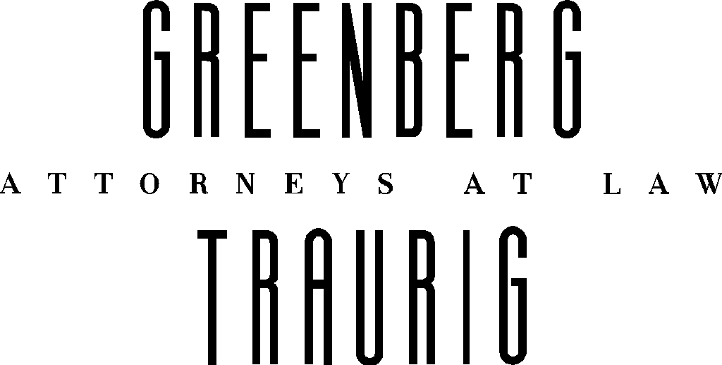
Memorandum
To Steve Krimsky
From Barbara A. Hall
Debbie M. Orshefsky
Date July 18, 2001
Re Petition for Declaratory Statement
You have requested that we provide you with a memo discussing the benefits and drawbacks of proceeding with a Petition for a Declaratory Statement as a strategy for dealing with the Broward County moratorium.
A. Statutory Authority for Declaratory Statements
State agencies are authorized to issue Declaratory Statements under the following statutory provision
120.565 Declaratory statement by agencies
(1) Any substantially affected person may seek a declaratory statement regarding an agency's opinion as to the applicability of a statutory provision, or of any rule or order of the agency, as it applies to the petitioner's particular set of circumstances.
(2) The petition seeking a declaratory statement shall state with particularity the petitioner's set of circumstances and shall specify the statutory provision, rule, or order that the petitioner believes may apply to the set of circumstances.
(3) The agency shall give notice of the filing of each petition in the next available issue of the Florida Administrative Weekly and transmit copies of each petition to the committee. The agency shall issue a declaratory statement or deny the petition within 90 days after the filing of the petition. The declaratory statement or denial of the petition shall be noticed in the next available issue of the Florida Administrative Weekly. Agency disposition of petitions shall be final agency action.

Section 403.182, which gives DEP the exclusive authority to issue permits and approve all local pollution control programs unless a local pollution control permitting program is authorized by a special act of the legislature, includes the following provisions.
(4) (a) If the department has reason to believe that a pollution control program in force pursuant to this section is inadequate to prevent and control pollution in the jurisdiction to which such program relates, or that such program is being administered in a manner inconsistent with the requirements of the act, it shall proceed to determine the matter.
(b) If the department determines that such program is adequate to prevent and control pollution in the municipality or county or municipalities or counties to which such program relates, or that such program is not accomplishing the purposes of this act, it shall require that necessary corrective measures be taken with a reasonable period of time not to exceed 90 days.
Therefore if we decide to file a Petition for Declaratory Statement we would assert that the Petition is being filed under 120.565 seeking to have the agency make a determination as required by Section 403.182(4)(a) that Broward County’s local pollution control program is being administered in a manner inconsistent with Section 403.182.. Broward County is likely to intervene in the proceeding.
B. Advantages and Disadvantages of Declaratory Statements
Advantages of a Petition for Declaratory Statement
1. Provides an alternative to Circuit Court litigation
2. We have the opportunity to speak with the agency before filing the Petition to get a sense as to whether the result will be favorable.
3. If the result is unfavorable the appeal could be taken to the First District Court of Appeal which decided Alachua County v. Lewis Oil Company, 554 So.2d 210 (Fla. 1st DCA 1989) which is favorable to our position regarding the County’s authority.
Disadvantages of a Petition for Declaratory Statement
1. The Department of Environmental Protection may decline to rule
2. It is not clear that the issue of Broward County’s permitting authority is properly a question for a Declaratory Statement. The case law prohibits agencies from issuing Declaratory Statements that result in agency statements of general applicability interpreting law and policy rather than deciding the Petitioner’s particular factual situation.
3. A unfavorable interpretation of the law by the Department of Environmental Protection would be difficult to overturn on appeal because an agency’s interpretation of the law is granted great deference unless the interpretation is clearly erroneous. To date the Department has declined to interpret Section 403.182, Florida Statutes in a manner favorable to our position because they prefer to allow local programs to continue to assist with the agency’s personnel shortages and to increase local environmental oversight.
4. A Petition for Declaratory Statement is not self-executing. The County could ignore a Declaratory Statement. If the Department choose to enforce its determination that Broward County may not require permits other than expressly delegated permits, the Department could seek enforcement under Section 403.182(4)(c) by prohibiting the County from issuing any pollution control permits until the County comes into compliance. Another alternative for enforcement is Section 120.69, Florida Statutes which allows the agency to enforce its orders in circuit court. If the agency does not pursue enforcement, an action to enforce agency action may be brought in the circuit court under Section 120.69 by a substantially interested person, such as Enron, in the name the state.
C. The Question Presented
If we are to proceed with a Petition for a Declaratory Statement, the inquiry must be carefully worded to ask a question that the Department is willing to answer and not run afoul of the prohibition on having the agency issue statements of general applicability.
Possible Questions.
Pursuant to Section 403.182, Florida Statutes confirm that Deerfield Beach Energy L.L.C. is not required to obtain an air permit from Broward County for the construction of the electrical power plant that is the subject of DEP File Number 0112534-001-AC (PSD-FL-314) because Broward County is not authorized under Section 403.182 to issue air permits for electrical power plants and does not otherwise have the authority to require such permits
or if that question goes too far, then.
Pursuant to Section 403.182, Florida Statutes confirm that Deerfield Beach Energy L.L.C. is not required to obtain an air permit from Broward County for the construction of the electrical power plant that is the subject of DEP File Number 0112534-001-AC (PSD-FL-314) unless Broward County has independent permitting authority by Special Act, because Broward County is not authorized under Section 403.182 to issue air permits for electrical power plants.

\\ftl-srv01\HALLB\354052v01\7L6S01!.DOC\7/17/01

