TIN 2001-1354

ENVIRONMENTAL SYSTEMS CORPORATION STATEMENT OF QUALIFICATIONS

Prepared by:



Environmental Systems Corporation
200 Tech Center Drive
Knoxville, TN 37912

August 24, 2001

The information contained in this document and any attachments is confidential, intended only for the use of the company addressed. Any dissemination, distribution, or copying of this communication outside of the named organization, without the express permission of ESC, is strictly prohibited.

Environmental Systems Corporation
Statement of Qualifications

Scope of Normal Work

ESC is the largest provider in the United States of data acquisition and reporting systems for ambient and source monitoring. ESC also serves as a provider of complete CEM packages, including dilution or extractive CEMS for traditional measurements, low-level NO_{X}, and ammonia slip. The source monitoring element provides affected sources with compliance under the following programs:

- Acid Rain Program (40CFR75)
- OTC NO_{X} Budget
- SIP Call
- Federal NO_{X} Trading/Section 126
- 40CFR60/Local/Permit Reporting

ESC’s source monitoring software provides reporting for full CEM systems, estimation systems based on fuel usage (Appendix D, E, and G), and PEM monitoring approaches. The software is adaptable to virtually any type of source – boiler, combustion turbine, refinery, industrial source, etc.

User Base – Ambient

ESC’s E-DAS Ambient and ATX software is in use at 38 state agencies (see Map 1), and dozens of local county and municipal monitoring agencies. Many states and localities have been using ESC data loggers and software in excess of 20 years.

User Base – Source

ESC’s source monitoring software packages are used by almost every type of source (utility, pulp and paper, cement/mineral, steel, chemical, refining). ESC is the dominant provider specifically in the utility industry, with over 38% market share, more than the next three competitors combined. ESC’s user base spans the spectrum from large companies (American Electric Power, Reliant, TVA) down to many small municipal power agencies and independent power producers (IPPs).

A partial list of ESC customers is included (Appendix A).

Resources

Data Systems is the largest division within ESC, comprising roughly half of the 200-person company. The Data Systems division has maintained a steadily increasing business level growing from $10 million to $15 million per year over the last five years. The steady business level has allowed ESC to maintain its staff with low turnover, retaining the considerable knowledge and experience it takes to properly run complex CEM DAS projects.

Staffing Levels

25 Programmers (15 associated with 40CFR75-level software)
5 Firmware Engineers
11 Project Engineers
3 System Integration
9 Software QA and Documentation
6 Software Support
5 Hardware/Firmware Support
4 Training/Post-Installation Services

Software Quality

ESC uses a standard set of software for all customers, using user-accessible configuration files to adapt the standard software modules to site-specific requirements (e.g., Appendix D reporting for fuel usage). All customization of menus and operator displays is also provided via configuration files. This vastly simplifies the process of new software development, testing, and promulgation of software supplements and upgrades.

All software follows a development path beginning with a written design document/specification and review, before any code is developed. The code is then tested by an independent software quality assurance (QA) group based on the design document, using sample customer configurations and data. Any reported software deficiencies follow a similar path (documentation, coding, and independent testing) before release to the customers.

This approach has provided ESC with a reputation in the industry for the highest quality software and the easiest product to maintain. Customers do not have to worry about whether a software fix will “break something else,” or worry about their vendor taking multiple attempts to address the same problem, which wastes the customer’s valuable time. ESC does the testing so that the customer does not have to.

Staff Professionalism

All ESC engineering and project staff attend week-long orientations to the regulatory environment they will be working under. The project staff is highly experienced with 40CFR75 and associated regulations. ESC is regularly the first to drive the EPA to clarify gray areas within new, and sometimes even established rules and policy statements.

ESC has Engineers that are highly trained both in the ESC software and in the regulatory environment. ESC’s project staff has been recognized as the most professional in the industry.

We consider our support staff to be equally important, and thus our in-house support group is also constantly kept up-to-date on changes in the regulatory environment, as well as software enhancements. Our support staff is able to resolve most problems immediately, and can draw on whatever resources are necessary to resolve issues that go beyond that level.

Our goal is the total satisfaction of every customer. We consider the combination of software quality AND a professional staff key to achieving that goal.

Sample Source Monitoring Customer List (DAS)

(Contact ESC for a full list of customers)

Large Utilities | Industrial Sources
American Electric Power | Motiva
Reliant Energy | TOSCO Refining
Southern California Edison | Westvaco
Tennessee Valley Authority | Wheelabrator
First Energy | Kaiser Aluminum
Duke Energy | Blue Circle Cement
 | Louisiana Pacific
CEMS Supplied  Dayton Power and Light Energy | ALCOA  Eastman Chemical
Great River Energy | Roanoke Electric Steel
Calpine
International Paper | Municipal Utilities
AECI | Associated Electric Cooperative (AECI)
First Energy | City of Colorado Springs, Colorado
East Kentucky Power | Michigan South Central Power
 | City of Lakeland, Florida
 | Holland (MI) Board of Public Works

ESC Ambient Customers
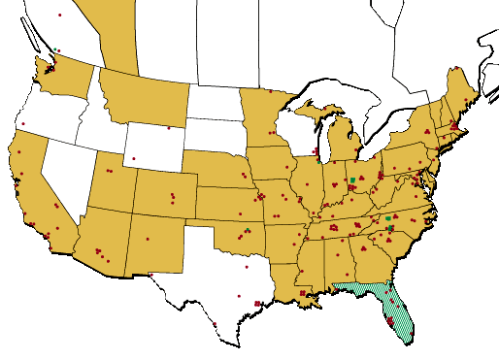
how do I delete pages

