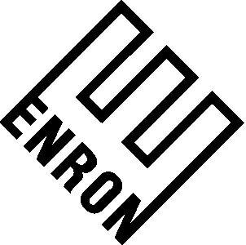

May __, 2001

FMI Weld LLC
1735 19th Street, 2nd Floor
Denver, CO 80202-1005
Attn: F. Lee Robinson

Re: Payment One pursuant to that certain letter agreement between FMI Weld LLC (“FMI Weld”) and Enron North America Corp. (“ENA”) dated March 15, 2001 concerning Kern River Gas Transmission Company’s March 12, 2001 Open Season as amended on April 16, 2001 (the “Letter Agreement”).

Dear Mr. Robinson:

This statement (this “Statement”) sets forth the calculation and payment method of Payment One (as such term is defined in the Letter Agreement) pursuant to the terms and conditions of the Letter Agreement. In accordance with the terms of the Letter Agreement, ENA has established Payment One to be an amount of $_______________. The detailed calculation of Payment One is set forth on Exhibit “A” attached hereto. FMI Weld agrees that in accordance with the terms and conditions of the Letter Agreement, the calculation of Payment One is conclusively binding on both ENA and FMI Weld.

Payment One is being paid to FMI Weld by ENA via the enclosed check #________ in the amount of $______________. Receipt of this check is hereby acknowledged by FMI Weld on May ___, 2001.

THIS STATEMENT SHALL BE GOVERNED BY AND CONSTRUED IN ACCORDANCE WITH THE LAWS OF THE STATE OF TEXAS, EXCLUDING ANY CONFLICTS-OF-LAW RULE OR PRINCIPLE WHICH MIGHT REFER TO THE LAWS OF ANOTHER STATE.

Except as to the detailed calculation of Payment One contained herein, all other terms and conditions of the Letter Agreement shall remain in full force and effect.

If the foregoing accurately reflects our agreement with respect to these matters, please so indicate by executing this Statement in the space provided below.

Sincerely,

ENRON NORTH AMERICA CORP.

By: _____________________________
Title: ____________________________

AGREED TO this __ day of May, 2001.

FMI WELD LLC

By: ________________________________
Title: _______________________________

