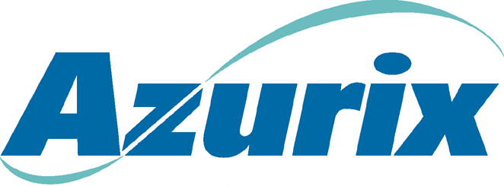To: | Stan Horton
From: | John L. Garrison
Date: | June 8, 2001
Subject: | Business activity update – Week of June 4, 2001
Operating Companies

ABA
- Negotiations with the government continue to be stalled. We are continuing to try to negotiate in good faith to resolve the government breaches and to make the necessary contractual changes to have a viable concession. We are significantly increasing the legal effort on the arbitration. A team of arbitration lawyers was in ABA to conduct due diligence. We will be in a position to file our consent to arbitration by July 12.

Cancun
- Financial performance continues on plan. We are having difficulty with GMD, local partner, as it pertains to operating matters. They can present problems as we move into the sales process.
Wessex
- The pound has fallen to a 15 year low against the dollar because of expectations that the returned Labour Government will seek early entry to the Euro.
- Potential engineering joint venture partners reduced to final three – Thames, Montgomery Watson and W.S. Atkins. Further due diligence and commercial discussions in progress prior to final selection panel on 21 June.
- Frustration at poor quality of Chase work on potential AEL refinancing. Good progress with West LB.
Lurgi
- Progressing redundancy programme to reduce costs at Lurgi Bamag
- Working up detailed program for shut down of Lurgi Invent and migration of contracts to Lurgi Bamag

Sales Process Update
Azurix North America
- Tyco, American Water Works and NUON received management presentations this week. NUON and American Water Works were the most enthusiastic about the business and indications are that they are likely to continue with the process. As we suspected, there are a significant number of questions around the proforma adjustments to the financials.
- United Water, BOC Group, Vivendi and Thames will be in next week to receive presentations.
Madera
- The party that gave a very low preliminary offer of approximately 1/3 of our book value has requested a face-to-face meeting and implied that they can increase their offer. Meeting is set for June 11.
Mendoza
- Received a non-binding letter of interest from Aqua Fund, a financial buyer. Still anticipate an offer from Saur, but we suspect Saur will wait and see how our sales process goes before making any type of firm offer.
Other Latin American Assets (Brazil, IASA, Cancun)
- We have received six letters of interest in buying Latin American assets, and expect to receive three more next week. Strong interest in Mexico, but only 1-2 parties interested in Brazil.

Financing Update
- Marlin is moving ahead and the team is 99% confident that the AEL revolver will not have to be refinanced prior to closing the Marlin II transaction.
- Both Chase and WestLB are having difficulty committing to our request for the £425 refinancing. It is likely that we will be able to obtain some extension of the facility; however, it might be for a lesser amount. This will not likely affect our future liquidity but will reduce or eliminate the amount of Azurix Senior Notes we can repurchase.
- Additionally, it now appears that Enron prefer that we put further AEL discussions on hold until mid-July when Marlin is closed.

