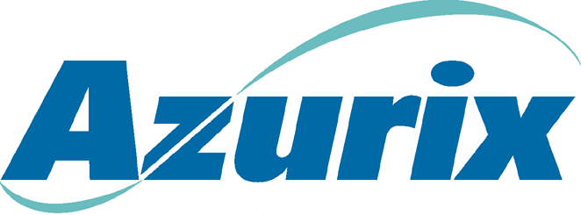To: | Stan Horton
From: | John L. Garrison
Date: | May 18, 2001
Subject: | Business activity update – Week of May 28, 2001
Operating Companies

ABA
- John Ale held detailed meetings with the arbitration attorneys and consultants in New York. The view is that we have a good case especially concerning the government’s failure to apply the tariffs in accordance with the contract.
- MOU discussions continue to be stalled. ABA senior management will meet with the Minister of Public Works on Tuesday. John Ale and I will be in BA next week to follow up on the Ministry meetings and to work with the local lawyers on the arbitration case and continue to develop the plan for how ABA would attempt to implement a termination if good faith negotiations are not successful.

Cancun
- Financial performance continues on plan. We are having difficulty with GMD, local partner, as it pertains to operating matters. They can present problems as we move into the sales process.
Wessex
- Comfort letter received from Vaccani, Zweig and Associates indicating that they are willing to back the MBO of Swiss Combi. Further due diligence is going to be required, however, we remain cautious.
- Due diligence for MBR buyout has not raised any concern and we are awaiting a revised offer.
- Anglian Water confirmed its intention to separate asset ownership from the rest of its business in structured finance transaction.
- Two confirmed parties interested in buying Southern Water - ENEL and Candover.

Sales Process Update
Azurix North America
- Selected 7 strategic buyers and 1 financial buyer to receive management presentations. Tyco, American Water Works, Nuon, and Thames Water will receive management presentations June 5 – 8, with Vivendi, United Water, BOC and Thoma Cressey, the following week. The online data room for ANA is complete and now open to the 8 potential buyers. The key to a successful deal is to hold their value indications throughout due diligence as we explain the adjustments to 2000 and 2001 financial performance.
Madera
- The party that gave a very low preliminary offer of approximately 1/3 of our book value has requested a face-to-face meeting and implied that they can increase their offer. Meeting is set for June 11.
Mendoza
- Received a non-binding letter of interest from Aqua Fund a financial buyer. Still anticipate an offer from Saur, but we suspect Saur will wait and see how our sales process goes before making any type of firm offer.
Other Latin American Assets (Brazil, IASA, Cancun)
- Approximately 20 different parties are reviewing the businesses. Initial indications of value are due June 8 and it is too early to tell what level of interest there will be.

Financing Update
- Marlin is moving ahead and the team is 99% confident that the AEL revolver will not have to be refinanced prior to closing the Marlin II transaction.
- Both Chase and WestLB are having difficulty committing to our request for the £425 refinancing. It is likely that we will be able to obtain some extension of the facility; however, it might be for a lesser amount. This will not likely affect our future liquidity but will reduce or eliminate the amount of Azurix Senior Notes we can repurchase. .
.

