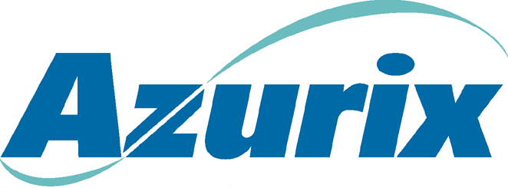To: | Stan Horton
From: | John L. Garrison
Date: | September 28, 2025
Subject: | Business activity update – Week of April 23, 2001
Operating Companies

Wessex
- QBR completed this week.
- Wessex is on track to achieve its budget despite incremental costs associated with foot and mouth disease.

Lurgi
- Lurgi Invent (UK company) and Lurgi Bamag (German company) both continue to under perform to budget due to lack of new contracts and contract execution.
- We are analyzing a shutdown of the Lurgi Invent operations and transferring all outstanding contracts to Lurgi Bamag. The cost of the shutdown and the timing are yet to be determined.
- I would anticipate that if we are not successful in selling Invent that we would start the shutdown process on or about the first of July.

ABA
- Progress continues with negotiations with the government. Focus of negotiations is to dramatically improve the terms of the contract so that a third party would be interested in acquiring our ownership.
- I will be in Buenos Aires next week to continue the negotiations and also to work with the litigation lawyers. I will schedule a meeting the week of May 7 to give a more in depth update of the situation.
- We are increasing our efforts and burn rate on the arbitration case so that if we make the decision to go to arbitration we will be in a position to make a formal filing by July 12.
- Overall Argentine macro economic situation continues to be a significant challenge as interest rates continue to rise as the government is trying to fund their budget deficit and roll over their existing debt. Unfortunately, the federal and provincial lack of funds will impact their willingness to settle at a price that we deem to be reasonable.
ANA
- Focus is on the residuals business in Canada and preparing the management presentations.
Corporate
- Work continues for the transition of Azurix employees to Enron Corp. An all employee training session for the Enron PRC process will take place on Monday, April 30.
WaterDesk
- The last potential candidate has indicated an interest. Should know within the next 2 weeks whether there is the ability to close a transaction. If not, WaterDesk will close down May 15 with the severance of the final two WaterDesk employees.
Sales Process
- Approximately 100 total parties contacted
  - 15 parties have signed CA’s and books
  - 10 parties are negotiating CA’s
  - 37 have no interest
  - Remaining approximately 40 may have some interest, but primarily in assets other than Azurix North America

- Azurix North America books are completed
  - Mailed to 15 parties; more will be sent next week
  - Indications of interest due May 24
- Latin American books are being finalized
  - Levels of buyer interest are lower than for ANA
  - Sale process will be 2 weeks behind ANA
  - Hopeful that many of these assets will move into a negotiated process with a selected buyer (e.g., Brazil, Mendoza)

