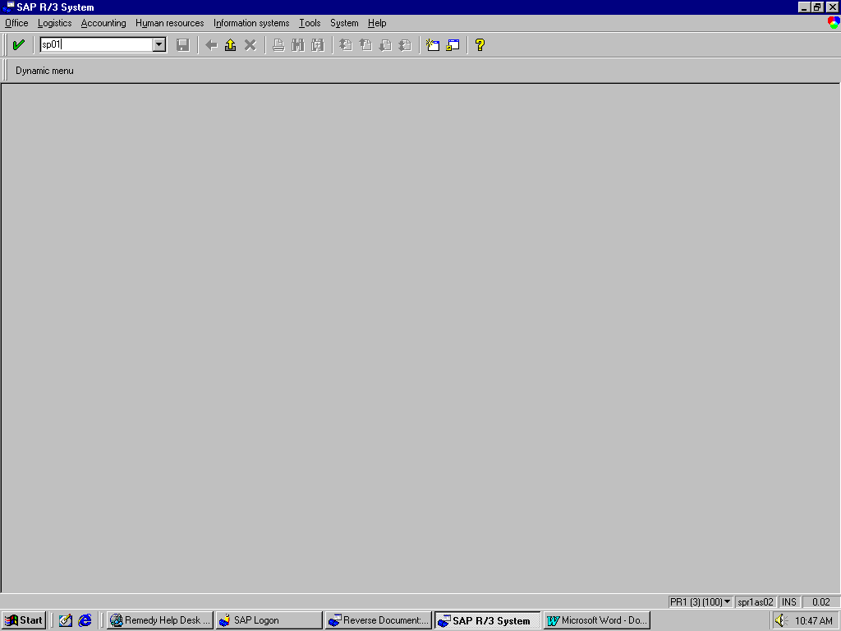
1. Transaction code SP01.

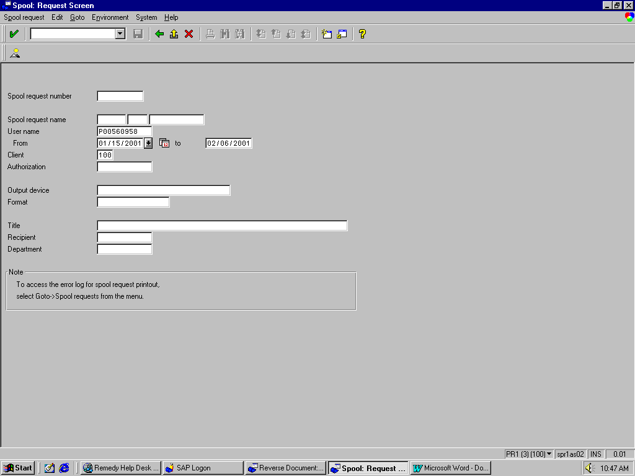
2. Fill in your user ID and the date range of spools you wish to review.

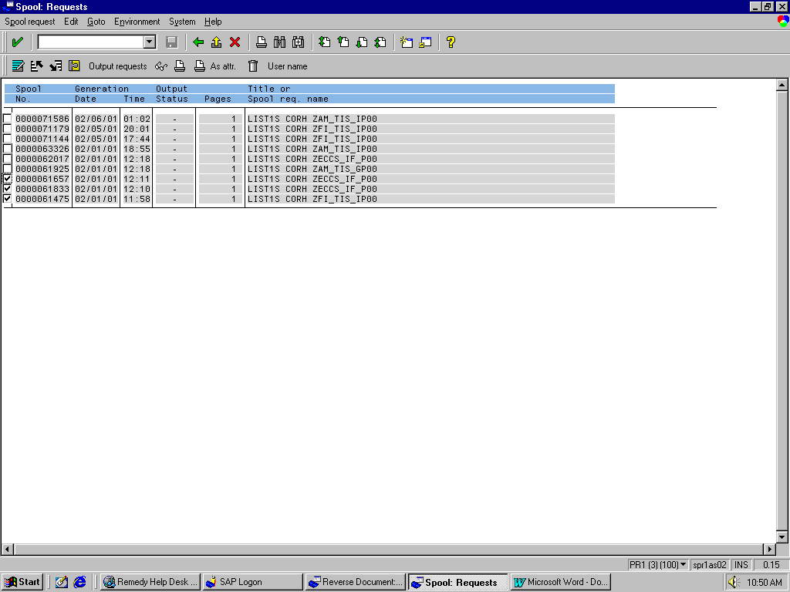
- Review spools and click on check boxes of those spools you wish to delete.

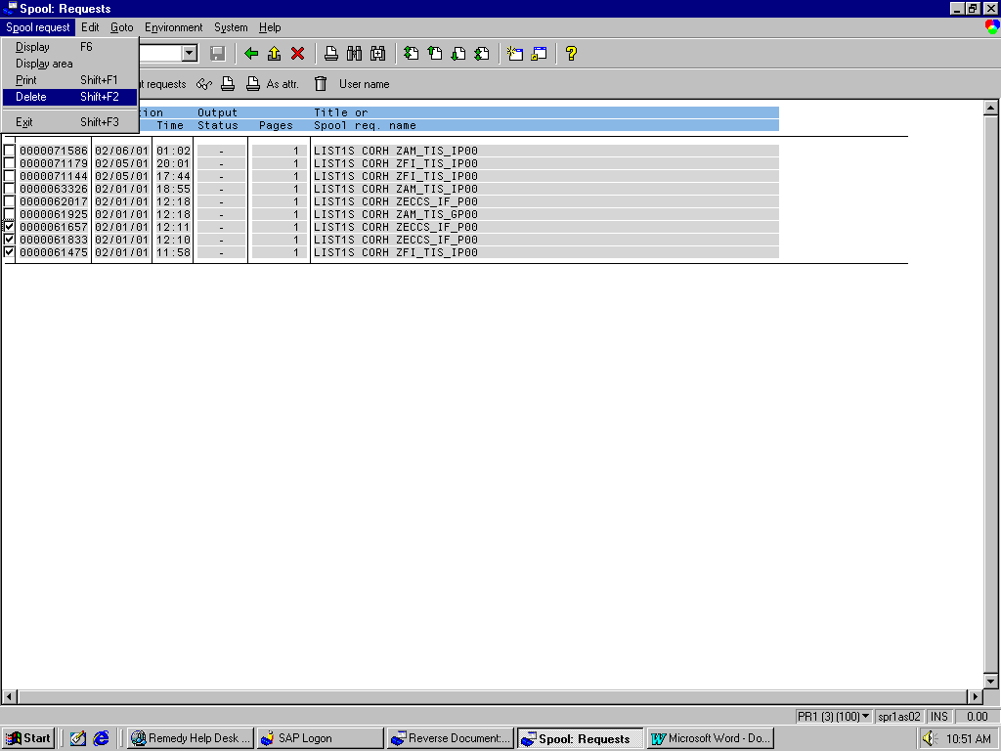
4. Go to menu path Spool request >Delete.

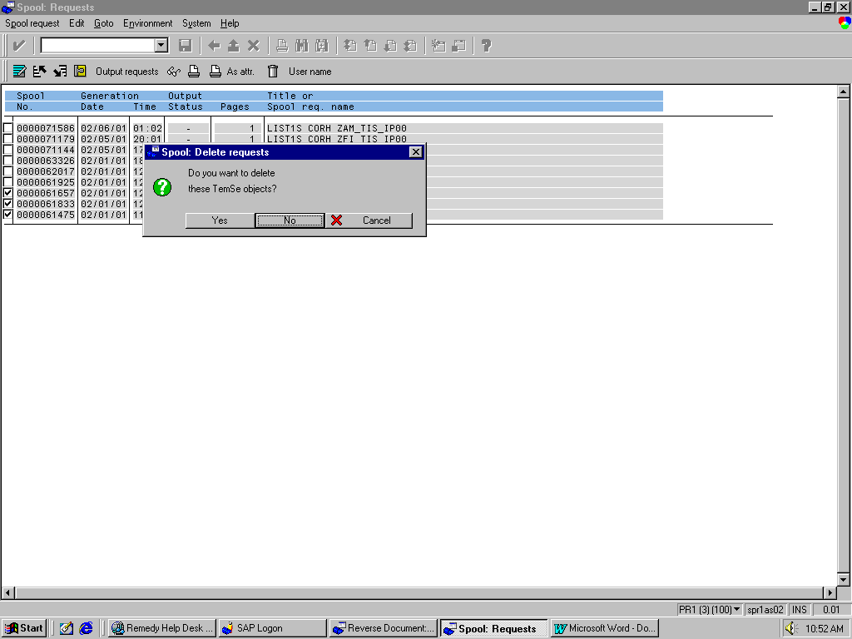
5. Hit Yes in the dialog box to delete the spools.

