December 3, 2001

Mr. R. B. Buy
Mr. R. R. Clark
Mr. C. A. Fox
Mr. M. Haedicke
Mr. R. E. Henderson
Mr. S. D. Josey
Mr. A. D. Keel
Mr. J. G. Melendrez
Mr. M. W. Strickler
Mr. L. G. Whalley
RE: Special Telephonic Quarterly Meeting
of the Boards of Directors of
Mariner Energy, Inc., Mariner Holdings, Inc. and Mariner Energy LLC (the “Companies”)
Gentlemen:

A Special Telephonic Quarterly Board Meeting of the Boards of Directors of the Companies will be held on Tuesday, December 4, 2001, at 2:00 p.m. and is expected to last no longer than 15 minutes. The purpose of the meeting is to elect certain new officers and to approve (i) the extension of the term of all existing employment agreements and certain consulting agreements through September 30, 2002, (ii) amending the terms of certain other consulting agreements so that the Company’s need for services thereunder (or payment for services in lieu thereof) is guaranteed though June 30, 2002, and (iii) approval of a severance plan for grade levels 9 and under.

For participating in the Special Telephonic Quarterly Board Meeting of the Boards of Directors, please dial 1-800-937-1654 approximately five minutes prior to conference time. The access code is 5845511.

Please advise Donna Cagle (281/584-5511) if you will be unable to participate.

Very truly yours,
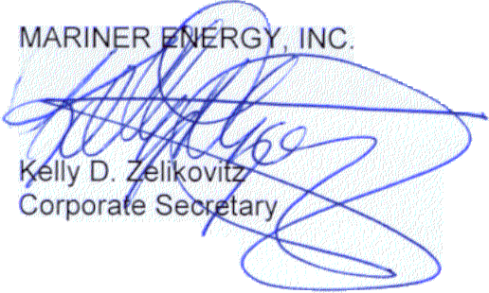
KDZ:dmc2
cc: D. M. Cagle
T. G. Bushman - ENAC

580 WestLake Park Blvd., Suite 1300 Houston, TX 77079-2643 Tel (281) 584-5500 Fax (281) 584-5555

