December 19, 2001

Mr. R. B. Buy
Mr. R. R. Clark
Mr. C. A. Fox
Mr. M. Haedicke
Mr. R. E. Henderson
Mr. S. D. Josey
Mr. A. D. Keel
Mr. J. G. Melendrez
Mr. M. W. Strickler
Mr. L. G. Whalley
RE: Special Telephonic Meeting
of the Board of Directors of
Mariner Energy, Inc. (the “Company”)

Gentlemen:

A Special Telephonic Board Meeting of the Board of Directors of the Company will be held on Friday, December 21, 2001, at 10:00 a.m. and is expected to last no longer than 15 minutes. The purpose of the meeting is to (i) approve the amendment, restatement and continuation of the Company’s retirement 401(K) Plan to ensure that the Plan complies with the requirements of recent legislation, including the Uruguay Round Agreements Act, the Uniformed Services Employment and Reemployment Rights Act of 1994 ("USERRA"), the Small Business Job Protection Act of 1996, the Taxpayer Relief Act of 1997, the Internal Revenue Service Restructuring and Reform Act of 1998, the Community Renewal Tax Relief Act of 2000, and the Economic Growth and Tax Relief Reconciliation Act of 2001 and (ii) approve an IRS Section 125 Cafeteria Plan (pretax payment of medical insurance premiums).

For participating in the Special Telephonic Board Meeting of the Board of Directors, please dial 1-800-937-1654 approximately five minutes prior to conference time. The access code is 5845511.

Please advise Donna Cagle (281/584-5511) if you will be unable to participate.

Very truly yours,
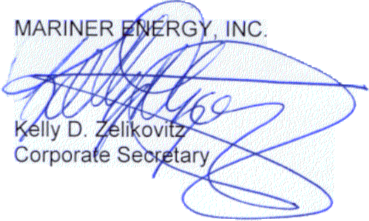
KDZ:dmc2
cc: D. M. Cagle
T. G. Bushman - ENAC
M. A. Wichterich

580 WestLake Park Blvd., Suite 1300 Houston, TX 77079-2643 Tel (281) 584-5500 Fax (281) 584-5555

