October 12, 2001

Mr. R. B. Buy
Mr. R. R. Clark
Mr. C. A. Fox
Mr. M. Haedicke
Mr. R. E. Henderson
Mr. S. D. Josey
Mr. A. D. Keel
Mr. J. G. Melendrez
Mr. M. W. Strickler
Mr. C. J. Thompson
Mr. L. G. Whalley
RE: Special Telephonic Meeting
of the Board of Directors of
Mariner Energy, Inc. (the “Company”)

Gentlemen:

A Special Telephonic Board Meeting of the Board of Directors of the Company will be held on Tuesday, October 16, 2001 at 4:00 p.m. and is expected to last no longer than 15 minutes. The purpose of the meeting is to approve the Company’s sale of its interest in the Aconcagua Field (Mississippi Canyon Block 305) and related interest in the Canyon Express Pipeline System.

For participating in the Special Telephonic Board Meeting of the Board of Directors, please dial 1-800-277-3082 approximately five minutes prior to conference time. The reservation number is 19878048, passcode 3252711.

Please advise Donna Cagle (281/584-5511) if you will be unable to participate.

Very truly yours,
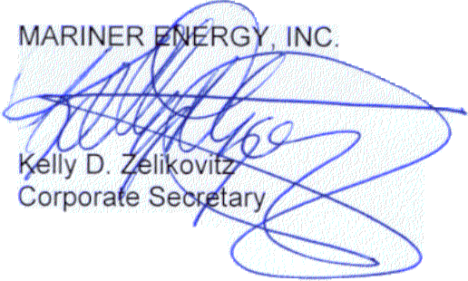
KDZ:dmc2
cc: C. K. Burgess
D. M. Cagle
D. M. Clement
G. K. Harless
D. S. Huber
M. C. van den Bold
M. A. Wichterich
T. E. Young
T. G. Bushman - ENAC

580 WestLake Park Blvd., Suite 1300 Houston, TX 77079-2643 Tel (281) 584-5500 Fax (281) 584-5555

