Vince Kaminski
Enron

June 4, 2001

Dear Vince,

Financial Mathematics to Energy Derivatives
London, June 28 & 29, 2001
New York, June 9 & 10, 2001
Houston, June 16 & 17, 2001

EPRM is delighted you have agreed to participate in the above titled course. I am writing to you on behalf of Paul Bristow, Course Producer and also to introduce myself as the Course Co-ordinator for this event.

I have enclosed some course brochures for your information. Please distribute these amongst your colleagues and clients, or anyone else who you think may be interested in attending the event. Please refer to the enclosed Information Sheet for details regarding speaker guests.

Within your speaker pack, you will find the following information:

- Information Sheet.
- Speaker Checklist.
- Presentation Guidelines.
- Speaker List.
- Priority Guest Registration Form
- Course Brochures.

The deadline for your presentation, speaker checklist and biographical details
is Thursday, May 24, 2001. The full details of where to send your materials can be found on the enclosed Information Sheet. Please note that you will only need to send in one copy of your presentation as the same presentation will be used for all three training courses.

I will contact you shortly to check that you have received your Speaker Pack and to answer any queries you may have.

In the meantime should you require any further information, please do not hesitate to contact me on (212) 925 1864x197 or email jvidal@riskwaters.com

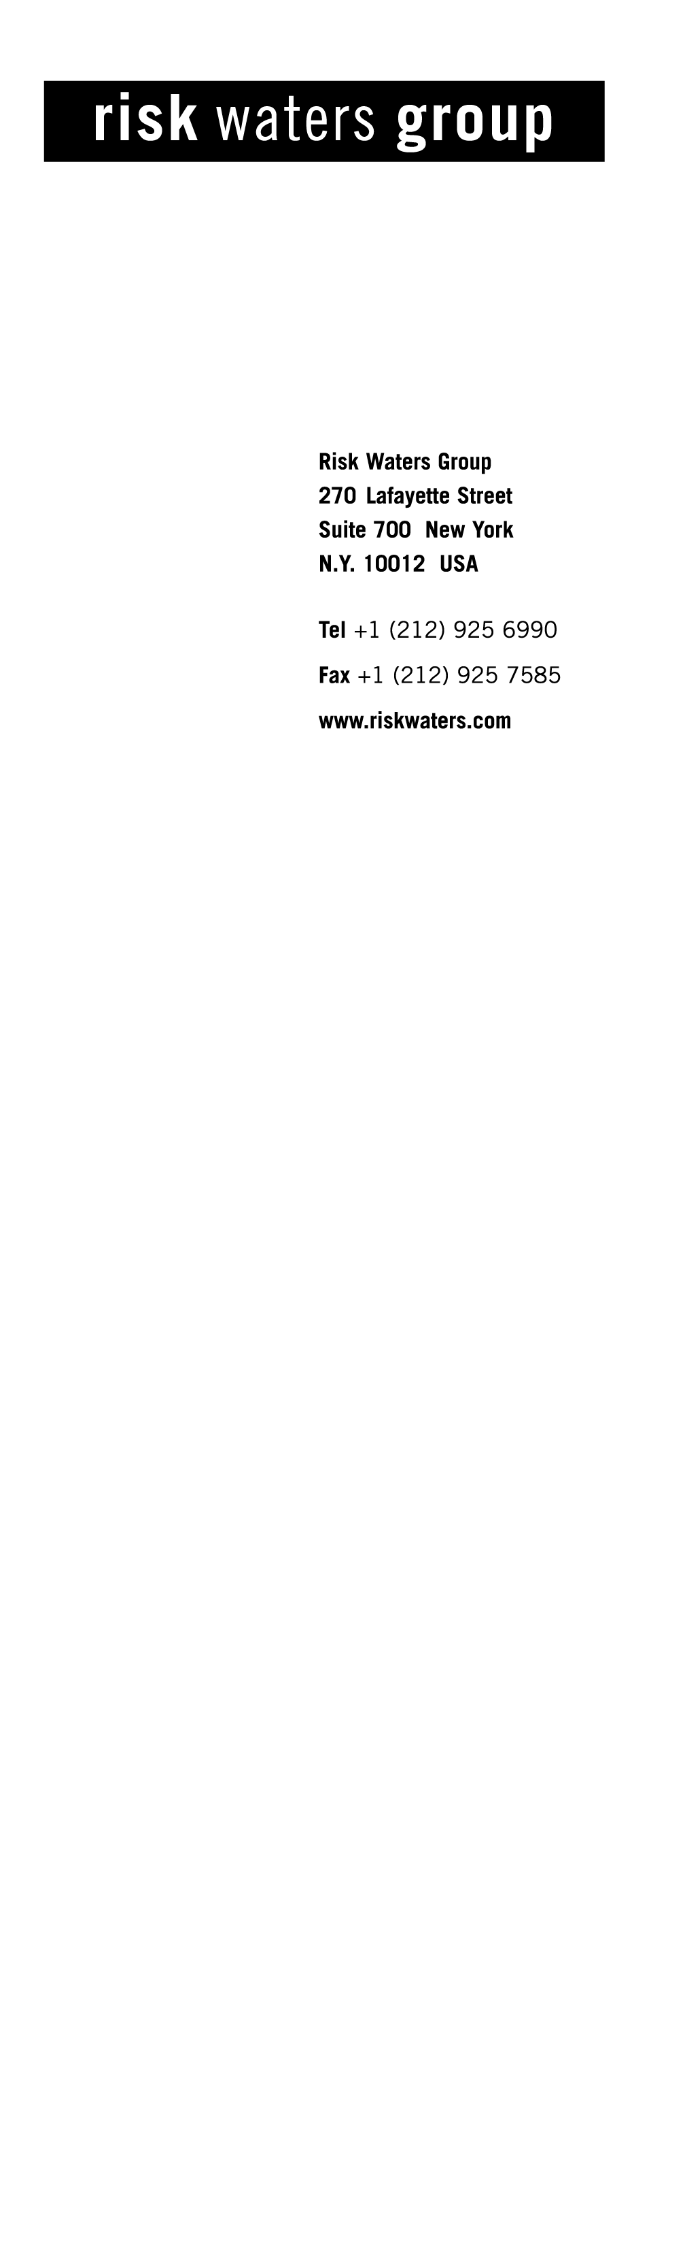Sincerely yours,

Joanna Vidal
Events Coordinator
Risk Waters Group, NY

