
EVENT TITLE: Financial Mathematics to Energy Derivatives
London – June 28 & 29
New York – July 9 & 10
Houston – July 16 & 17

SPEAKER GUEST REGISTRATION FORM

As a speaker you are entitled to bring 1 guest at 50% discount and further guests at 25% discount. Please have the guest(s) fill in the details below to take advantage of these discounts.

SPEAKER NAME Vince Kaminski

Speaker Guest contact details in full

1ST NAME: (50% discount) _____________________________
JOB TITLE/POSITION: _____________________________
COMPANY: _____________________________
ADDRESS: _____________________________
CITY: _____________________________
POST/ZIP CODE: _____________________________
COUNTRY: _____________________________
TELEPHONE: _____________________________
FAX: _____________________________
EMAIL: _____________________________

2ND NAME: (25% discount) _____________________________
JOB TITLE/POSITION: _____________________________
COMPANY: _____________________________
ADDRESS: _____________________________
CITY: _____________________________
POST/ZIP CODE: _____________________________
COUNTRY: _____________________________
TELEPHONE: _____________________________
FAX: _____________________________
EMAIL: _____________________________
(Please copy this form for additional guests)

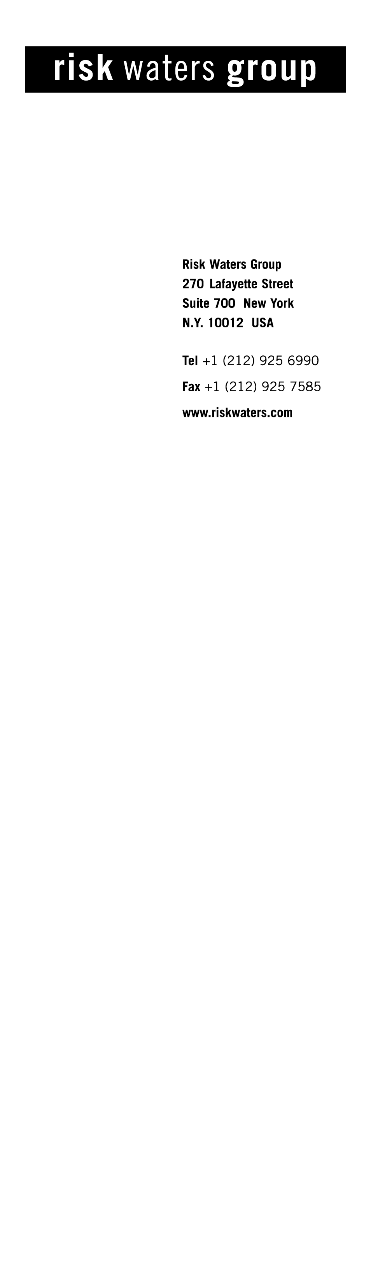PAYMENT DETAILS
By Cheque made payable to Risk Waters Group
Please debit my
Amex Visa Mastercard Diners Club (valid from date__________)
CARD NO:____________________________EXP DATE__________
For the amount of _________________
Account address (if different from above)
_______________________________________________________
Please invoice me

