THE ENRON TRAVEL CLUB presents

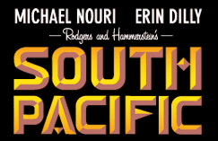

WINNER OF 9 TONY AWARDS, INCLUDING BEST MUSICAL, BEST BOOK AND BEST SCORE!!

Rogers & Hammerstein’s SOUTH PACIFIC, the timeless Broadway musical of wartime and romance in an island paradise.
The unforgettable score is full of some of the most enduring standards in Broadway history, including:

“There’s Nothing Like a Dame”, “I’m Gonna Wash That Man Right Outa My Hair”, “Bali Ha’i” and the beautiful “Some Enchanted Evening”.

Date: Thursday, January 24, 2002
Time: 8:00 PM
Place: Jones Hall
Price: $43.00 for ETC Members and $52.53 for Non-Members

Coordinator: Margaret Doucette
x5-7892 - ECN 3855-A

Great Play, Great Show, Great Music, Need I Say More!!!

