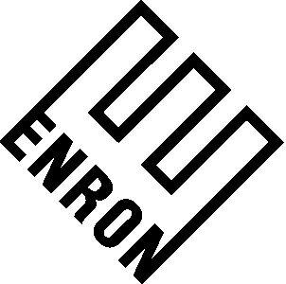

To: | Brian R. Redmond
From: | Gerald Nemec | Department: | ENA-Legal
Subject: | Sorrento Storage | Date: | September 28, 2025

CONFIDENTIAL ATTORNEY WORK PRODUCT

Per our meeting on Monday, I have reviewed the Project Hurricane Documents concerning the two issues with Texaco Exploration and Production, Inc.’s contribution of the Sorrento II Storage Cavern. Specifically I reviewed the Contribution Agreement and the Amended and Restated Limited Partnership Agreement of Bridgeline Holdings, L.P (the “Documents”).

(1) The Capacity of the Sorrento II Cavern

Agreement References:

(a) In Section I.A.1. of Schedule 3 to the Partnership Agreement, TEPI has the obligation to contribute a fully leached second natural gas storage cavern with all appurtenant facilities installed and connected to the Bridgeline Gas Distribution LLC system and shall be able to operate in natural gas service with a working capacity of not less than 3.0 BCF. No other references to the capacity of Sorrento II or the parameters around such capacity are contained in the Documents.

(b) In Section 3.16 of the Contribution Agreement, Texaco represents and warrants that the Texaco Assets (which inlcudes the Sorrento II Cavern) are sufficient for the continued conduct of each of the Texaco Company’s businesses and operation of such Texaco Assets after the Closing in substantially the same manner as conducted prior to the Closing.

Discussion:

Since no specific parameters concerning the 3 BCF exists, an acceptable minimum pressure per industry standards or an independent expert will be the best approaches here to establish the minimum pressure for the cavern. Section 3.16 of the Contribution Agreement, could be used to support the proposition that the Sorrento II Cavern minimum pressure should not be less than the Sorrento I Cavern minimum pressure.

(2) Injection of Pad and Working Gas at the same time.

Agreement References: No specific references in the Documents

Discussion:

Since this issue is not addressed by the documents, Bridgeline has interpreted all the provisions of Schedule 3 to indicate the intent of the Schedule 3 to support that all initial gas injected is Pad Gas. This argument can be made, although industry standards and an independent expert which support the all initial gas should be pad gas is likely more persuasive. Let’s discuss this in relation to Enron’s position.

CC:

