CONSULTING SERVICES AGREEMENT

between

Alstom Power Inc.
("Consultant")

and

Enron North America Corp.
(“Company”)

in association with the

Solid Fuel Initiatives Program

October 17, 2001
Contents

Article

1 Term

2 Services

3 Billing and Payment

4 Confidentiality Obligations

5 Changes and Force Majeure

6 Indemnification

7 Insurance

8 Independent Consultant

9 Notices

10 Waiver

11 Applicable Law

12 Severability

13 Successor and Assignment

14 Affiliates

15 Termination
16 Requirement to Advise

17 Liability

18 Disputes

19 No Third Party Beneficiaries

20 Other Agreements/Modifications

Exhibits

A Sample Tasking Letter Release Form
Schedule 1 Sample SFI Consulting Staff Cost and Expense Estimate Form

B Consulting Services Fee Schedule

C Sample Monthly Statement Form

D Sample Itemized Listing of Consultant’s Expense Form

CONSULTING SERVICES AGREEMENT

This Agreement made and entered into and effective as of October 17, 2001, by and between Alstom POWER INC., a Delaware corporation with its principal offices at 2000 Day Hill Road, Windsor, CT 06095 ("Consultant") and Enron North America Corp., a Delaware corporation with its principal offices at 1400 Smith Street, Houston, Texas 77002-7361 (“Company”) (individually each Consultant and Company are a “Party” and collectively they are the “Parties):

W I T N E S S E T H:

WHEREAS, Consultant has substantial experience and knowledge regarding solid fuel power plants; and

WHEREAS, Company desires to secure the services of Consultant for the provision of Services (as defined herein) regarding solid fuel power plants within the United States and Consultant desires to provide such Services to Company based on the terms and conditions contained herein;

NOW, THEREFORE, in consideration of the mutual covenants contained herein, the Parties do hereby agree as follows:

- Term: This Agreement will commence on October 1, 2001, and shall extend through December 31, 2002 unless sooner terminated in accordance with the provisions of Section (15). Upon termination of this Agreement, Company does not waive any rights it may possess under Sections (4), (6) and (7); said rights shall survive any termination of this Agreement.

(2) Services:

A. As Company identifies conceptual project opportunities related to certain solid fuel power plants by Notification Letters issued under this Agreement by Company in association with the Memorandum of Understanding entered into October 17, 2001 between the Parties (“MOU”) (“Conceptual Project”), the Parties shall collaborate to prepare a set of documents, including but not limited to a Tasking Letter (in a form similar to that shown as Exhibit A) and SFI Consulting Staff Cost and Expense Estimate (in a form similar to that shown as Exhibit A, Schedule 1), setting forth the schedule and scope of consulting services to be performed (“Services”). Upon mutual agreement and execution of a Tasking Letter, Solid Fuels Initiative (“SFI”) Consulting Staff Estimate and Expense Estimate and any other specific terms and conditions mutually agreed and set forth in writing between the Parties, such documentation shall collectively be called a “Tasking Letter Release”. When executed by the Parties, Consultant will perform the Services as will be described in the Tasking Letter Release at the unit rates set forth in the attached Consulting Services Fee Schedule, Exhibit B.

B. Consultant shall use commercially reasonable efforts to complete the Services in accordance with any schedules in the applicable Tasking Letter Release. Company and Consultant shall each advise the other in writing from time to time of the representative(s) authorized to act for such Party under this Agreement and the limitations, if any, on the authority of such representative(s).

C. Consultant shall provide all supervision, labor, equipment, materials and transportation, and shall control the means and methods of work necessary for performance of the Services. Company shall not have the right to control the manner(s) or prescribe the method(s) by which Consultant performs the Services.

D. Consultant represents and warrants that it has all necessary licenses and registrations required to provide the Services. Consultant shall secure, at its sole cost and expense, any and all additional licenses and registrations necessary in order for Consultant to perform the Services, and shall pay in connection therewith, without reimbursement from Company, any and all such applicable license or registration fees.

E. Consultant represents and warrants that Consultant shall perform the Services using that degree of skill, care and judgment exercised by similarly recognized professional firms performing services of a similar nature. In the event that the Services performed by Consultant hereunder do not conform to the foregoing warranty, Company shall promptly notify Consultant in writing and Consultant shall promptly reperform at its own expense such Services as are required in order for the Services to conform with the foregoing warranty, provided Company has notified Consultant of the requirement promptly upon discovery, or promptly upon such time when such defect should have been discovered during prudent and ordinary course of business, but in no event later than twelve (12) months following completion of the Services in question. For the avoidance of doubt, Consultant shall be liable with respect to the Services furnished through its subcontractors and agents as if provided by Consultant. EXCEPT FOR THE WARRANTIES SET OUT IN THIS AGREEMENT, CONSULTANT MAKES NO OTHER WARRANTIES, EXPRESS OR IMPLIED, INCLUDING ANY WARRANTIES OF MERCHANTABILITY OR FITNESS FOR PURPOSE.

F. Consultant acknowledges that all work product prepared by Consultant in its performance of the Services and furnished as deliverables under this Agreement (hereinafter “Work Product”) will become the property of Company upon payment in full for the Services. The Services are performed exclusively for the benefit of Company, and no other person or entity will be entitled to rely on the Work Product. Notwithstanding any of the foregoing, ownership of the any underlying intellectual property rights in such Work Product, including all rights to the intellectual processes and procedures of Consultant that it utilizes for the preparation of the Work Product and Consultant’s proprietary pricing information, shall remain the exclusive property of Consultant.

G. Consultant warrants that the Services to be provided hereunder will not cause a conflict with any other duties or obligations of Consultant to third parties.

H. Each Party represents and warrants that this Agreement has been (a) validly executed and delivered by such Party, (b) has been duly authorized by all corporate governance actions of such Party necessary for the authorization hereof, and (c) is the legal, valid and binding obligation of such Party, enforceable in accordance with its terms.

(3) Billing and Payment:

A. Billing. On or before the twenty-fifth day of each month during the term hereof, the Consultant shall submit to Company a monthly statement setting forth the total reimbursable Fees and Expenses incurred in the previous month in the form substantially similar to the Monthly Statement Form attached hereto as Exhibit C.

B. Payment Terms. Company shall pay Consultant for performance of the Services and reimburse expenses incurred by Consultant in performance of the Services as set forth in a Tasking Letter Release, its attachments and Exhibit B (such fees and expenses hereinafter called “Fees and Expenses”), in accordance with the terms hereof.

C. Expenses. With each Monthly Statement delivered during the term of this Agreement, Consultant shall provide a detailed schedule of Expenses (if applicable) to Company by attaching an Itemized Listing of Consultant Expenses, and the amount due therefore, in a form substantially similar to the attached Exhibit D (“Itemized Listing of Consultant Expenses”) together with all records, receipts or other evidence in support of Consultant's reimbursable Expense statement. Expense reimbursements shall be made at cost, without overhead or profit or other burden applied.

D. Payment. Pursuant to the terms of this Section (3), Company shall pay Consultant within thirty (30) days of Company's receipt of each Monthly Statement submitted in accordance with this Agreement. All payments hereunder shall be made by electronic wire transfer to the account designated by Consultant in each Monthly Statement.

Consultant shall be responsible for and agrees to pay any and all contributions and taxes payable under federal and state social security laws, unemployment compensations laws and income tax laws as to all of its employees engaged in the performance of the Services hereunder, and to pay any and all valid sales or use taxes levied on supplies and Services performed or provided by Consultant hereunder.

E. Tasking Letter Release Cost & Schedule Control. When Consultant has expended seventy-five (75%) of the estimated amount set forth in the SFI Consulting Staff Cost and Expense Estimate and schedule, comprising a Tasking Letter Release (“Budget and Schedule”), Consultant shall promptly notify Company in writing indicating that Consultant reasonably believes that the Budget and Schedule is adequate to complete the Tasking Letter Release. If Consultant discovers that the remaining Services will exceed either of the Budget and Schedule, Consultant shall advise Company in writing of the additional funding or time and requesting Company’s authorization in order to complete the remaining tasks and Company shall promptly provide Consultant with a written determination of whether Company desires Consultant to continue the matters described in the Tasking Letter Release. In the event Company desires Consultant to proceed with the matters described in the Tasking Letter Release, Company shall issue a change order to the Budget and Schedule and Consultant shall continue its Services at the rates set forth in Exhibit B. In the event Company instructs Consultant not to continue with the Services, Consultant shall deliver to Company such Work Product in its then completed stage. Unauthorized expenditures and cost overuns incurred by Consultant in performance of Services shall be at Consultant’s sole risk. Company is not obligated to reimburse such costs.

(4) Confidentiality Obligations: In connection with the activities and discussions that the Parties will have in connection with the matters addressed by this Agreement, the Parties are prepared to furnish one another with information (whether written, oral or electronically-generated and including this Agreement) which is confidential, proprietary or generally not available to the public (the "Confidential Information"). The Parties each agree that during the term of this Agreement and for a period two (2) years from the date of the termination of this Agreement neither Party shall disclose the other Party’s Confidential Information without the other Party’s prior written consent; provided, however, a Party may disclose:

A. The other Party’s Confidential Information to the Party’s affiliates, representatives, officers, directors, employees, advisors, lawyers, accountants, lenders and potential lenders, investors, equity participants, partners, co-venturers, or other participants in a Project or Conceptual Project, and their respective governing leaders, representatives, affiliates, directors, officers, employees, advisors, lawyers, accountants, lenders and potential lenders, investors, equity participants, partners or co-venturers in a Project or Conceptual Project (collectively, "Representatives"), who agree to maintain the confidentiality of such Confidential Information in accordance with the terms hereof, and;

B. Any of the other Party’s Confidential Information that: (i) becomes generally available to the public; (ii) is already known to the Party at the time of disclosure by the other Party; or (iii) is acquired from a third party not known to the receiving Party to be prohibited from making disclosure.

Consultant and Company further agree that neither Party shall use the other Party’s Confidential Information other than for the purpose of evaluating, negotiating and consummating Conceptual Projects in connection with this Agreement. Upon a Party’s request, the other Party shall return all written Confidential Information of the requesting Party, except for that portion of such Confidential Information that may be found in analyses, compilations, studies or other documents prepared by, or for, the returning Party, and the returning Party and its Representatives shall not retain any copies of such written Confidential Information. The portion of written Confidential Information that may be found in analyses, compilations, studies or other documents prepared by, or for, the returning Party, any Confidential Information furnished by the requesting Party not so requested or returned, will be held by the returning Party and kept subject to the terms of this Agreement, or destroyed.

Notwithstanding anything contained in this Agreement:

(i) Confidential Information may be disclosed to any governmental, judicial or regulatory or exchange authority requiring such Confidential Information, or to comply with any applicable law, order, regulation or ruling provided that: (a) each Party shall promptly inform the other Party of the substance of any inquiries received by such Party from any governmental, judicial or regulatory or exchange authority in connection with attempts to gain access to Confidential Information concerning the proposed transaction; (b) prior to such disclosure, the Party who originally supplied the Confidential Information is given the earliest practicable notice of any disclosure requirement so that it may take whatever action it deems appropriate, at its sole expense, including intervention in any proceeding and the seeking of an injunction to prohibit such disclosure; (c) such Confidential Information is submitted under applicable provisions in the jurisdiction in which disclosure is sought for confidential treatment by such governmental, judicial or regulatory authority; and (d) the Party subject to the governmental, judicial or regulatory or exchange authority endeavors to protect the confidentiality of any Confidential Information to the extent reasonable under the circumstances and to use its good faith efforts to prevent the further disclosure of any Confidential Information provided to any governmental, judicial or regulatory authority. If any court or other tribunal having jurisdiction orders that a Party is obligated to disclose any documents containing Confidential Information, then the Party shall first request from the other Party a “Public Disclosure Copy” in which the Confidential Information has been redacted at the other Party’s discretion to the extent that such redaction is permitted by the applicable court or tribunal requiring disclosure, as the case may be, and

(ii) The provisions of this Section (4) shall not apply to Work Product, and Company shall be permitted to use Work Product for any purpose whatsoever and to freely disclose Work Product to third parties, it being understood and agreed, however, that Consultant’s proprietary pricing information and intellectual processes and procedures shall constitute the Confidential Information of Consultant and shall be subject to the obligations of this Section (4) in accordance with its terms. Further, in performing its review of Consultants estimate details, pricing components, equipment quotations or supporting estimating material and notwithstanding Article (4)A, Company may disclose any such pricing components, equipment quotations or supporting estimating material information, only to its employees having a reasonable need to know.

Although a Party furnishing Confidential Information has endeavored to include materials which the furnishing Party believes to be reliable and relevant for the receiving Party's evaluation, the furnishing Party makes no representation or warranty as to the accuracy or completeness of any such provided information. Furthermore, neither the furnishing Party nor its Representatives shall have any liability to either the receiving Party or its Representatives resulting from the use of any such information by the receiving Party or its Representatives in accordance with the terms, and for the purpose set forth in this Agreement. Notwithstanding the foregoing sentence, a Party shall be liable for any breach of the other provisions of this Section (4) by such Party or any of its Representatives.

(5) Changes and Force Majeure: Should any change in the Services occur which: (a) was requested in writing by Company and (b) causes Consultant an increase or decrease in the Budget and Scheduled agreed for performance of the Services, then an equitable adjustment in the Budget and Schedule utilizing the rates set forth in Exhibit B, will be made as applicable. Any other provision(s) of this Agreement that is, or are, thereby affected shall also be revised as appropriate.

If either Party is impacted by an event of Force Majeure, the affected Party shall notify other in writing within five (5) days of such event, describing the event and the impact to the Services. If Consultant is impacted by Force Majeure, Consultant shall promptly prepare and submit to the Company a written estimate of the increase or decrease, if any, in the Budget and Schedule agreed for performance of the Services, as well as any adjustment to any other provisions of this Agreement. The term “Force Majeure” shall include acts of God; strikes, lock-outs, or other industrial disturbances; revisions required by revised laws, codes, ordinances or regulations; or any cause or event, whether similar or dissimilar, beyond the reasonable control of either Party in connection with the performance of Services. Neither Party hereto shall be considered in default of its obligations hereunder, except the obligation to make payments, to the extent that the performance of any such obligation is prevented or delayed by Force Majeure.

(6) INDEMNIFICATION:

CONSULTANT SHALL INDEMNIFY, DEFEND, AND HOLD COMPANY, ITS AFFILIATES, AND THEIR RESPECTIVE DIRECTORS, OFFICERS, EMPLOYEES, LENDERS, CONTRACTORS AND AGENTS HARMLESS FROM AND AGAINST ALL LIABILITY, CLAIMS, COSTS (INCLUDING WITHOUT LIMITATION COURT COSTS AND REASONABLE ATTORNEY FEES), EXPENSES, DEMANDS, SUITS AND CAUSES OF ACTION OF EVERY KIND AND CHARACTER (ALTOGETHER, "CLAIMS") ARISING IN FAVOR OF ANY PERSON, CORPORATION OR OTHER ENTITY FOR PERSONAL INJURIES OR DEATH OR THIRD-PARTY PROPERTY DAMAGE ARISING FROM AND TO THE EXTENT CAUSED BY THE NEGLIGENCE OR WILLFUL MISCONDUCT OF CONSULTANT, ITS DIRECTORS, OFFICERS, EMPLOYEES, CONTRACTORS, AGENTS OR OTHERS FOR WHOM CONSULTANT IS LEGALLY RESPONSIBLE, ARISING OUT OF (A) CONSULTANT’S PERFORMANCE OR NON-PERFORMANCE OF ITS OBLIGATIONS UNDER THIS AGREEMENT (B) THE PRESENCE OF CONSULTANT ON THE PREMISES OF COMPANY OR ON PREMISES OWNED BY THIRD PERSONS; OR (C) THE NEGLIGENT OR INTENTIONAL ACTS OR OMISSIONS OF CONSULTANT, EXCEPT, AND TO THE EXTENT, THAT ANY SUCH CLAIM IS ATTRIBUTABLE TO COMPANY’S OWN NEGLIGENCE OR WILLFUL MISCONDUCT.

(7) Insurance:

A. Consultant shall procure prior to commencing the Services and shall maintain while completing the Services, at its sole expense maintain insurance coverage of at least the following, in policies which shall be subject to Company's approval as to form and issuing company, which approval shall not be unreasonably witheld:

1. Automobile liability policy which shall include coverage for all owned, non-owned and hired vehicles, with limits as follows:

Bodily Injury $1,000,000.00 Each Person, Each Occurrence,

Property Damage $1,000,000.00 Each Occurrence or, alternately,

Bodily Injury and $1,000,000.00 Combined Single Limit, Each Property Damage Occurrence

Workers’ Compensation and Employers’ Liability Insurance, statutory.

3. General Liability Insurance with limits of at least $1,000,000 for each occurrence and in the aggregate.

All such liability policies (except workers comp and employer’s liability) shall include Company, its subsidiaries, all entities affiliated with Company, its subsidiaries and their respective officers, directors and employees, as an additional insured with respect to all claims arising out of the Services, except for those arising out of Company’s, its subsidiaries, all entities affiliated with Company, its subsidiaries and their respective officers, directors and employees sole negligence.

B. Contemporaneously upon the execution of this Agreement, Consultant shall furnish to Company evidence that all the foregoing policies have been obtained in accordance with the terms hereof. Consultant shall furthermore require its insurance carrier to give Company 30 days' written notice prior to the cancellation of any policies required hereunder. Finally, all policies shall contain provisions whereby underwriters agree to waive their rights of subrogation, in favor of Company.

(8) Independent Contractor: The Parties hereto agree that the Services rendered by Consultant in the fulfillment of the terms and obligations of this Agreement shall be as an independent contractor and not as an agents or employee, and with respect thereto, Consultant, its directors, officers, employees and those of its subcontractors, employees or agents shall not be entitled to the benefits provided by Company to its employees including, but not limited to, group insurance and participation in Company's employee benefit and pension plans. Further, Consultant is not an agent, partner, or joint venturer of Company. Consultant shall not represent itself to third persons to be other than an independent contractor of Company, nor shall it offer or agree to incur or assume any obligations or commitments in the name of Company or for Company without the prior written consent and authorization of Company, and shall indemnify Company from any breaches of this obligation. Consultant shall not subcontract any part of the Services without obtaining the prior written consent of Company, which shall not be unreasonably withheld.

(9) Notices: All notices required or permitted by the terms hereof shall be sent by Certified Mail or facsimile (with written confirmation, generated by the transmitting fax machine, of successful transmission to the recipient’s fax number indicated below) to the following addresses if sent to Consultant or Company:

To Company: To Consultant:

Enron North America Corp. Alstom Power, Inc.
1400 Smith Street 2000 Day Hill Road
Houston, Texas 77002 Windsor, CT. 06095

Attention: General Counsel Attention: General Counsel
Fax: 713 646 6280 Fax: 860 285 9790

(10) Waiver: Failure of Company at any time to require performance by Consultant of any provision hereof shall in no way affect the right of Company hereafter to enforce the same. No waiver by Company of any breach of any provision hereof shall be taken or held to be a waiver of any succeeding breach of such provision or as a waiver of this provision itself.

(11) Applicable Law: This Agreement shall be governed by and be construed in accordance with the laws of the State of New York, except its choice of law rules.

(12) Severability: It is the desire and intent of the Parties that the terms, provisions and covenants contained in this Agreement shall be enforceable to the fullest extent permitted by law. If any such term, provision or covenant or the application thereof to any person or circumstances shall, to any extent, be construed to be invalid or unenforceable in whole or in part, then such term, provision or covenant shall be construed in a manner as to permit its enforceability under the applicable law to the fullest extent permitted by law. In any case, the remaining provisions of this Agreement or the application thereof to any person or circumstances, other than those to which they have been held invalid or unenforceable, shall remain in full force and effect.

(13) Successors and Assignment: This Agreement or any right or obligation contained herein may be assigned (a) by Company, to financial lenders (“Lender”) as collateral security (and in connection therewith, Consultant shall execute and deliver to the Lender a consent agreement in a form reasonably requested by Lender); or (b) by Company (i) to an Affiliate of Company, (ii) a special purpose company established by Company (or its financing entity) for the purpose of development of the Project. Upon an assignment in compliance with the foregoing provisions of this Article 13, Company shall be released from any further obligations or liabilities under this Agreement. This Agreement may be assigned by Consultant to affiliates of Consultant, provided that Company shall have consented in writing to such assignment and Consultant has delivered to Company a confirmation of security in form and substance reasonably acceptable to Company. This Agreement may be assigned to other parties only upon the prior written consent of the other Party hereto. When duly assigned in accordance with the foregoing, this Agreement shall be binding upon and shall inure to the benefit of the assignee; any other assignment shall be void and without force or effect.

(14) Affiliate(s): As used in this Agreement, "Affiliate" shall mean any entity which owns or controls, is owned or controlled by, or is under common control or ownership with, Company or Consultant as applicable.

(15) Termination: This Agreement shall terminate, and all compensation under paragraph (3) shall cease, in the event any of the following occurs:

A. Consultant or Company (i) commits a material breach hereof or (ii) refuses without proper legal cause to perform their duties and responsibilities under paragraph (2) of this Agreement; or (iii) willfully engages in illegal conduct which either the other has reason to know is injurious to it, as the case may be. Termination under this subparagraph (15)(B) shall be effective upon notice thereof delivered by Company to Consultant or Consultant to Company.

B. Consultant or Company may terminate this Agreement at any time for any other reason by furnishing the other Party with thirty (30) days' advance notice of such termination. In the event of such an early termination, Consultant shall invoice Company for any amounts owed to Consultant for Services performed but not yet previously invoiced prior to such date of termination. Company shall pay such amounts to Consultant in accordance with the terms hereunder.

(16) Requirement to Advise; Consultant agrees to advise its employees, subcontractors and agents that it is the policy of Company that:

A. The use, possession and/or distribution of illegal or unauthorized drugs, drug related paraphernalia or weapons on Company’s premises are prohibited and the use or possession of alcoholic beverages, except where authorized by Company's management, is also prohibited;

B. Entry onto or presence on Company's premises by any person, including Consultant, Consultant's employees, subcontractors, subcontractors' employees, contract personnel, temporary employees and visitors, constitutes consent to Company to conduct searches, whether announced or unannounced, on Company's premises of the person and his or her personal effects for such prohibited items; and

C. Any person who is found in violation of the policy or who refuses to permit a search may be removed and barred from Company's Premises, at the discretion of Company.

(17) LIABILITY:

A. Limit on Total Liability. The total liability of Consultant and its subcontractors (if any) to Company, including Company’s Affiliates, arising out of or in connection with this Agreement, from any and all causes except for breach of Article 4 and indemnities expressly provided herein, shall not exceed the total amount set forth in the Budget and Schedule comprising the Tasking Letter Releases issued to Consultant under this Agreement, or $1,000,000, whichever is less. The total liability of the Company to Consultant, includes Consultant’s Affiliates, arising out of or in connection with this Agreement, from any and all causes, except for breach of Article 4, shall not exceed the amount of payments due to Consultant for services performed hereunder.

B. Waiver of Consequential Damages: NOTWITHSTANDING ANYTHING HEREIN TO THE CONTRARY, NEITHER CONSULTANT NOR COMPANY, NOR ANY OF THEIR RESPECTIVE OFFICIALS, DIRECTORS, OFFICERS, SHAREHOLDERS, MANAGERS, OR EMPLOYEES WILL BE LIABLE TO ANY OTHER PARTY, OR ITS RESPECTIVE OFFICIALS DIRECTORS, OFFICERS, SHAREHOLDERS, MANAGERS OR EMPLOYEES, WHETHER UNDER BREACH OF CONTRACT, BREACH OF WARRANTY, INDEMNITY, TORT LIABILITY (INCLUDING WITHOUT LIMITATION BOTH NEGLIGENCE AND STRICT LIABILITY), STRICT LIABILITY OR OTHERWISE, FOR ANY INCIDENTAL, SPECIAL, INDIRECT, EXEMPLARY, OR CONSEQUENTIAL DAMAGES WHATSOEVER (INCLUDING WITHOUT LIMITATION LOST PROFITS OR REVENUE) OF ANY NATURE CONNECTED WITH OR RESULTING FROM PERFORMANCE HEREUNDER BUT RATHER SHALL BE LIABLE ONLY FOR DIRECT ACTUAL DAMAGES ARISING FROM THE BREACHING PARTY’S WILLFUL BREACH OR SOLE, JOINT OR CONCURRENT NEGLIGENCE.

C. Extent of Releases: Releases from liability and limitations on liability expressed in this Paragraph 17 shall apply equally to all claims against Consultant arising out of or in connection with this Agreement, whether sounding in contract or in tort, including claims for breach of contract, breach of warranty, guarantee, indemnity, tort liability (including, without limitation, both negligence and strict liability), strict liability, or any other claims. Such releases from liability and limitations on liability extend and apply to the directors, officers and employees, and related or affiliated entities of Consultant, and their directors, officers and employees.

(18) Disputes: All claims, disputes and other matters in question between Consultant and Company, arising out of or relating to this Agreement or the breach thereof, shall be settled, if possible, by negotiation and mutual agreement of the Parties thereto. Each Party hereto shall give notice promptly to the other of the claim, dispute or other matter in question arising out of or relating to this Agreement or the breach thereof. Within fifteen (15) calendar days following such notice, the Parties’ nominated senior representatives shall conduct good faith negotiations with the object of reaching mutual agreement. If the nominated senior representatives of the Parties are unable to agree, the claim, dispute or other matter in question, it shall be resolved by binding arbitration pursuant to the Federal Arbitration Act. The arbitration shall be administered by the American Arbitration Association ("AAA"). There shall be three arbitrators. Each Party shall designate an arbitrator, who need not be neutral, within 30 days of receiving notification of the filing with the AAA of a demand for arbitration. The two arbitrators so designated shall elect a third arbitrator. If either Party fails to designate an arbitrator within the time specified or the two Parties' arbitrators fail to designate a third arbitrator within 30 days of their appointments, the third arbitrator shall be appointed by the AAA. The location of any arbitration shall be New York City, New York.

Pending final resolution of any dispute, whether or not submitted to arbitration hereunder, Consultant shall continue to fulfill its obligations hereunder.

Upon request of either Party, any arbitration under this Agreement shall be consolidated with any pre-existing dispute under the MOU, with the arbitrator appointed under the MOU hearing all disputes under this Agreement.

(19) No Third Party Beneficiaries: Except with respect to any permitted assignees of this Agreement as set forth above in Section 13, no other parties shall be deemed to be third party beneficiaries of this Agreement.

(20) Other Agreements/Modifications:

A. This Agreement modifies and supersedes all other preceding agreements between the Parties and constitutes the entire agreement of the Parties regarding the matters addressed herein, except for the MOU.

B. This Agreement may be amended, modified, superseded, canceled, renewed or extended and the terms and conditions hereof may be waived only by a written instrument executed by both Parties hereto or, in the case of a waiver, by the Party waiving compliance.

IN WITNESS WHEREOF, the Parties have caused this Agreement to be executed as of the day and year first above written.

COMPANY
ENRON NORTH AMERICA CORP.

By:

Name: ________________

Title:

CONSULTANT
ALSTOM POWER, INC.

By:

Name:

Title:

EXHIBIT A
TASKING LETTER RELEASE # ____

Date Prepared: [xxxx xx, xxxx}
Effective Date of Task Order: [xxxx xx, 2001] [at signature]

Reference: Consulting Services Agreement # __________dated [xxxx xx, 2001], between Alstom Power Inc. and Enron North America Corp.

Company Contact: Bill Fox, Ph # 713 345 5627, Fax # [ ]

Consultant Contact: Jacques Paren, Ph # 804-763-8481, Fax # 804 763-7108

Scope of Work: The scope of work involves the conceptual

[-To be completed in detail upon issue -]

TL Completion Date: _______________________-

Budget Amount: Consultant shall provide a written, ‘Not To Exceed’ Estimate to Company for the work referenced above.

Based on that offer, Company authorizes Consultant to expend up to ___ thousand and No/100ths Dollars ($___,000.00) (the “Budget Amount”) for services and expenses relating to the matters described in the above referenced section, the Initial Scope of Work, and as quantified on the Solid Fuel Initiative Consultant Staff Cost & Expense Estimate (2 pgs) attached hereto as Schedule 1.

Agreed and ACCEPTED:

COMPANY:
ENRON NORTH AMERICA CORP.

By: ___________________________

Name: ______________________

Title: _____________________________

CONSULTANT

ALSTOM POWER, INC.

By:

Name:

Title: _______________________________

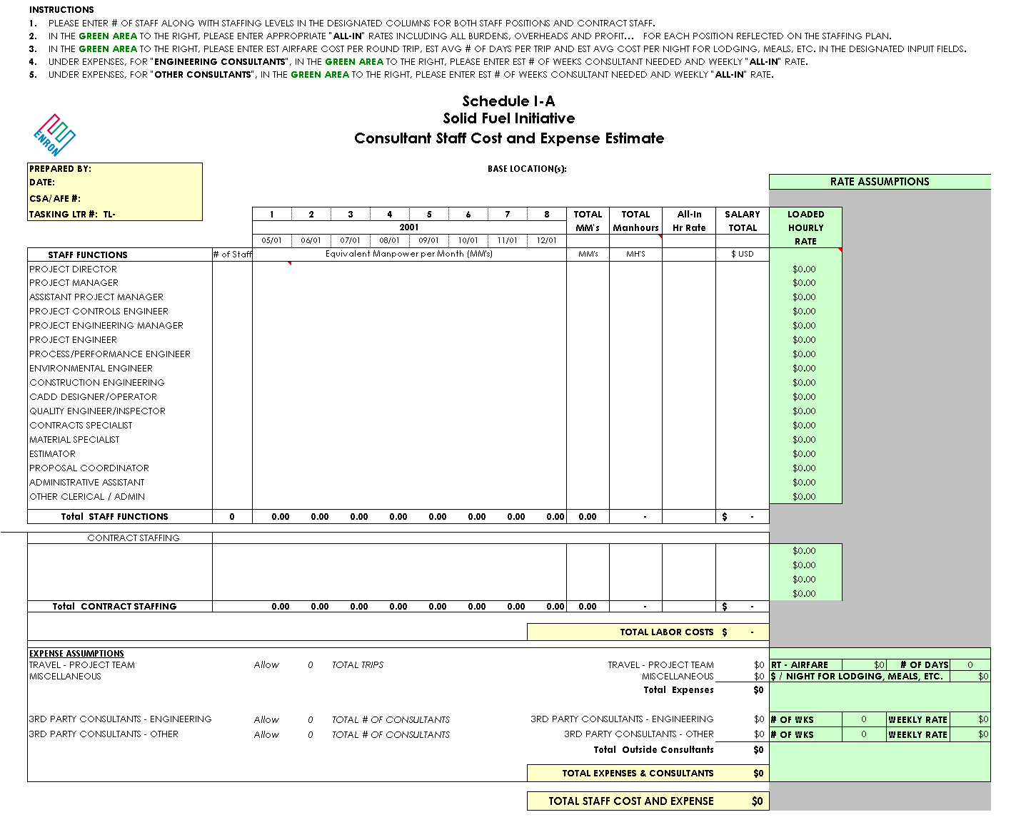
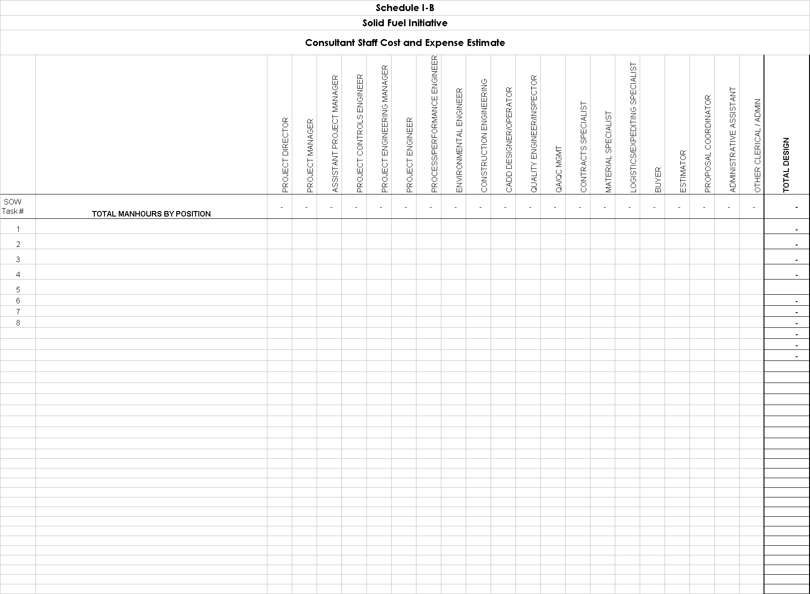
EXHIBIT B
CONSULTING SERVICES FEE SCHEDULE
ALSTOM POWER INC
Cost Center Name | Cost Center Number |  | Sell Rate
Project Planning | 6305218 |  | $ 94.00
Quality | 6305273 |  | $ 113.00
Logistics | 6305274 |  | $ 111.00
Expediting | 6305274 |  | $ 73.00
Project Procurement | 6305275 |  | $ 106.00
Contract Administration | 6306136 |  | $ 103.00
Finance | 6306285 |  | $ 91.00
Proposal Development | 6307031 |  | $ 101.00
Sales - Americas | 6307043 |  | $ 141.00
Mtl Cost Standards/Estimating | 6307141 |  | $ 112.00
Engineering Analysis & Dev. | 6308102 |  | $ 106.00
Process Control | 6308107 |  | $ 86.00
Project Engineering | 6308122 |  | $ 92.00
CFB & IND Performance | 6308125 |  | $ 100.00
Strategic Engineering | 6308128 |  | $ 127.00
Contract Engineering | 6308137 |  | $ 91.00
Project Engineering Operations | 6308139 |  | $ 103.00
Process Design Engineering | 6308152 |  | $ 109.00
Field Operations | 6308157 |  | $ 123.00
Site Field Operations | 6308158 |  | $ 100.00
BOP Engineering | 6308159 |  | $ 103.00
Asset Enhancement | 6308171 |  | $ 109.00
Project Management | 6308210 |  | $ 136.00
CPC Engineering | 6308228 |  | $ 129.00
Structural Engineering | 6309809 |  | $ 97.00
Pressure Parts Engineering | 6309810 |  | $ 81.00
Plant Engineering | 6309812 |  | $ 89.00
Non-Pressure Part Engineering | 6309814 |  | $ 80.00
Clerical Services | 6308210 |  | $ 36.00

EXHIBIT C
Sample Monthly Statement

DATE: _________

CONSULTANT: INVOICE NUMBER: TAX ID NUMBER: __________________

COMPANY TO BE BILLED: Enron North America Corp.
P. O. BOX 1188
HOUSTON, TX 77251-1188

PERIOD OF SERVICES RENDERED: From: To: ___________

CONSULTING FEE: Month of: $

NET CONSULTING FEE: $

Lodging:
Transportation:
Meals:
Miscellaneous:

TOTAL EXPENSES:

TOTAL AMOUNT DUE: $

I have incurred the above expenses I have reviewed the above expenses
on behalf of ____________. and approve this invoice for payment.

ALSTOM POWER, INC. ENRon North America Corp.

By: By:
Name: Name:

Title: Title:

Date: Date:

EXHIBIT D
Sample Itemized Listing of Consultant Expense Form

NAME: |  | TAXPAYER ID NUMBER: | MONTH: |  | DATE PREPARED:
Day of Month: | Purpose/Comments: |  | Lodging: | Transportation: |  | Meals: | Misc:
See Receipts | TOTAL

