
Cambridge Energy Research Associates (CERA) is the leading independent firm providing insight into the energy future. We specialize in energy markets, technology, geopolitics, and strategy. CERA’s expertise covers all major energy sectors -oil, refined products, natural gas, and electric power- on a regional and global basis, and we deliver this knowledge to you electronically.

To create your individual profile for access to cera.com, open your web browser to: http://www.cera.com. Click on ‘Create A Profile’ on the left of the main screen. You will be prompted to enter your COMPANY’s USERNAME and PASSWORD. (If your browser prompts you to remember THIS password, select NO.)

Your Company Username: enron
Your Company Password: ravencall

As you begin the profile creation process you must create YOUR OWN username and password. PLEASE DO NOT use your Company’s username and password. Continue on to the ‘Terms of Use’ page and choose ‘I Agree’. This will bring you to the ‘e-mail notifications options’ page where you will be asked to select the CERA services and report types you wish to receive notification of via e-mail.

Help Is Available
If you would like to learn more about the features of cera.com, please go to www.cera.com/help to access the FAQs & UserTips available in Flash or PowerPoint.

Please forward comments or questions to the CERA Webmaster at webmaster@cera.com.
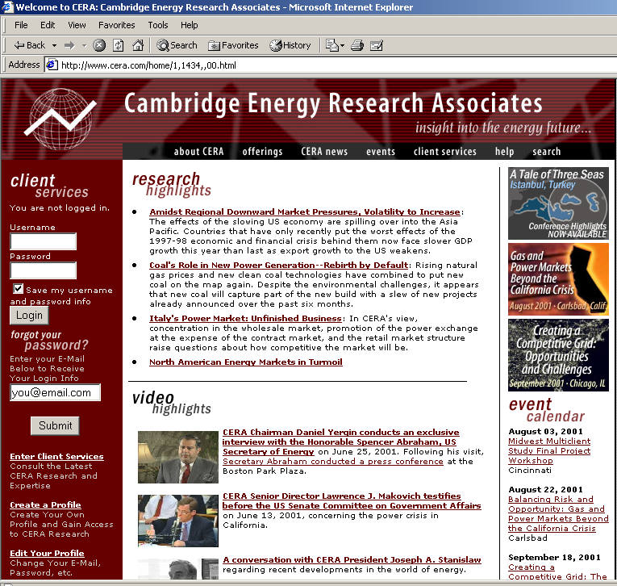
Thank you.
The cera.com Team

1.
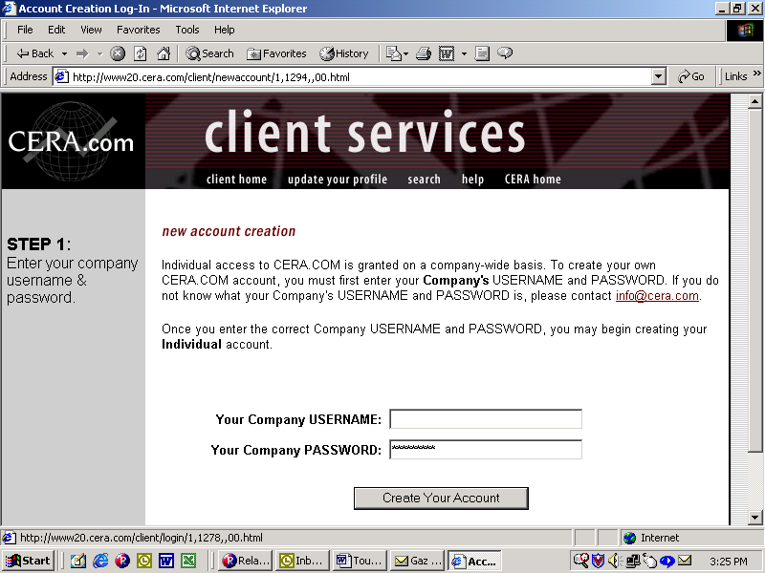

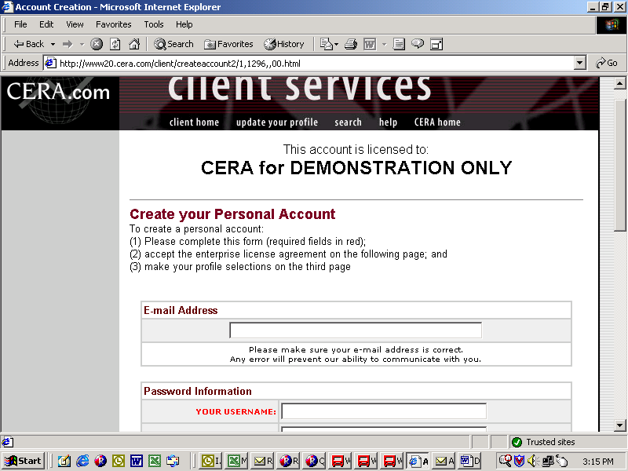
2.
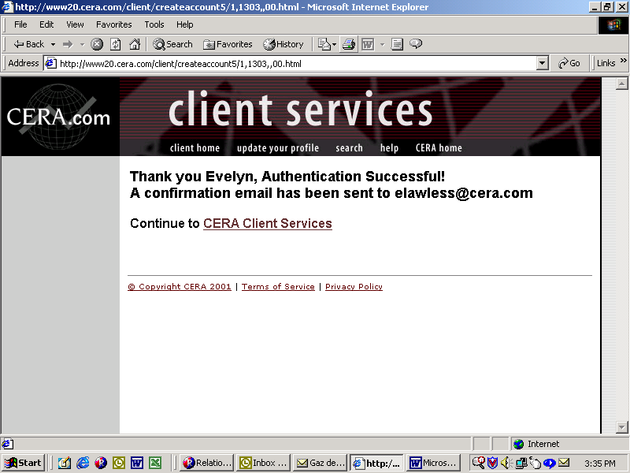
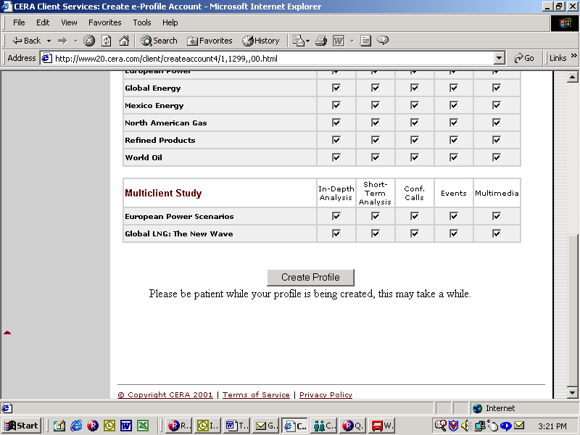
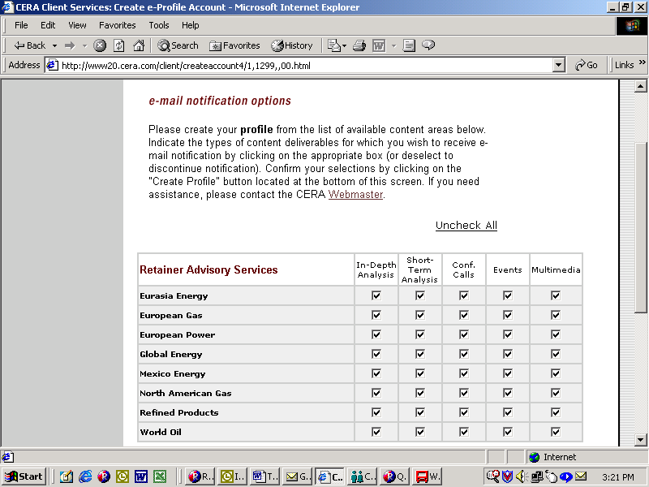
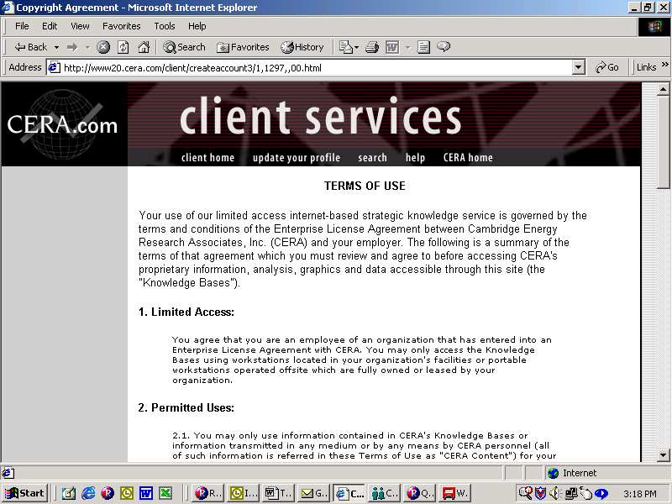
3.
5.
4.

