September 2001 Short Circuits - Electricity by Rita Hartfield
Short Circuits

A key feature of the US power generation market is the vast economic and pricing disparities between regions. The nature of the transmission system limits the ability to transport electricity long distances between regions. Interregional connections do exist, but for the most part these were built mainly for reliability purposes. The grid was never designed to transfer large quantities of power easily around the country.

Capacity Additions
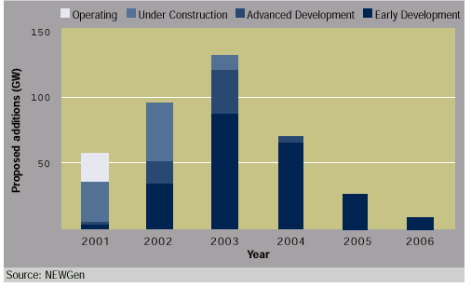

According to RDI’s NEWGen, over 450,000 MW have been proposed since 1999 and more than 90% of those capacity additions stand ready to move forward nationwide. This would result in a capacity surplus of more than 70,000 MW by 2005.

However, it is highly unlikely that all will be built. In fact, 10,000 MW scheduled to begin operating by July 2001 did not meet their on-line date, creating problems for regional planner.

RDI have developed an expected value of capacity additions for each year from 2001 to 2005. RDI projects that 180,000 MW of capacity additions will become operation by 2005. 55% of these capacity additions either began operating in 2001 or are now under construction. The Midwest and the Southeast regions account for about half of the expected capacity additions. (This projection is display in the chart to the right. The unit of measure is MW.)
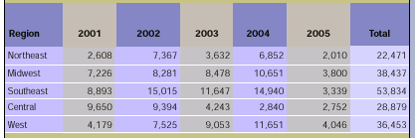
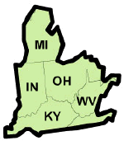

East Central Area Reliability Coordination (ECAR) Region

Market Design:
- Relies almost exclusively on bilateral agreements.
- Has no regional centralized power exchange. First Energy initiated a sub-region power exchange in 1999 and NYMEX manages the Cinergy Hub for trading futures and options contract.

Transmission:
- 16,137 miles of line greater than 230 kV.
- Reliability is relatively stable.
- Import capacity from
  - Kentucky 2,600 MW
  - Northeast Study Area 6,300 MW

Peak Electric Demand:
- 2000 region peak demand was 92,033 MW or 14% of the US market.
- Demand estimated to grow at an annual rate of 2.0% from 2001-2006.
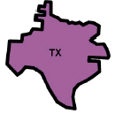

Electric Reliability Council of Texas (ERCOT)

Market Design:
- Operates as bilateral market where scheduling, coordination, and market pricing are negotiated between buyers and sellers.

Transmission:
- 7,175 miles of line greater than 230 kV.
- Constrained during high-demand periods.
- Isolated with only two high-voltage interconnects with SPP totaling 800 MW.
- Future ties to other areas are currently deemed uneconomical.

Peak Electric Demand:
- 2000 region peak demand was 57,606 MW or 9% of the US market.
- Demand estimated to grow at an annual rate of 3.0% from 2001-2006.


Florida Reliability Coordination Council (FRCC)

Market Design:
- Operates as a bilateral market. Wholesale market has an active broker system that allows electric utilities to share generation reserves but the market remains largely closed to other market participants not obligated to serve retail customers.

Transmission:
- 6,669 miles of line greater than 230 kV.
- 416 miles of transmission lines planned over next several years.
- Isolated region.
- Import capacity from
  - SERC 3,600 MW

Peak Electric Demand:
- 2000 region peak demand was 37,197 MW or 6% of the US market.
- Demand estimated to grow at an annual rate of 2.3% from 2001-2006.

Mid-Atlantic Area Council (MAAC)


Market Design:
- PJM is one of the most sophisticated and liquid centralized power exchanges in the US featuring real-time, day-ahead, and an ancillary services market.

Transmission:
- 7,094 miles of line greater than 230 kV.
- Reliable performance.
- Import capacity from
  - ECAR 4,000 MW
  - SERC 2,900 MW
  - NPCC 2,000 MW

Peak Electric Demand:
- 2000 region peak demand was 49,477 MW or 7% of the US market.
- Demand estimated to grow at an annual rate of 2.3% from 2001-2006.

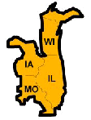
Mid-American Interconnected Network (MAIN)

Market Design:
- Lacks centralized power exchange. Purchases and sales of power take place mainly through bilateral agreements.

Transmission:
- 6,102 miles of line greater than 230 kV.
- Adequate capacity. However, congestion on MAPP interface can restrict bulk power transfers into or within Wisconsin.
- Import/export capacity from
  - ECAR 3,800 MW
  - MAPP 1,500 MW
  - SPP 1,300 MW
  - TVA 1,800 MW
  - SERCW 650 MW

Peak Electric Demand:
- 2000 region peak demand was 52,552 MW or 8% of the US market.
- Demand estimated to grow at an annual rate of 2.0% from 2001-2006.

Mid-Continent Area Power Pool (MAPP)
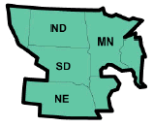
Market Design:
- Lacks a major centralized power exchange and is operated as a bilateral market.

Transmission:
- 15,107 miles of line greater than 230 kV.
- Primarily an energy exporting region and does not have import constraints.
- Import capacity from
  - WSCC 460 MW
  - SPP 700 MW
  - MAIN 950 MW
  - SERC 850 MW
  - Canada 1,700 MW
Peak Electric Demand:
- 2000 region peak demand was 28,605 MW or 4% of the US market.
- Demand estimated to grow at an annual rate of 1.6% from 2001-2006.



NPCC: New England Power Pool (NEPOOL)

Market Design:
- ISO New England operates a centralized power exchange with a day-ahead and hourly market.

Transmission:
- 2,387 miles of line greater than 230 kV.
- Significant congestion reduction since the implementation of an ISO-NE transmission planning process.
- Import capacity from
  - Canada 2,700 MW

Peak Electric Demand:
- 2000 region peak demand was 21,919 MW or 3% of the US market.
- Demand estimated to grow at an annual rate of 1.7% from 2001-2006.

NPCC: New York


Market Design:
- New York ISO operates a centralized power exchange that includes a day- ahead, hour-ahead, real-time, and an ancillary service market.

Transmission:
- 4,069 miles of line greater than 230 kV.
- Congestion into New York City can cause higher average prices in Eastern New York.
- Import capacity from
  - MAAC 2,600 MW
  - Canada 2,875 MW

Peak Electric Demand:
- 2000 region peak demand was 28,138 MW or 4% of the US market.
- Demand estimated to grow at an annual rate of 1.7% from 2001-2006.

Southeastern Electric Reliability Council (SERC)
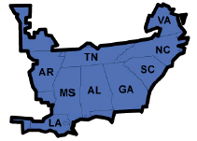

Market Design:
- Currently a bilateral market functioning without any centralized ISOs or power exchanges.

Transmission:
- 33,719 miles of line greater than 230 kV.
- Divided into four geographic regions.
- Limited capabilities to transfer electricity above contractual commitments within and outside this region.
- System may not be able to perform reliably given the amount of planned generation capacity and the increase in power marketing activities.
- Import capacity from
  - MAAC 2,800 MW
  - ECAR 5,000 MW
  - FRCC 2,100 MW
  - MAIN 5,300 MW
  - MAPP 1,700 MW
  - SPP 1,600 MW

Peak Electric Demand:
- 2000 region peak demand was 156,289 MW or 23% of the US market.
- Demand estimated to grow at an annual rate of 2.6% from 2001-2006.

The Southwest Power Pool (SPP)

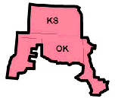
Market Design:
- Lack a centralized power exchange and operates as a bilateral market.

Transmission:
- 13,882 miles of line greater than 230 kV.
- Reliable performance in the short-term.
- Current system will be inadequate to handle large bulk power transfers.
- Import capacity from
  - WSCC 400 MW
  - MAPP 1,650 MW
  - MAIN 550 MW
  - SERC 660 MW
  - ERCOT 785 MW

Peak Electric Demand:
- 2000 region peak demand was 40,199 MW or 6% of the US market.
- Demand estimated to grow at an annual rate of 2.2% from 2001-2006.

WSCC: California
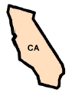

Market Design:
- Flawed. Utilities forced to sell off a large portion of their generation capacity while their ability to cover their power short position through long-term forward purchases was substantially limited. The utilities were required to buy all their power on the spot market to supply their retail customers.
- Has centralized power exchange.
- California Department of Water Resources has replaced the utility as the primary buyer of power for retail customers.
- Federal “floating” price caps currently imposed in California and eleven other Western States.

Transmission:
- Transmission constraints limit transfer of power between Northern and Southern California.
- Declared 265 power emergencies in 2000 and 2001 compared to a total of 17 in 1998 and 1999.
- Import capacity from
  - Oregon 8,000 MW
  - Nevada 180 MW
  - Arizona 7,550 MW
  - Utah 1,920 MW
  - Mexico 408 MW

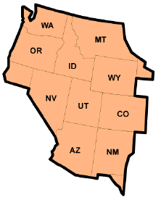
Western Systems Coordinating Council (WSCC) excluding California

Market Design:
- Almost exclusively based on bilateral contracts. However, two informal spot markets, a formal short-tem market, and the formal NYMEX COB futures market do exist.

Transmission:
- Does not export large amounts of electricity outside region.
- Limited transfer capabilities outside this region.
- Congestion usually occurs on transmission lines surrounding California and within and out of the Rocky Mountain area.
- Import capacity from
  - MAPP 510 MW
  - SPP 400 MW
  - Canada 3,150 MW

Peak Electric Demand:
- Demand estimated to grow at an annual rate of 2.5% from 2001-2006.

Source: Credit Suisse/First Boston, Power Generation – A Regional Analysis of Supply and Demand in the US Power Market, September 5, 200; Platts, Inside RDI, September-October, 2001

