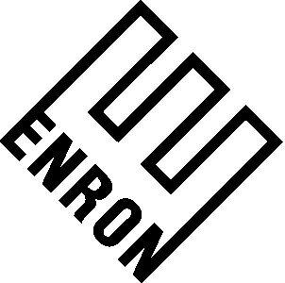
CONFIDENTIAL

To: | RAC Distribution
From: | Rick Carson | Department: | Risk Assessment & Control
Subject: | PortRAC 2Q 2001 Highlights | Date: | September 28, 2025

The Portfolio group has developed the attached “Highlights Report” utilizing 2Q 2001 investment information. The information contained in this report should be treated as “confidential” within RAC. The investment population includes EA, EBS, EGA, EGM, EIM, Net Works, Europe, and the Europe EES assets.

The PortRAC site can be accessed at http://portrac.corp.enron.com or by clicking on the following icon appearing throughout the document:


You may also click on the blue underlined asset names appearing in this report, which will take you directly to the PortRAC site with more detailed information on the asset.

Please note that the revaluation of the EGA assets is still under review and the carry value of the international assets remain at their cost basis.

We would very much appreciate your comments and suggestions for improvements before we provide this report to a larger group of PortRAC users outside of RAC.

Please direct your comments to me, Lynn Bellinghausen or Ken Horton.

Thank you for your cooperation.

PORTFOLIO BY BUSINESS UNIT – MTM Carry Value/Revaluation Amount
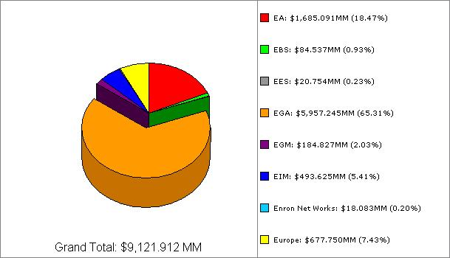

On a percentage (>1%) or dollar (>$50MM) basis, there were several significant shifts in the composition of the portfolio vs. 1Q 2001 on a business unit basis: EA, down $238MM or 12%, EGA, up $98MM or 2%, and EIM, up $393MM or 389%.

PORTFOLIO ACTIVITY – ADDITIONS AND DISPOSALS BY BUSINESS UNIT – MTM Carry Value/Revaluation Amount ($ MM)

PORTFOLIO PERFORMANCE –CHANGES IN PERFORMANCE RATING – 2Q01 vs. 1Q01 - ($ MM)

PORTFOLIO BY PERFORMANCE CATEGORY – 2Q01
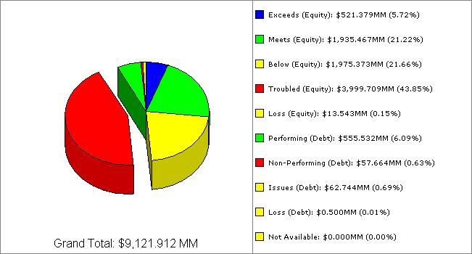

Significant items (Carry or Reval Amount for Investment Leg >$100 MM) in the Portfolio include the following:

Carry Value Carry Value ($ MM) ($ MM)
EXCEEDS (Equity) MEETS (Equity)/PERFORMING (Debt)
EcoElectrica 117 Mariner 517
Vengas (Industrias Ventane) 141 TGS 451
Miscellaneous 263 East Coast Power 405
Comp. Papiers Stadacona 357
BELOW (Eq.)/ISSUES (Debt) CEG 199
Sarlux 350 Bahia Las Minas 110
SK Enron 297 Miscellaneous 452
Trakya 216 TROUBLED (Eq.)/NON-PERFORMING (Debt), or LOSS
Gaspart 194 Elektro 2,026
Promigas 157 Dabhol 873
Miscellaneous 824 Cuiaba 535
Transredes 146
Miscellaneous 492
PORTFOLIO E-RATINGS BY BUSINESS UNIT – 2Q01 vs. 1Q01 - EQUITY

The following table provides the average e-rating by business unit and by quarter for equity assets. The average e-ratings are weighted according to the assets’ Carry Value or Revaluation amount at quarter-end.
PORTFOLIO E-RATINGS BY BUSINESS UNIT – 2Q01 vs. 1Q01 - DEBT

The following table provides the average e-rating by business unit and by quarter for debt assets. The average e-ratings are weighted according to the assets’ Carry Value or Revaluation amount at quarter-end.
PORTFOLIO CAPITAL PRICES BY BUSINESS UNIT – 2Q01 vs. 1Q01

The following table provides the average capital price by business unit and by quarter. The average capital prices are weighted according to the assets’ Carry Value or Revaluation amount at quarter-end.
PORTFOLIO BY INDUSTRY – MTM Carry Value/Revaluation Amount
Total 2Q01 Portfolio remained virtually unchanged at $9.1 Billion, vs. $8.9 Billion in 1Q01. Significant shifts included Industrial Paper & Allied Products (+$386 MM), Wholesale Energy Downstream O&G (-$89 MM), Wholesale Energy Services/Tech. (-$93 MM), Wholesale Energy Non-Regulated Power Generation (+$164 MM), and Wholesale Energy Upstream O&G (-$177 MM).

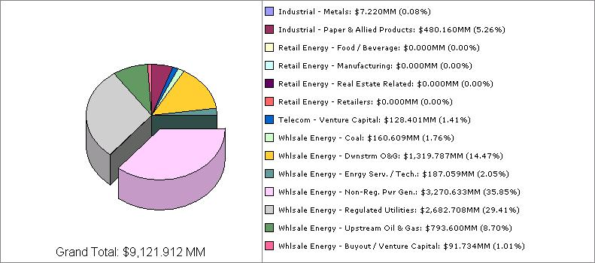

Significant items (Carry or Reval Amount >$100 MM) in the Portfolio include the following:

Carry Value ($MM) Carry Value ($MM) Carry Value ($MM)

Elektro 2,026 Sarlux 350 Transredes 146
Dabhol 873 SK Enron 297 EcoElectrica 145
Cuiaba 535 Trakya 216 Vengas (Ventane) 142
Mariner 517 CEG 199 Bahia Las Minas 110
TGS 451 Gaspart 194 Smith/Enron Cogen 101
East Coast Power, LLC 405 Promigas 157 Miscellaneous 1,901
Comp. Papiers Stadacona 357

2Q 2001 CASH FLOW BY BUSINESS UNIT

Total cash flow for 2Q01 was ($173 MM). Significant items (>$10MM), by business unit, include the following:

EA $ MM Comments
KCS 186 Global Finance syndicated KCS during 2Q01
Las Vegas Cogen II (22) 2Q01 bridge loan
Invasion 25 Sold to Wiser Oil Company during 2Q01
Active Power 16 Remaining shares sold during 2Q01
COPEL 11 Portion of investment sold during 2Q01 for a $2MM loss “
East Coast Power 14

EGA
Cuiaba (43)
Accroven (21)
Dabhol (20)
Miscellaneous (26)

EIM
Stacona (346) Purchased 100 % of company from Daishowa North America Corp.
Miscellaneous 26

Europe
Dolphin 31 Received reimbursement of original entry fee and share of remaining cash.
Miscellaneous (2)

MISCELLANEOUS $ (2)

CARRY/REVALUATION AMOUNT BY COUNTRY AND BUSINESS UNIT

SIGNIFICANT CURRENT EVENTS

EA
- Invasion - During 2Q01, the investment, consisting of equity, debt and an overriding royalty interest, was sold.
- HV Marine - It is expected that the HV Marine Warrants will be sold for $13.5MM - $15MM and therefore the carry value was written down to $13.5MM, which is still greater than cost basis.
- Ameritex Ventures - Ameritex Ventures has been informed that JEDI has elected to enter into the wind-down phase of the partnership commencing 7/1/01 and ending 12/31/01.
- iMedeon - iMedeon's CEO was asked to resign and a new CEO is currently in-house. The Company is expected to need additional capital during Q4 2001 at its current burn rate.
- Advanced Mobil Power Systems - Advanced Mobil Power Systems' prototype needs additional improvements, which will require additional capital, to improve its marketability. The Company also needs additional working capital and Enron is evaluating participation in a bridge loan.
- East Coast Power - The monetization of the swaps has been delayed due to issues with El Paso Energy. Enron is pursuing relief through arbitration.
- Las Vegas Cogen - A Purchase and Sale Agreement was executed for the divestiture of Las Vegas Cogen I and II. Transaction close and funding scheduled for 8/31/01.
- Venoco - Venoco made a binding offer of $52MM to acquire our position; ENA countered with $75MM, and both offers were rejected. ENA cannot sell its position in Venoco to a 3rd party for less than the average of both counter-offers ($63.5MM). The investment is currently being carried at $77MM on the books.

EGA
- CEG and CEG Rio - In April 2001, a Purchase and Sale Agreement was signed by Enron and Petrobras for the sale of Enron's interest in CEG and CEGRIO for US $241MM.
- EcoElectrica - In July 2001, a Purchase and Sale Agreement was signed by Enron, Edison Mission Energy, and Mirant for the sale of Enron's and Edison's interest in EcoElectrica.

EIM
- Compagnie Papiers Stadacona - Purchased Compagnie Papiers Stadacona, a large Canadian paper mill, for $357MM from Daishowa Paper Manufacturing Co. Ltd.

EUROPE
- Dolphin - Enron submitted its final termination notice and received reimbursement of its original $25MM entry fee plus $5.5MM as its share of cash remaining in the company.
- Encom - Recently obtained approval to purchase an option on a site for development of a 2,000 MW gas-fired IPP and to make a downpayment towards purchase of a site for a 1,400 MW coal-fired plant.
- Gaza - The project is currently under a Political Force Majeure event due to the disturbances in the Gaza Strip. Negotiations are underway with the contractor company to re-start the works on the site.
- Octagon - Enron declared an event of financial default following Octagon's failure to meet its minimum target of 10MW of generation by 1Q01. The Octagon board has agreed to explore a sale of the company to its only competitor, Alkane. Enron is also negotiating with Alkane over the possibility of selling its investment in Octagon.
- OPET - OPET has been adversely affected by the considerable macroeconomic difficulties that Turkey has experienced in the last six months. OPET has been able to obtain short term financing of $12MM needed to address its working capital difficulties following the devaluation.
- Paladin - Enron's holdings were sold in July 2001 for $26MM against an original purchase price of $19MM.
- Sarlux - Sarlux continues to negotiate with the turnkey contractor for a large claim ($80MM) for delay and additional costs.
- Trakya - By early July, overdue receivables were $117MM, in addition to $2.5MM from the Turkish energy fund. Also, Trakya has still not received the insurance payment for loss of gross margin following the break-down of the steam turbine generator last January.

