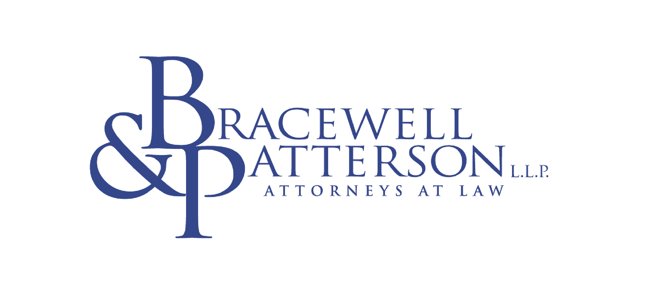

M E M O R A N D U M

FROM: Bracewell & Patterson, L.L.P.
DATE: October 1, 2001
RE: Notice of Proposed Rulemaking
Standards of Conduct for Transmission Providers,

Docket No. RM01-10-000

Introduction

On September 27, 2001, the Federal Energy Regulatory Commission ("FERC") issued a Notice of Proposed Rulemaking ("NOPR") proposing new standards of conduct applicable to both interstate natural gas pipelines subject to the marketing affiliate standards of conduct in Part 161 of the Natural Gas Act regulations and to transmitting public utilities that are subject to the standards of conduct in Part 37 of the Federal Power Act regulations. FERC proposes to adopt one set of standards that would govern the relationship of these "transmission providers" with all of their energy affiliates, not merely their relationships with marketing affiliates to which the current rules apply. Significantly, this would include applying the standards of conduct to all electric power supply functions, including bundled native power supply to a public utility’s retail customers (i.e., “native load”), and to natural gas producing, gathering, and asset management affiliates.

The proposed expansion of the applicability and scope of the standards of conduct apparently grows out of conditions that FERC applied to the merger of Dominion Resources, Inc. (an electric transmission provider with several affiliated power projects and generating plants) and Consolidated Natural Gas Company (an integrated natural gas company with interstate pipeline, LDC, marketing, producing, and field services affiliates) in 2000. Because the FERC was concerned that the merged companies could exercise vertical market power in natural gas delivery service to raise the costs of rival power generators or inhibit entry of new power generators, FERC required the merged company either to apply the gas pipeline standards of conduct to all of their affiliates or to submit a revised competitive merger analysis. Dominion elected the former. See Dominion Resources, Inc. and Consolidated Natural Gas Company, 89 FERC ¶ 61,162 (1999), compliance filing, 91 FERC ¶ 61,140 (2000), reh'g denied, 93 FERC ¶ 61,214 (2000), appeal pending, Dominion Resources, Inc. v. FERC (D.C. Cir. No. 01-1169, Jan. 19, 2001). The NOPR expresses similar concerns.

Summary

In light of its concerns, FERC has proposed to codify, in a new Part 358 of its regulations, uniform standards to control the relationships between gas and electric transmission providers and their energy affiliates. The new standards would:

- Broadly define "energy affiliate" to include affiliates of transmission providers that engage in or are involved in electric or natural gas transmission transactions, manage or control capacity, buy, sell, trade, or administer gas or electric energy, or engage in financial transactions relating to such sale or transmission. This would include affiliated generators, project developers, gatherers, producers, distribution companies, and asset managers.

- Reaffirm that a pipeline's internal sales employees and establishes for the first time that electric transmission provider employees engaged in bundled retail sales are considered to be engaged in sales or marketing under the definitions and are subject to the standards. With respect to the electricity transmission provider, this proposal narrows substantially the “native load” exemption from open access requirements.

- Eliminate current exemptions in the gas pipeline standards for affiliated producers, gatherers, and distributors.

- Exempt from the standards an electric transmission provider that also is a FERC-approved regional transmission organization (“RTO”). This exemption would be available only to RTO members that relinquish to the RTO physical control over their transmission assets and have no direct access to transmission information.

- Continue to require transmission service employees to function separately from affiliates, subject to emergency exceptions affecting system reliability. FERC will carefully review emergency claims.

- Strengthen the separation standards by eliminating the proviso in the current gas standards that permits pipelines and their affiliates to operate separately only “to the maximum extent practicable.”

- Expand organizational chart and detailed employee-posting requirements and codify prohibitions against repeatedly transferring employees between transmission providers and affiliates in order to circumvent the standards of conduct (i.e., “cycling”). FERC also requests comments on a need for clearer cycling standards.

- Continue to require that separate books and records be maintained separately to ensure independent operation and prevent cross-subsidies.

- Require the filing of detailed compliance statements; the NOPR requests comments on posting of these statements.

- Prohibit disclosure of "insider" information to an expanded range of affiliates, require uniform tariff implementation, and website or OASIS posting of all discounts, not merely affiliate discounts. Receipt points are not included in the items proposed to be posted.

In addition, the FERC seeks comments on a variety of affiliate issues. The NOPR asks whether additional measures, including structural remedies, are necessary to limit the ability of transmission providers to grant undue preferences to affiliates. FERC specifically requests comments on whether pipeline affiliates are making above-market bids for capacity on affiliated pipelines, how such bids affect the gas market. It also asks whether FERC should adopt any or all of several measures proposed at the March 15, 2001, gas affiliate conference, including proposals to:

- Limit the amount of capacity (by volume or by percentage of capacity) an affiliate can hold on a transmission provider;

- Revise policies to allocate firm capacity to as many shippers as possible and thereby minimize an affiliate's ability to exercise market power;

- Revise the policies for bumping interruptible transportation;

- Prohibit transmission providers from entering into profit-sharing agreements with both affiliates and non-affiliates;

- Limit pipelines' ability to sell to their affiliates call options on capacity;

- Require pipelines to disgorge marketing affiliate payments in excess of the pipeline's opportunity costs;

- Require the geographic (physical) separation of transmission operations from affiliate businesses; or

- Prohibit affiliated power generators from connecting with affiliated pipelines.

Further, the FERC is seeking comments on whether the current and proposed behavioral remedies are sufficient to limit anti-competitive behavior or whether it should consider imposing structural remedies. Such comments should discuss competitive impact and explain the economic consequences of proposed remedies.

Finally, FERC seeks comments on whether it should codify current case law applying a code of conduct to affiliated power marketers selling power at market-based rates.

Discussion

The proposed changes to the existing standards of conduct appear to grow out of both FERC and energy industry evolution. Over the past year, the FERC staff has been reorganized to combine the natural gas and electric power branches. FERC’s Office of Markets, Rates, and Tariffs monitors both the power and gas markets. FERC’s internal organizational structure reflects the convergence and consolidation that have been taking place in the energy business. Based on his public statements, newly appointed FERC Chairman Wood also feels strongly about the importance of broadly applicable standards of conduct to ensure against undue discrimination and preference in the markets; his views appear to be supported by a majority of the sitting commissioners.

FERC clearly believes that there have been significant changes in the natural gas and electric power industries and that such changes require the modification of the current standards of conduct. In the gas industry, those changes include unbundling, capacity release and expanding e-commerce, an active market in both physical and financial transactions, business consolidations, and the establishment of a wider array of gas pipeline affiliates in all sectors of the energy business. In particular, FERC notes the emergence of pipeline affiliates that do not market natural gas in the traditional sense, but instead provide a variety of services, including asset management, price hedging, risk management, and electronic trading. The power industry has undergone similar changes, including an increased number of power marketers selling power at market-based rates, a more active market for transmission capacity and commodity sales, particularly with the development of on-line trading, and new uses of the transmission grid. In addition, more power marketers and generation facilities are affiliated with both gas and electric transmission providers.

FERC defends its proposal as needed to address the growing instances in which pipeline or transmitting utility affiliates not subject to existing standards (e.g., affiliates not in marketing or otherwise exempt) compete with non-affiliates for transmission services, for released capacity, and in citing new power plants. The current standards of conduct do not prohibit interstate pipelines and electric transmission providers from sharing confidential shipper information, with affiliates such as asset managers, or disclosing, to generating affiliates, information about generation projects proposed by competitors. Nor do they prohibit non-wholesale merchant employees of transmission providers from engaging in bundled retail sales or limit such employees' preferential access to confidential transmission information. The broader applicability of the proposed rules to all energy affiliates is expected to eliminate both opportunities and incentives to misbehave.

Although FERC significantly has proposed the separation of electric transmission provider employees managing the bundled retail procurement and sales function, the NOPR largely retains FERC’s historical focus on behavioral remedies. Although FERC seeks comments on structural remedies, it notes that there have been relatively few affiliate-related complaints, particularly under the gas standards, and generally it has had only anecdotal evidence of abuse. The NOPR urges the industry to provide both evidence of abuse and economic impact analysis supporting proposed structural remedies in comments.

Industrial end users, certain major natural gas producers and marketers, and some power marketers have urged FERC to implement structural remedies in the past and will likely do so in this proceeding as well. According to FERC, these parties have provided little or no evidence to date and FERC apparently believes it does not have a sufficient record to support the imposition of divorcement, divestiture, or other structural remedies. Pipelines and utilities, particularly those with affiliates deeply involved in asset management, power project development, and field services will likely argue that the current rules are working and that there is no reasonable basis to expand the scope of the standards beyond current marketing affiliates.

Interestingly, the NOPR does not address the relationship between the behavioral rules proposed in the NOPR and the structural rules FERC has imposed on transmission providers in RTO proceedings (e.g., the FERC-mandated combination of PJM, the New York Power Pool, and NEPOOL into one RTO). As FERC moves toward promulgating final standard of conduct rules, its rulings on RTOs will likely become relevant to the process and may be the subject of comments by electric transmission providers and others.

Comments on the NOPR are due within 45 days of publication of the order in the Federal Register. The order has not yet been published.

Please contact us if we can be of further assistance in providing tailored analysis or preparing comments on the NOPR.

Paul Fox (512) 494-3622 Rhonda Ryan (512) 494-3627
Randy Rich (202) 828-5879 Tracey Bradley (202) 828-5848
Phil Ricketts (512) 494-3630 Kim Curry (202) 828-7623
Chuck Shoneman (202) 828-5860 Aryeh Fishman (202) 828-7625
Dan Watkiss (202) 828-5851 Jackie Java (202) 828-5828
Ron Carroll (202) 828-5872 Andrea Settanni (202) 828-7631

BRACEWELL & PATTERSON, L.L.P.
148908.2

