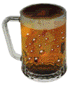
SMU HOMECOMING 2000
BETA PARTY
AT
ELVIS AND MARGARET’S HOUSE
3716 WENTWOOD DRIVE
UNIVERSITY PARK

FRIDAY, OCTOBER 27TH
7PM TIL THE KEG FLOATS

AGENDA

“BEER, LIES, MINI-DORG AND MORE LIES”

PASS THIS INVITATION ON TO ALL BETAS YOU KNOW!

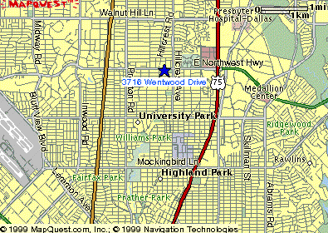
2 blocks south of Northwest Hwy and 3 blocks west of Hillcrest

