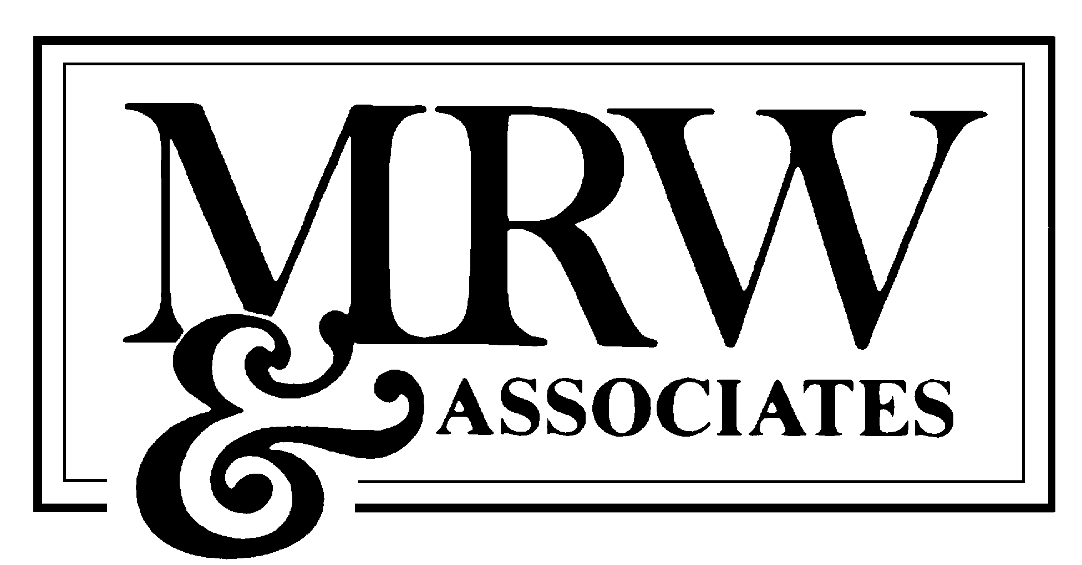

MEMORANDUM
CONFIDENTIAL

To: Steven Kelly, Independent Energy Producers
Doug Kerner, Ellison & Schneider

From: Bob Weisenmiller and Roger Yang
MRW & Associates, Inc.

Subject: Impact of SCE-DWR MOU on Payments for Past Debts

Date: April 12, 2001

Summary

The Independent Energy Producers (IEP) requested MRW & Associates (MRW) for an expedited assessment of the impact of the Memorandum of Understanding (MOU) between Southern California Edison and Edison International (collectively "Edison") with the California Department of Water Resources (DWR), executed on April 9, 2001, on payments for past debts incurred by Edison.

MRW found that:

- Funds from the gain on sale of Edison's transmission system to DWR and securitization of a portion of Edison's net under-collections will be available to pay for power procured through January 31, 2001;
- These funds will not be available until legislation is passed to direct the California Public Utilities Commission (CPUC) to establish a non-bypassable dedicated rate component;
- Edison's cost of retained generation and purchased power contracts, including Qualifying Facilities (QF) contracts, are suppose to be recovered on a timely basis to maintain investment grade credit for Edison; and
- Successful implementation of the MOU depends on supporting legislation and regulatory decisions from the CPUC and Federal Energy Regulatory Commission (FERC).

- Recovery of Edison's Under-collections through January 31, 2001

Pursuant to Section 9 of the MOU, Edison will recover net under-collections incurred through January 31, 2001. Edison estimates its net under-collections for its restructuring balancing accounts to be $3.5 billion. Edison will recover its net under-collection primarily through two sources of funds: the anticipated $1.56 billion gain on sale of its transmission system and securitization of $2 billion to be recovered as a dedicated rate component from retail customers. Edison's net under-collected balance will be adjusted to reflect the net book value on December 31, 2001, and amortization of capital costs based on the expected remaining life for Edison's retained generation, among other things. Further, Edison's operations and purchases through January 31, 2001, would not be subject to reasonableness review by the CPUC. The provision in the MOU for recovery of net under-collections through January 31, 2001, would allow Edison to pay its debt incurred through January 31, 2001.

- Availability of Funds to Pay Debt Incurred through January 31, 2001

Following its filing of a final federal income tax return for the year 2000, Edison will transfer no less than $400 million associated with tax benefits from the parent company to the utility pursuant to Section 8 of the MOU. It is unclear whether this amount will impact Edison's receivables from retail customers or is merely to help Edison in its money management to pay its debts. As identified above, additional funds will not be available until an estimated $2 billion in bonds are issued for Edison's net under-collection and bridge financing is arranged for the expected $1.56 billion gain on sale of Edison's transmission system. Pursuant to Section 15 of the MOU, all necessary legislation and agreements must be implemented by August 15, 2001. Further, decisions implementing various provisions of the MOU must be taken or adopted on or before 60 days after the date the MOU is executed. The constraints imposed by this 60-day deadline and the timeframe allowed for legislation to be enacted by August 15, 2001 do not appear to be consistent. In any event, bond funds may not be available until the late 2001.

- Recovery of Going-Forward Costs

Under Section 10 of the MOU, DWR would be obligate to procure power for Edison's entire net short position beginning January 18, 2001 through December 31, 2002. DWR will also be responsible for all purchases from the California Independent System Operator from that date, except for those purchases replacing power from certain QFs not delivering power to Edison for the period between January 18 and April 7, 2001. (See the second to the last paragraph in Section 10). The MOU also would ensure Edison will collect sufficient revenues through its retail rates to cover its accrued costs, including QF payments, in a timely manner through CPUC implementation of balancing accounts and trigger mechanisms. CPUC implementation must be in a manner to maintain an investment grade credit rating for Edison. Further, analysis would be required to determine whether implementation of the dedicated rate components and trigger mechanisms would result in further rate increases in order that Edison may pay its suppliers and creditors.

- Implementation Depends on Legislative and Regulatory Support

In order that neither party may exercise its right to terminate the contract, both legislative and regulatory support is necessary to implement the MOU within the timeframe prescribed by the MOU. Legislation must be enacted to authorize DWR to purchase Edison's transmission system, as well as enacting or modifying Public Utility Codes governing the CPUC. The CPUC must implement various ratemaking decisions. Finally, FERC must approve the sale of the transmission system. In various press reports, many customer groups have been reported to be outraged by the conditions in the MOU. The MOU has been characterized as both a utility bailout and a surrender to paying high prices to generators for past purchases. Even though the MOU contains language that any refunds would flow through to retail customers, this public perception may adversely impact implementation of the MOU.

In conclusion, Edison appears to have successfully negotiated many concessions from the Governor to assure payment for all past and future costs. Edison's benefits will translate to payments to its creditors. However, there may still be a delay on those payments until the necessary legislative and regulatory approvals are enacted. Further analysis is necessary to determine whether implementation will result in further rate increases or merely extension of rate increases previously adopted. If the MOU is not successfully implemented, Edison will find itself in bankruptcy court.

