SAP Office Connector for Outlook 2
Overview 2
Prerequisites – Determining where, or if, to begin 2
Setup 3
Recovering from an Error 7
Special Issues 8
SAP Logon Dialog 8
Deleting Regular Messages 8
Emptying Trash Folder 8
Refreshing the SAP Inbox 8
Removing Completed Workflow Workitems 8
Message Cache 8
Offline Support - Folder Synchronization on Outlook Logout 9

SAP Office Connector for Outlook

Overview
The SAP Office Connector is a piece of software that seamlessly displays your SAP Office folders in Outlook. If you are an SAP user, there are several reasons why you might receive an SAP Office message:
- You are the agent for an SAP workflow item
- An error has occurred for which you are the person responsible
- Someone (or some process) just sent you SAP mail

SAP Office messages can be viewed in Outlook, and you can launch any attached links to an SAP transaction directly from the Outlook mail.

Use of the SAP Office Connector is optional. If you use SAP only to enter your timesheet information, you probably won’t get much mail in your SAP Inbox – and so probably won’t benefit from using this product.

NOTE: there are several SAP systems, including Apollo Production (FI) and HR Production. You (may) have a separate set of SAP Office folders in each system. Repeat the setup steps that follow for EACH SAP system you want to be displayed as folders in Outlook. There is no way to have multiple SAP systems consolidated and displayed in one set of folders.

You already have the SAP Office Connector if you have the new SAPGUI 4.6D installed. You will need to follow the steps below to setup the connector.

Prerequisites – Determining where, or if, to begin
- The SAP MAPI Service Provider must be installed. If you have installed the SAPGUI 46D, then you probably have the SAP MAPI Service Provider– verify your SAPGUI version and upgrade if necessary:
  - Start – Programs – Business Applications – SAPlogon
  - If you have not started SAP GUI since 04/06/2001, you may experience a re-installation of SAPGUI, and be prompted to reboot – please perform this upgrade.
  - When SAP Logon starts, note the 46D in the title 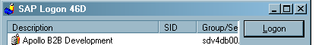

- You must be an Enron Outlook user.
- You have a need to more easily view your SAP Office notifications.

Setup
- Start Outlook
- On the Outlook main menu, Choose: Tools – Services
- On this Services Dialog Click the button “Add” then scroll to select SAP MAPI Service Provider and click the button “OK” 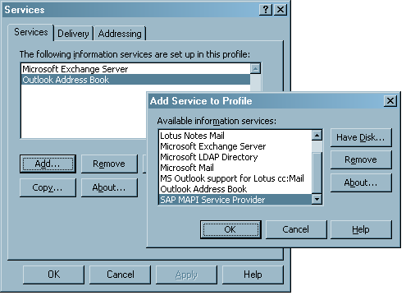
- Choose the SAP System – Click “OK”. 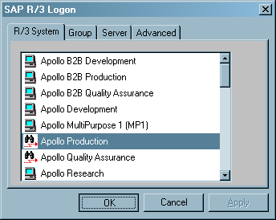
- Enter your logon information – Click “OK”. 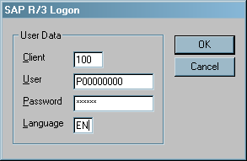
- On the Configuration Dialog, General tab, check “Save Password Enable”- also Uncheck “Offline Support Enable” – then Click “Apply”.
The Save Password feature will prevent your having to enter your SAP password again. If you change your SAP password, you will be asked by the SAP Connector to reenter the SAP password the next time you start Outlook.
The Offline Support Enable feature will completely synchronize your local Outlook folder with the SAP Inbox, so that you may read the messages while disconnected from the Enron network. Because most users will only use the SAP Office Connector at their Enron desktops, this should be disabled to prevent unecessary folder synchronization on Outlook logout.
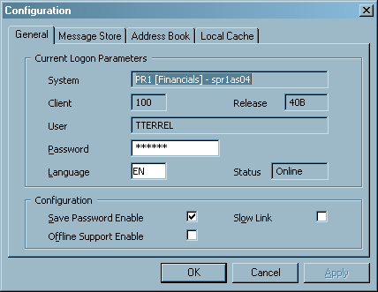
- Move to the Message Store tab and select the checkbox “Workflow Enable”. Click “Apply”. 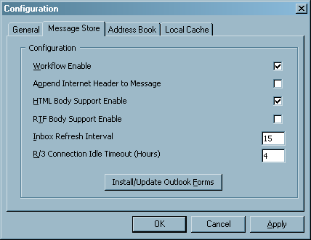
- Move to the Address Book tab, and under the heading Insertion of Addresses Resolved against R/3 select the radio button Never. Click “Apply”. 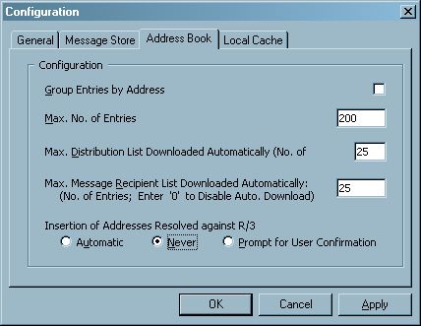
- Move to the Local Cache tab and under the heading Increase Cache Size choose radio button Automatic - Click “OK”. 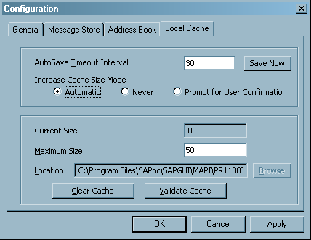
- Confirm and restart Outlook.
- When Outlook restarts – you should see a new set of folders, as shown on the first page of this document. You may want to choose the Outlook main menu option View – Folder List to more easily verify existence of the new SAP folders. The folders will be named something like “PR1100 SAP – P00000000” and will be at the same hierarchy level as your “Outlook Today” folder set.

Recovering from an Error
If you experience an error that seems to leave you in an inconsistent state, take the following steps to UNDO the installation before repeating.
- Start Outlook
- On the Outlook main menu, Choose: Tools – Services
On this Services Dialog select SAP MAPI Service Provider and click the button “Remove”, then Confirm “OK”. Click “OK” again to exit Service configuration or goto step (4) in the section above to re-install.
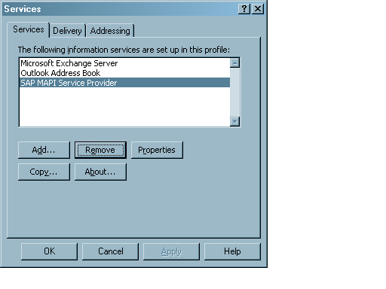

Special Issues

SAP Logon Dialog
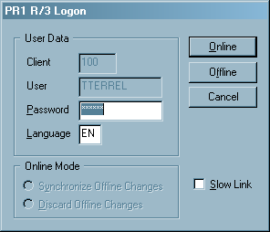
When you start Outlook, this dialog will appear to prompt you to logon to SAP. If you receive a large volume of message in SAP, it may take longer for Outlook to start. You may select “Offline” to skip the connection to SAP and start Outlook more quickly to check regular email. You must restart Outlook to put the SAP folders in “Online” mode.

Deleting Regular Messages
For simple inbox messages, you can delete or move the messages between SAP folders, just like you would in Outlook.

Emptying Trash Folder
To empty your “trash” folder, right click on the folder and choose Empty “trash” folder.

Refreshing the SAP Inbox
The SAP Inbox folders will refresh every 15 minutes by default. You can refresh manually by selecting the Inbox foder, and clicking the “Send/Receive” button on the main Outlook Toolbar.

Removing Completed Workflow Workitems
For more complex items, such as messages that represent workflow tasks, you cannot delete the message from your inbox manually. An automated process will sweep COMPLETED items from your inbox approximately every 30 days. If you feel the volume of workitems in your inbox neccessitates more frequent clearing of completed items, please contact the ISC help line.

Message Cache
A cache is the place on your computer where information about the messages in your SAP inbox is stored. If during any part of the installation the SAP MAPI service warns with information regarding the local Cache, just take the default option and continue. Every so often, you may be prompted to allow the Connector to validate the local cache, please confirm and allow this process to complete.

Offline Support - Folder Synchronization on Outlook Logout
If you elected to enable Offline Support, you may receive the following dialog when you exit Outlook:
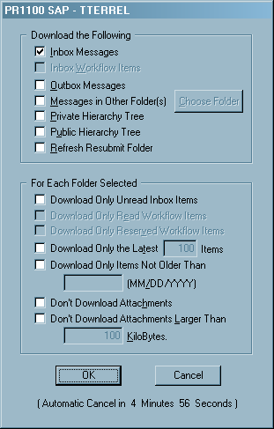

This dialog allows you to control the synchronization of the local Outlook folders with the SAP folders. See step (7) for explanation.

