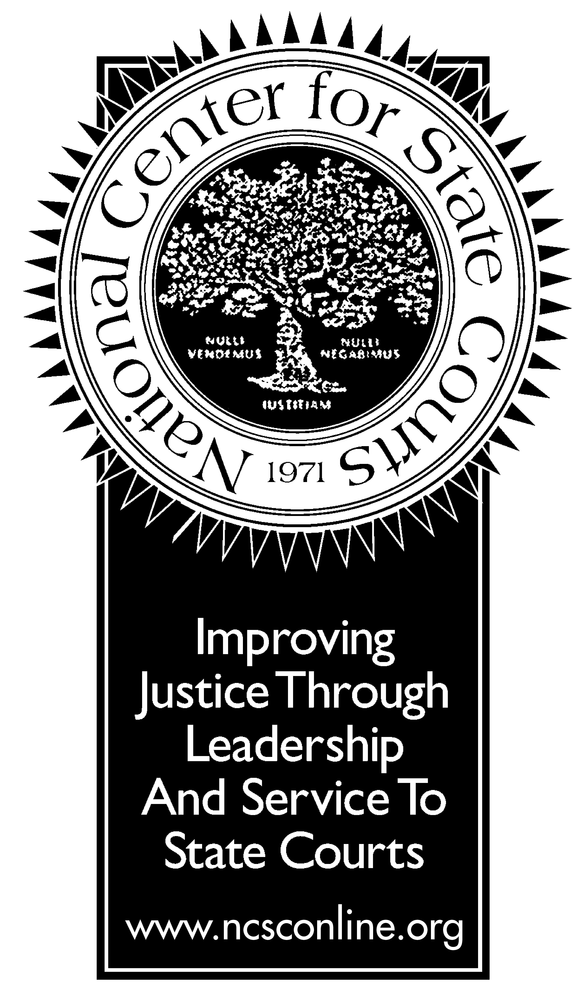
JUSTICE ROUNDTABLE

Improving Judicial Selection: The Call to Action

Friday, November 16, 2001 (9-11:30 a.m.)
Willard Inter-Continental Washington
Pierce Room

AGENDA

Participants: State chief justices, general counsel,
invited members of the Bar, NCSC Board of Directors

Format and Objective
Participants will view a videotape of judicial campaign ads used in the 2000 judicial elections in prominent states. In light of the contemporary campaign, advertising and funding practices reflected on the videotape, participants will discuss how best to reform judicial election processes without infringing First Amendment requirements in order to promote a well-qualified, impartial judiciary that enjoys the public’s trust and confidence.

Welcome and Call to Action: www.ncsc.dni.us/SummitCalltoAction.htm
Honorable Roger K. Warren
President of the National Center for State Courts

Symposium on Judicial Campaign Conduct and the First Amendment

Honorable Randall T. Shepard
Chief Justice of Indiana

Panelists
Honorable Shirley S. Abrahamson
Chief Justice of Wisconsin

George S. Frazza, Esq.
Patterson, Belknap, Webb & Tyler, New York, New York

R. William Ide, III
Senior Vice President and General Counsel, Monsanto Company (ret.)
Co-chair, NCSC General Counsel Committee

D. Dudley Oldham, Esq.
Fulbright & Jaworski, Houston, Texas

Robert S. Peck

President, Center for Constitutional Litigation/ATLA

Honorable Randall T. Shepard
Chief Justice of Indiana

Participant Discussion

Closing Comments
Roger K. Warren

