After the Bubble – Candlesticks reveal

The spike, the rosiest of outlooks. The wonders of technology leapfrogging upon itself. New innovations being put out on the market media almost weekly. Potential earnings growth looking extremely strong. The Nasdaq at 5000, going to 10,000. Then POP, the bubble bursts. $120 stocks go to $7. The Nasdaq gives back all its gains of the past two years. What happened?

Exuberance! Was it warranted? Maybe. But the speculative fervor got years ahead of itself. Is technology going to advance to the proportions that were projected. More than likely. But what is the Nasdaq going to do now?

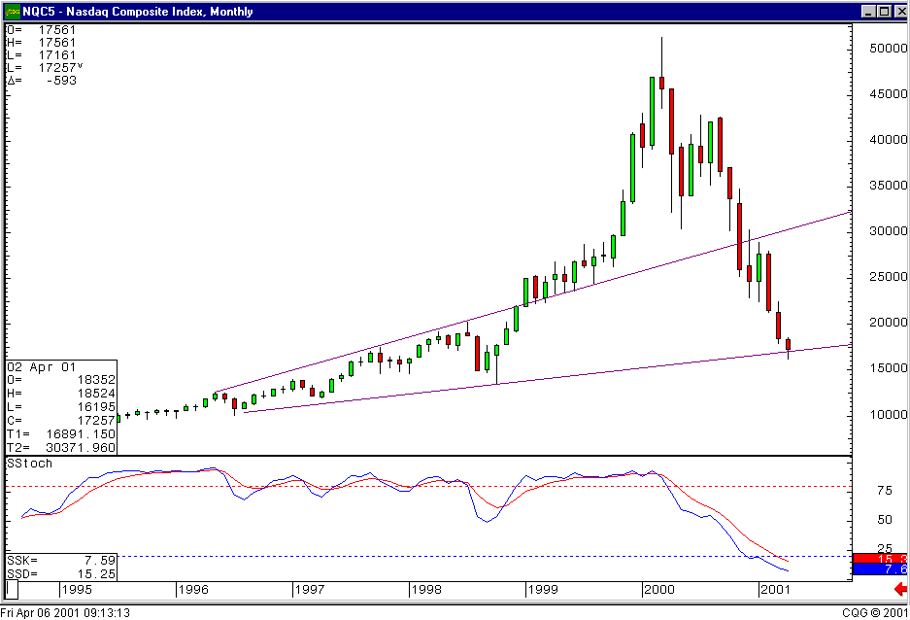Unfortunately, all the research studies that have been performed, to discover what occurs after a massive spike up and retracement, provide no relevant or consistent data results.

The monthly Candlestick chart illustrates the powerful run up. Note how the Doji at the top warned of the reversal back in March of last year. The Stochastics, being in the overbought area, confirmed the sell-off by curling down. Notice also that the Stochastics are now down in the oversold area after a twelve month decline. At the same time, prices are right on the lower trend-line. This should indicate that the bottom is very near.

The expanding trendlines, coming off the trading range prior to the breakout to the upside, indicate that the trading range may be widening. This could easily fit the scenario of what the new technology boom could do to the Nasdaq. Stock prices have washed out the speculative values. A great number growth stock prices have been brought back to more realistic levels. The pain of watching prices diminish by 90% or greater should have investors doing a much greater amount of due diligence into the background of companies. The pie-in-the-sky analysis will not work.

This will provide opportunities to make large profits. Investment funds will be moving to the more sound companies in each sector. Fortunately, the candlestick formations easily illustrate where those opportunities are occurring. Additionally, the leading companies in each sector may be changing fairly rapidly as new technology advances puts one competitor ahead of the other. Or sectors may overtake other sectors as new technology makes existing methods of operation obsolete.

Don’t give up on the economy. Somebody is out there right now developing new innovations that can revolutionize an industry, or create a whole new industry. Plus, the recent 400 point move in the DOW and 120 point move in the Nasdaq was not short covering. Also, it was not reaction to Dell announcing that they will meet the lower earnings expectations. The dynamics have changed for some reason. Those reasons will make themselves known very soon.

The candlestick charts, daily, weekly and monthly are all in the oversold status. The major up day of 4/5 demonstrated that the buyers are ready to set in. However, the downward trading channel on the daily chart is quite obvious. A break out through the upper part of the trend channel should be a very bullish sign. Until then, keep your powder dry. Great profit opportunities are very near at hand.

Steve Bigalow has been utilizing candlestick analysis for over fifteen years. This technical analysis works accurately on all investment vehicles. Please utilize his expertise for your trading area. His extension is 37583.

