CANDLESTICK ANALYSIS – PUTTING PROBABILITIES IN YOUR FAVOR.

Candlestick analysis has a beneficial aspect that out performs all other technical analysis. It is the graphic depiction of the cumulative knowledge of all investors involved in investment decisions pertaining to a particular trading entity during a specific period of time.

Knowing how to interpret this information produces immense profit potential. You will be surprised at how the knowledge divulged by the signals will dramatically enhance your investment abilities for all investment vehicles and all trading time frames. Over four hundred years of refined reversal-identification is now at your disposal. Mastering the candlestick methodology will be the major step for controlling your investment returns.

Once the basic formations are learned, and are coordinated to the position of the Stochastics,( a well-used formula for identifying overbought or oversold conditions ) an investor can dramatically enhance their profits.

Note how the Shooting Star signal indicated the market top for the NASDAQ back in March of last year. Would you have known that this was the ultimate top? Probably not. But the signal indicated that long positions should be liquidated during that time. The second sell signal, a Spinning Top formation told the investor that indecision was occurring. This potentially weak signal occurred before the NASDAQ could rally up to a new high. Knowing that a new high was not going to be made, all longs should have been liquidated and shorts put in place.

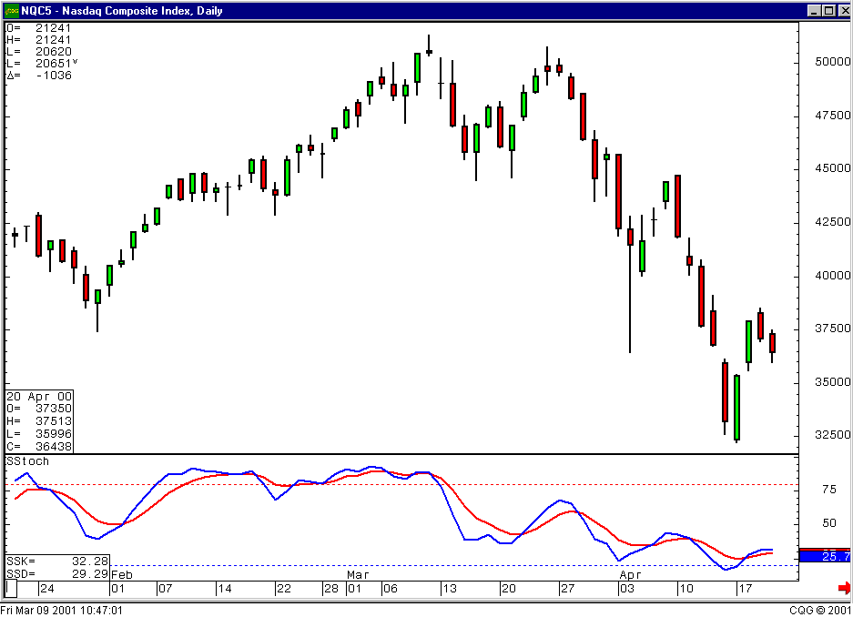

Identifying a Doji ( a day where the open and the close are at or very close to the same level ) at the top of an extended up-trend is a definite sell signal. The Japanese has witnessed this phenomenon enough times to make this a rule. Note how it indicated the top in the natural gas market a few months ago.

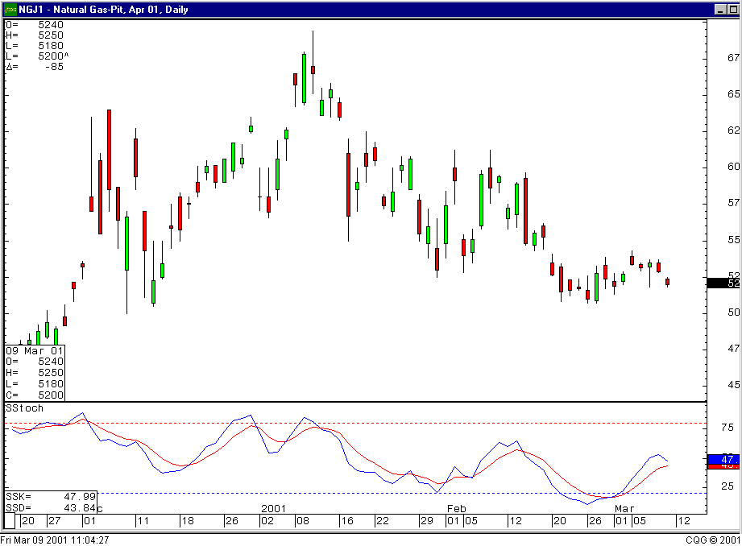

Candlestick formations easily analyze the direction of market indexes or any other indicator, pertaining to the entity that you are following, Simple put, if the candlestick signals indicate a strong buy for the NASDAQ, AND you find a NASDAQ related stock that has a strong buy signal also, the probability of that stock moving up is greatly in your favor.

The signals identify the change of investor sentiment. Having the ability to recognize the signals produces the ability to apply the accuracy for the timing of trades. A buy signal occurring when the Stochastics show an oversold condition provides a highly profitable potential. Conversely, if the trade fizzles, the downside impetus is greatly reduced due to being in the oversold area already. Maximizing upside potential while minimizing downside risk.

Profit capabilities expand greatly when a signal provides a high profitability trade. Concurrently, that trade will produce minimum losses if it doesn’t perform. Applying this concept into a portfolio management program, the aggressive investor can produce an 8% to 15% month return consistently.

Candlestick analysis, implemented properly, dramatically expands the universe of profitable investment programs. Having the visual ability to detect where reversals occur will improve your investment abilities well beyond your expectations.

