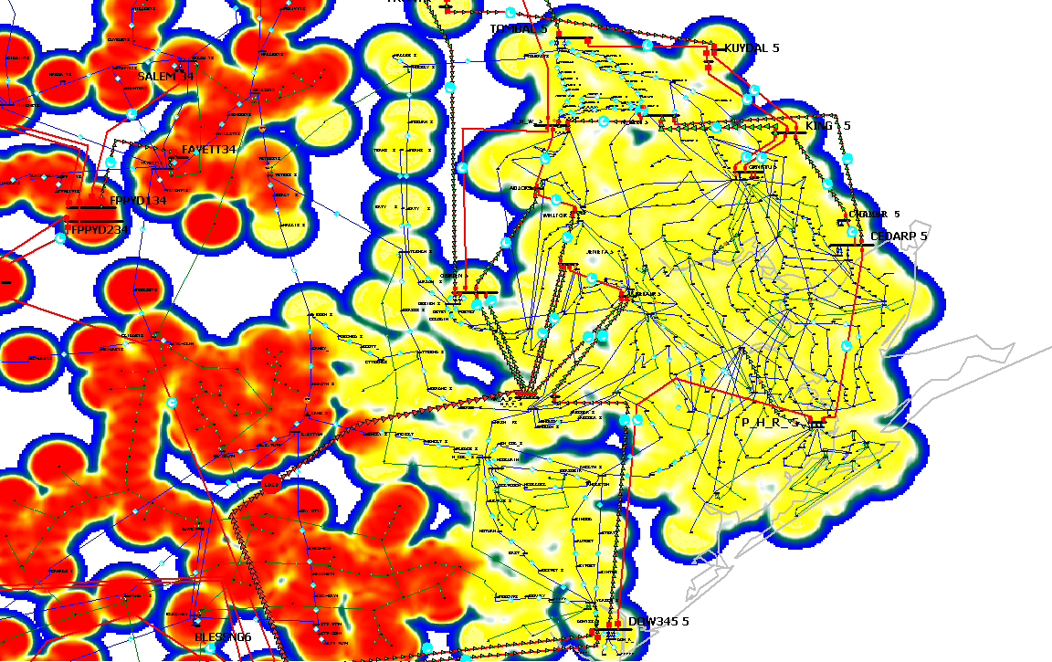
TW Wharton power plant
Tomball
The Yellow zone is the Reliant zone

PH Robinson Power Plant
WA Parish power plant
Dow Chemicals

