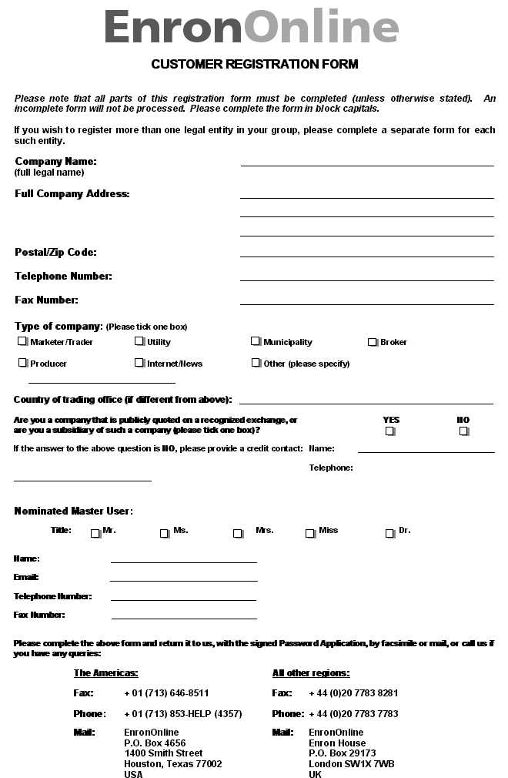

CUSTOMER REGISTRATION FORM

Please note that all parts of this registration form must be completed. An incomplete form will not be processed

If you wish to register more than one Master User, please complete a separate form for each such master User. Please note Master User’s can set up multiple sub-users.

Company Name:

(full legal name)

Full Company Address:

Postal/Zip Code:

Telephone Number:

Fax Number:

Type of company: (Please tick one box)
Marketer/Trader Utility Municipality Broker
Producer Internet/News Other (please specify)

Country of trading office (if different from above):

Are you a company that is publicly quoted on a recognized exchange, or YES NO
are you a subsidiary of such a company (please tick one box)?

If the answer to the above question is NO, please provide a credit contact:

Name: Telephone:

Nominated Master User:

Title: Mr. Ms. Mrs. Miss Dr.

Name:

E-mail:

Phone:

Fax:

For Enron Office Use Only: LEGAL TAX RAC

- - - - - - - - - - - - - - - - - - - - - - - - - - - - - - - - - - - - - - - - - - - - - - - - - - - - - - - - - - - - - - - - - - - - - - - - - - - - - - - - - - - - - - - - - - - - - - - -
Please print, complete and return this form to us, along with the signed Password Application, by facsimile or mail, or call us if you have any queries:
The Americas: All other regions:

Fax: + 1 (713) 646-8511 Fax: + 44 (0)20 7783 8281
Phone: + 1 (713) 853-HELP (4357) Phone: + 44 (0)20 7783 7783
Mail: EnronOnline Mail: EnronOnline
P.O. Box 4656 Enron House
1400 Smith Street P.O. Box 29173
Houston, Texas 77002 London SW1X 7WB
USA UK

