DRAFT
Environmental Report
for the
Red Rock Mainline Expansion

March 2001
Prepared for:
TRANSWESTERN PIPELINE COMPANY
6381 North Main Street
Roswell, New Mexico 88201

Prepared by:
ENSR Consulting and Engineering
2700 Wycliff Road, Suite 200
Raleigh, North Carolina 27607
Table of Contents
Page
1.0 Project Description 1
1.1 Proposed Facilities 1
1.1.1 Location of Facilities 1
1.1.2 Detailed Project Activities 1
1.1.3 Non-Jurisdictional Facilities 4
1.2 Land Requirements 4
1.3 Construction Procedures 4
1.4 Workforce Requirements and Schedule 5
1.5 Future Plans 5
1.6 Permits, Clearances and Approvals 5
1.7 Affected Landowners 5
2.0 Water Use and Quality 7
3.0 Vegetation and Wildlife 7
4.0 Cultural Resources 8
5.0 Socioeconomics 8
6.0 Geological Resources 8
7.0 Soils 9
8.0 Land Use, Recreation and Aesthetics 9
9.0 Air and Noise Quality 9
9.1 Air Quality 9
9.1.1 Existing Air Quality 9
9.1.2 Operation Impacts on Air Quality 10
9.1.3 Air Quality Mitigation 10
9.2 Noise Quality 10
9.2.1 Existing Noise Quality 10
9.2.2 Operation Noise Impacts 11
9.2.3 Noise Mitigation 11
9.3 References 11
10.0 Alternatives 11
10.1 No Action Alternative 11
10.2 Facility Alternatives 12
10.3 Conclusions 12
11.0 Reliability and Safety 12
12.0 PCB Contamination 12
12.1 PCB Regulations 12
12.2 References 12
13.0 LNG Plants 13

List of Tables
Page
Table 1-1. Project Location Summary. 1
Table 1-2. Compressor Units to be Abandoned In-place. 4
Table 1-3. Station Easement Description. 4
Table 1-4. Permits and Clearances Required for the Project. 6
Table 9-1. Permitted “Potential to Emit”. 10
Table 9-2. Summary of Noise Quality Analysis. 11

List of Figures
Figure 1 Location of Kingman Compressor Station (Station No. 1)
Figure 2 Location of Flagstaff Compressor Station (Station No. 2)
Figure 3 Location of Leupp Compressor Station (Station No. 3)
Figure 4 Location of Klagetoh Compressor Station (Station No. 4)

List of Appendices
Appendix A Compressor Station Plot Plans
Appendix B Agency Correspondence
Appendix C Project Upland Erosion Control, Revegetation and Maintenance Plan
Appendix D Project Spill Prevention Containment and Countermeasure Plan
Appendix E Air Permit Documents
Appendix F Noise Analysis Reports
Appendix G Project Gantt Chart

Project Description

Proposed Facilities
Transwestern Pipeline Company (Transwestern) is proposing to install a new gas turbine driven compressor unit at each of its existing mainline compressor stations in Arizona. The new units will replace existing engines and compressors at each station. The existing compressor units will be abandoned in-place.

Location of Facilities
Location information for each compressor station is summarized in Table 1-1. In addition, Figures 1 through 4 show the location of each station on portions of U.S. Geological Survey (USGS) 7.5-minute topographic maps.
Table 1-1. Project Location Summary.
Station | County | Legal Description | USGS Quad
Kingman  Station 1 | Mohave | NW ¼, S20 & SW ¼, S17, T21N, R10W | Fort Rock Ranch
Flagstaff  Station 2 | Coconino | SE ¼, S16, T22N, R5E | Wing Mountain
Leupp  Station 3 | Coconino | T22N, R14E (no section, lands not surveyed) | East of Old Luepp
Klagetoh  Station 4 | Apache | SW ¼, S18, T25N, R28E | Tudecoz Spring

Detailed Project Activities
Transwestern is proposing to install one nominally rated ISO 38,000 horsepower (hp) ________ turbine/compressor unit at each of its four mainline stations in Arizona. The installation will include the turbine driven centrifugal compressor, automated unit valves, station piping and a compressor building. Plot plans showing the new compressor station lay out have been included in Appendix A.
Additional equipment to be installed includes station and unit control systems, backup power generator and associated control system, lube oil cooler, gas cooler with electric driven fans, new scrubbers and associated piping, and valves for tie-ins into the existing station yard piping. Existing fuel, water, oil, air and electrical sub-systems will be modified for the new unit installation.
To ensure a smooth transition to the new compressor units, the existing units at each station will remain operational for approximately six months. Should the new units experience operational problems, the existing units will be utilized. After this transition period, the old units will be permanently taken out of service and abandoned in-place. Table 1-2 lists the units to be abandoned in-place at each station.

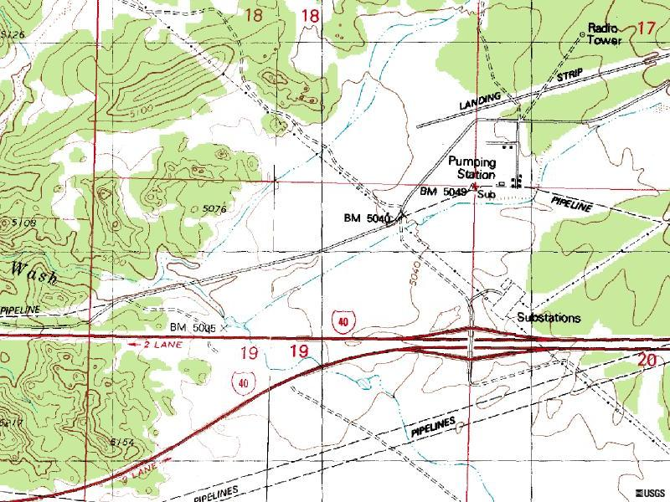
Figure 1. Location of Kingman Compressor Station (Station No. 1)
Station No. 1

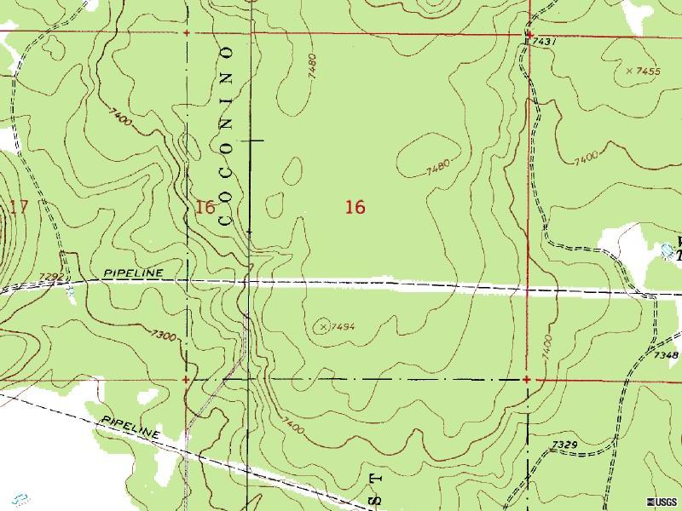
Figure 2. Location of Flagstaff Compressor Station (Station No. 2)
Station No. 2

Station 2

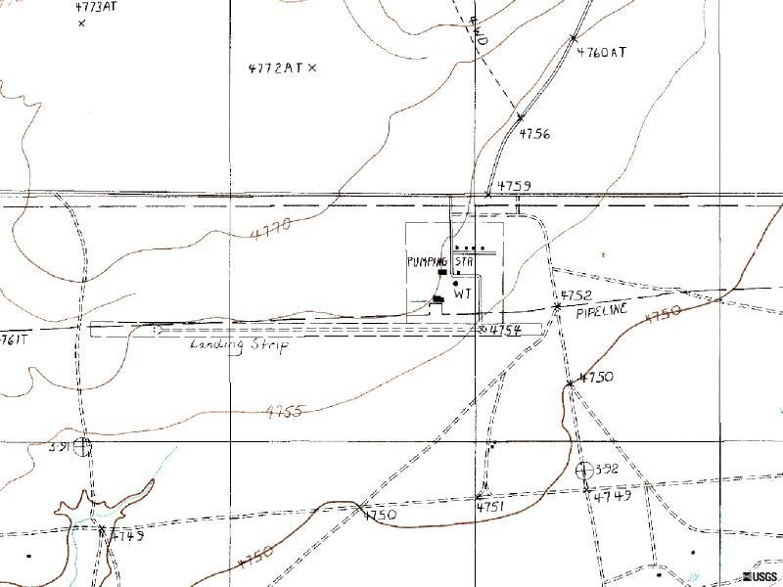
Figure 3. Location of Leupp Compressor Station (Station No. 3)
Station No. 3

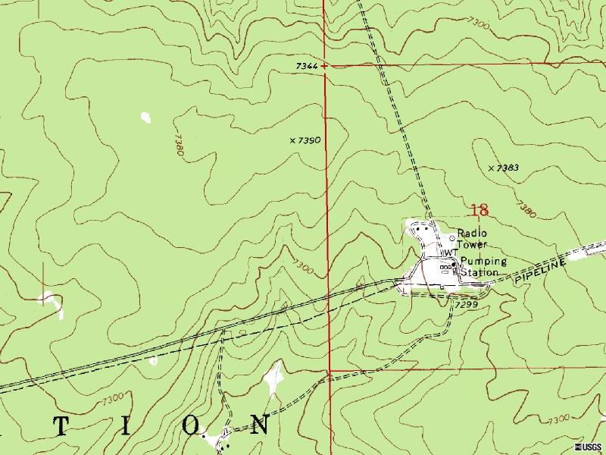
Figure 4. Location of Klagetoh Compressor Station (Station No. 4)
Station No. 4

Table 1-2. Compressor Units to be Abandoned In-place.
Station | Compressor Unit | Quantity
Kingman  Station 1 | Ingersoll Rand type 616-KVT | 3
Flagstaff  Station 2 | Ingersoll Rand type 616-KVT | 3
Leupp  Station 3 | Cooper Bessemers LSV with  RFB-24 centrifugal compressor | 3
Klagetoh  Station 4 | Clark type TCV-12 | 3

Non-Jurisdictional Facilities
There are no non-jurisdictional facilities associated with this project.

Land Requirements
All work will occur within Transwestern’s existing fenced compressor station facilities. No additional land will be required. The Kingman (Station No. 1) station is located on private and state land. The Flagstaff (Station No. 2) station is located on national forest land. The Leupp (Station No. 3) and Klagetoh (Station No. 4) stations are both located on Navajo Nation land. Station easement descriptions are listed in Table 1-3.
Table 1-3. Station Easement Description.
Station | Easement Description
Kingman  Station 1 | Section 17, Transwestern purchased a fee easement from private owners.  Section 20, right of grant from the State of Arizona (RW#14-52330).
Flagstaff  Station 2 | Special Use Permit from U.S. Forest Service, Kaibab and Coconino National Forest. File No. A-73 and A-73A.
Leupp  Station 3 | Site owned by Navajo Nation, Transwestern easement and site agreement No. A-40.
Klagetoh  Station 4 | Site owned by Navajo Nation, Transwestern easement and site agreement No. A-9.

Construction Procedures
Construction activities will be limited to the existing fenced-in compressor station yards. Less than five acres at each station will be disturbed. Minimal grading is anticipated and generally will conform to the existing topography. Transwestern will follow guidelines described in its Upland Erosion Control, Revegetation, and Maintenance Plan (Plan). A copy of the Plan is provided in Appendix C. Transwestern’s Plan will provide equal or greater protection than the Federal Energy Regulatory Commission’s (FERC) plan. During construction, Transwestern will also follow procedures outlined in its Spill Prevention, Containment and Countermeasure Plan (SPCC). A copy of the SPCC plan is included in Appendix D.
Construction of the buildings, foundations and related systems will be completed in accordance with applicable local codes. The compressor units and related station piping will be installed in accordance with applicable Department of Transportation (DOT) safety regulations.
Each station will be designed so that storm water runoff will conform to applicable regulations for each site. Culverts will be provided where necessary to carry flow under roads and walks. Any culverts installed will be made of corrugated steel or reinforced concrete as allowed by local codes.
Compacted rock roads will be constructed within each station to provide access to new compressor and auxiliary buildings. Access to each station will be via existing highways or county roads. No new access roads outside of the stations will be required. Any remaining areas within each station disturbed by construction will be restored and planted with native grasses.

Workforce Requirements and Schedule
Construction is scheduled to begin in August of 2001, with operation of the new compressor units to begin in the spring of 2002. Construction is expected to last nine months and will require approximately 80 to 100 personnel during the peak construction period. A Gantt chart has been included in Appendix G detailing the proposed schedule.

Future Plans
Transwestern has no additional plans for any of these compressor stations at this time.

Permits, Clearances and Approvals
Table 1-4 lists the environmental permits and clearances required for the proposed project. The table also includes the current status of each application. Copies of correspondence with these agencies have been included in Appendix B.

Affected Landowners
A list of potentially affected landowners and their mailing addresses are included in Exhibit Z-1 of Transwestern’s application. Transwestern will notify these landowners as required pursuant to FERC regulations.

Table 1-4. Permits and Clearances Required for the Project.
Agency – Permit/Clearance | Status
Federal Energy Regulatory Commission
Certificate of Public Convenience and Necessity | Pending.
U.S. Fish and Wildlife Service
Federal threatened/endangered species clearance | Clearance Request submitted February 15, 2001, verbal clearance obtained.
U.S. Forest Service
Pre-construction notification pursuant to existing special use permit. | Transwestern submitted notification on March __, 2001.
Arizona Department of Fish and Game
State threatened/endangered species clearance | Clearance Request submitted February 15, 2001.
Arizona State Historic Preservation Office
Cultural resource clearance | Clearance Request submitted February 15, 2001.
Navajo Nation, Department of Fish and Wildlife
Threatened/endangered species clearance. | Clearance Request submitted February 15, 2001, verbal clearance obtained.
Navajo Nation, Department of Navajo Archeology
Cultural resource clearance | Clearance Request submitted February 15, 2001.
Arizona Department of Environmental Quality
Air permit | Air permit applications are being prepared and will be submitted by March 21, 2001.
Environmental Protection Agency
Air permit | Meeting w/EPA scheduled for March 20, 2001. Applications to be submitted by March 28, 2001 pending outcome of meeting.

Water Use and Quality
All work will be conducted within existing fenced-in compressor station facilities. No surface waters occur within the proposed construction areas. Consequently, no adverse impacts to surface or ground water are expected. Therefore no detailed discussion has been presented.
Transwestern will hydrostatically test station piping. At this time, Transwestern proposes to use nearby municipal water or a local potable well. Water will be tested prior to usage to ensure that there are no contamination concerns. Test water will be discharged within each station yard and allowed to soak into the ground. Transwestern will use an appropriate dissipation device to control potential erosion. Other sediment and erosion controls as outlined in Transwestern’s Plan will be utilized to maintain test water on-site.
Do we need volume of hydro-test water?

Vegetation and Wildlife
All work will be conducted within existing fenced-in compressor station facilities. Previous construction and operation activities have disturbed the majority of each site. On going operations, including vehicular traffic, foot traffic and vegetation maintenance (such as mowing), have also disturbed each site. Consequently, no significant adverse impacts to vegetation or wildlife are expected. Therefore only a brief overview has been presented.
Vegetation types in and around each compressor station site were determined based on a review of available USGS aerial photographs, published maps and previous knowledge of the ecosystems present near the compressor stations. Vegetation types have been summarized below.
- Station 1. Vegetation near the Kingman Compressor Station is dominantly Mohave Desert scrub species such as creosotebush (Larrea tridentata), all-scale (Atriplex polycarpa), brittlebush (Encelia farinosa) and desert holly (Atriplex hymenelytra). Cacti also may be present along with a few grass species.
- Station 2. Vegetation in and around the Flagstaff Station is dominantly ponderosa pine (Pinus ponderosa) with understory vegetation consisting of mutton bluegrass (Poa fendlerlana) and pine dropseed (Blepharoneuron tricholepis). Transwestern has maintained some of the existing ponderosa pine (Pinus ponderosa) trees within a portion of this site. Some of these trees will be removed to facilitate safe construction of the proposed compressor unit. Removal of these trees will not significantly impact vegetative resources, since similar habitat is abundant surrounding Station 2. Additionally, Transwestern has contacted the U.S. Forest Service (USFS) to make sure tree removal poses no other concerns.
- Station 3. Grassland steppe is the primary vegetation coverage at the Leupp Compressor Station site. Grass species include black grama (Bouteloua eriopoda), blue grama (B. gracilis), galleta grass (Hilaria jamesii), bluegrass (Poa spp.), needlegrasses (Stipa spp.), and Indian ricegrass (Oryzopsis hymenoides) along with others may be found. Several cacti, including cholla, prickly pear, and hedgehog cacti, may also occur near the station.
- Station 4. The dominant vegetation type located in and near the Klagetoh Compressor Station is pinyon-juniper woodland and includes pinyon (Pinus edulis) and Rocky Mountain juniper (Juniperus scopulorum). The understory vegetation is typically composed of a variety of grass species such as blue grama, galleta grass, and Indian ricegrass. Forb species such as threadleaf groundsel (Senecio longilobus) and snakeweed (Gutierrezia sarothrae) may also occur.
Transwestern has also requested comments about the proposed project from the U.S. Fish and Wildlife Service (USFWS), Arizona Department of Fish and Game (ADFG) and Navajo Nation Department of Fish and Wildlife (NNDFW). Copies of these requests have been provided in Appendix B. To date, Transwestern has received verbal responses from the USFWS and NNDFW. Based on these responses, no threatened and/or endangered species or environmentally sensitive habitats in or near the project area will be affected by the proposed action. Copies of phone logs have been provided in Appendix B. Written responses from both agencies will be provided to FERC as soon as they are received.

Cultural Resources
All work will be conducted within existing fenced-in compressor station facilities. Consequently, no impacts to cultural resources are expected. However, to ensure that no cultural resources near the project area will be affected by the proposed action, Transwestern has requested comments from the Arizona State Historic Preservation Office (SHPO) and the Department of Navajo Archeology. Copies of these requests and responses received to date have been provided in Appendix B.
In response to Transwestern’s request, the Department of Navajo Archeology asked that cultural resource surveys be conducted at the two stations (3 and 4) located on Navajo Nation land. Department of Navajo Archeology policy requires cultural resource surveys for any “new undertaking” (i.e. ground breaking activity) regardless of previous disturbance.
Likewise, the USFS requested that a cultural resource survey be conducted at Station 2. In anticipation that the SHPO may also suggest that cultural resource surveys be conducted, Transwestern decided to have surveys completed at all four stations.
Cultural resource surveys were conducted during the week of March 12, 2001 for Stations 3 and 4. Surveys for Stations 1 and 2 were completed during the week of _____, 2001. Results of the surveys indicated that no cultural resources occur within any of the four stations.
Reports for each station are currently being prepared. Copies of the reports will be provided to FERC as soon as they are available. Reports are expected to be available ___, 2001.

Socioeconomics
The proposed project does not include the construction of a major pipeline or significant new above ground facilities. Consequently, no impacts to socioeconomic resources are expected. Therefore no discussion is presented.

Geological Resources
All work will be conducted within existing fenced-in compressor station facilities. No blasting is anticipated and no known geological hazards exist near the stations. Consequently, no adverse impacts to geological resources are expected. Therefore no further discussion is presented.

Soils
The Natural Resources Conservation Service (NRCS) has not mapped the soils for the areas in which these compressor stations currently reside; therefore soils information is not readily available. Additionally, all work will be conducted within existing fenced-in compressor station facilities. Topography at each station is relatively flat, thus erosion potential is relatively low. Consequently, no adverse impacts to soils are expected. Therefore, no detailed discussion has been presented.
However, soils disturbed during construction are more vulnerable to wind and water erosion. To ensure that impacts to soils are minimized, Transwestern will follow guidelines described in its Plan. A copy of the Plan is provided in Appendix C. Transwestern’s Plan will provide equal or greater protection to soils within each station than FERC’s plan. Furthermore, the guidelines listed in Transwestern’s Plan will be utilized to ensure that sediment will be maintained on-site during construction. Any remaining areas within each station disturbed by construction will be restored and planted with native grasses.

Land Use, Recreation and Aesthetics
All work will be conducted within existing fenced-in compressor station facilities. Consequently, the project will not alter existing land use. No known recreational areas will be impacted by the proposed project and since the stations already exist, no significant changes in aesthetics will occur. Therefore no further discussion is presented.

Air and Noise Quality

Air Quality

Existing Air Quality
The four compressor stations are located in rural areas where air emissions are generally low. Typical sources of air emissions in rural areas are primarily related to agricultural or silvicultural operations and include roadway traffic, farm machinery and fugitive dust from various agricultural or silvicultural activities. Oil and gas related activities are also minor sources of air emissions within the project area. However, according to Environmental Protection Agency (EPA) information, the regions surrounding the four Transwestern compressor station sites are in attainment with the National Ambient Air quality Standards (NAAQS) for all criteria pollutants (EPA, 2001).
Currently, there are three compressor units at each of the four stations (totaling 49,500 hp). These units are due for an overhaul and will require modifications in order to maintain reliability and efficiency. The compressor units at these stations were installed in 1959 and 1966. The compressor equipment pre-dates the EPA’s New Source Review construction permit rules, therefore they were “grandfathered” from construction permitting.
The Kingman (Station No. 1) and Flagstaff (Station No. 2) stations currently operate under a Title V Air Quality permit issued by the Arizona Department of Environmental Quality. Since the Luepp (Station No. 3) and Klagetoh (Station No. 4) stations are located on Navajo Nation land, they operate under an EPA permit. Copies of these permits are included in Appendix E. The facilities are permitted to operate 365 days a year, 24 hours a day. Emission levels currently permitted for nitrogen oxides (NO_{x}) and carbon monoxide (CO) are summarized in Table 9-1.

Table 9-5. Permitted “Potential to Emit”.
 | Pollutant
Station | NO_{x} |  | CO
 | tpy¹ | lbs/hr² | tpy | lbs/hr
Kingman  Station 1 | 1427.5 | 325.9 | 429.4 | 98.0
Flagstaff  Station 2 | 1427.5 | 325.9 | 429.4 | 98.0
Leupp  Station 3 | 1479.0 | 337.7 | 248.0 | 56.6
Klagetoh  Station 4 | 1583.0 | 361.4 | 527 | 120.3
¹Tons per year
²Pounds per hour

Operation Impacts on Air Quality
As proposed, Transwestern will install one new compressor unit at each of its existing mainline stations in Arizona (totaling 152,000 hp). Since these units are considerably more efficient than the existing units, significant decreases in NO_{x} emissions are expected.
As provided by the manufacturer, projected NO_{x} emissions for the new unit are estimated to be 172 tpy (39.3 lbs/hr). CO emissions are projected to be 58 tpy (13.2 lbs/hr). These rates are based on the unit being operated at 100 percent full load, 24 hours per day, 365 days per year. Even under full load, operation of the new units will significantly reduce Transwestern’s NO_{x} and CO emissions at each station, improving the Arizona airshed.
Transwestern is currently in the process of obtaining the required air permits for the proposed new compressor units. Copies of the applications are provided in Appendix E. The subsequent permits for each station will be provided to FERC as soon as they are available. The status of the permit applications is listed in Table 1-4.

Air Quality Mitigation
Since Transwestern expects to significantly reduce NO_{x} and CO emissions by installing the new units, no other air quality mitigation is proposed. However, Transwestern will adhere to any additional permit conditions imposed by the air permitting agencies.

Noise Quality

Existing Noise Quality
Noise level analyses have been conducted for each of the four compressor stations. Results of these analyses have been summarized in Table 9-2. Copies of the detailed noise reports have been included in Appendix F.
Table 9-6. Summary of Noise Quality Analysis.
Station | Distance to NSA¹ | Measured Ambient Noise Level² | Calculated Ambient Noise Level³ | Estimated Noise Level⁴
Kingman  Station 1 | 2,700 | 44.9 | 51.3 | 48.0
Flagstaff  Station 2 | 4,600 | 38.2 | 44.6 | 45.4
Leupp  Station 3 | 2,000 | 38.8 | 45.2 | 50.0
Klagetoh  Station 4 | 1,000 | 46.5 | 52.9 | 53.0
¹Distance from existing compressor building to nearest Noise Sensitive Area (NSA) in feet.
²Existing daytime noise level (L_{d}) measured at the NSA in decibels (dBA).
³Calculated day/night noise level (L_{dn}) at the NSA in decibels (dBA).
⁴Estimated day/night noise level in decibels (L_{dn}) at the NSA after new compressor unit installed.

Operation Noise Impacts
The predicted noise level attributable to the new compressor unit and associated equipment was calculated for each station. Based on this analysis, predicted noise levels will be below the FERC required 55 dBA L_{dn} at the nearest NSA for all four stations. Please refer to Appendix E for specific details of the noise analysis.

Noise Mitigation
Transwestern will adhere to the FERC required 55 dBA L_{dn} at the nearest NSA for each station. Mitigation measures suggested in the noise analyses will be evaluated for each station and utilized as necessary to meet this requirement.

References
U.S. Environmental Protection Agency, Region IX Air Program. 1999. Air Quality Maps for Region IX, http://www.epa.gov/region09/air/maps.

Alternatives
The proposed project will allow Transwestern to increase its system’s capacity to provide natural gas to California. Currently, the California market has a critical need for additional energy, including natural gas. There is also a long-term need to meet an ever-increasing demand. Transwestern’s proposed expansion is designed to balance the long-term need for large quantities of gas with the immediate need that has to be met quickly.

No Action Alternative
Under the "No Action" alternative, Transwestern would not replace existing units with new compressor units at each of their mainline stations in Arizona. Failure to install the new units would result in Transwestern being unable to meet the projected growth in demand for California. If Transwestern is unable to meet this demand, other facilities may need to be constructed. Construction of other facilities are likely to incur increased environmental impacts. Furthermore, if the proposed facilities are not constructed, other sources of energy may have to be utilized that are not as clean burning as natural gas.

Facility Alternatives
Essentially there are two primary methods to increase system capacity. One is to construct additional pipeline and the other is adding compression. Constructing additional pipeline was not considered a viable alternative for two reasons. First, new pipeline construction would incur increased environmental impacts. Secondly, constructing new or loop line to meet the existing demand would take considerably more time and would not allow the project to meet short-term goals.
Adding compression can include new stations or modifying existing stations. Again, new stations were not considered since environmental impacts would be higher and construction of new facilities would take longer. Therefore, the only alternative considered was modifying existing stations.

Conclusions
In engineering the proposed expansion, Transwestern analyzed both short-term and long-term capacity demands to determine the optimal design. The proposed action represents this analysis. By modifying existing stations, Transwestern will be able to meet the project goals while avoiding significant environmental impacts and decreasing emissions.

Reliability and Safety
The project does not include the construction of new or recommissioned LNG facilities. Therefore, no discussion is provided.

PCB Contamination

PCB Regulations
Transwestern will comply with all applicable environmental laws and regulations in connection with activities proposed herein including, where appropriate, the storage, destruction and disposal requirements of 40 C.F.R. Part 761.
On June 29, 1998 the Environmental Protection Agency (EPA) issued the PCB Mega-Rule which became effective August 28, 1998. The Mega-Rule was a comprehensive revision to the PCB regulations. As a result of the new rules, the EPA has notified Transwestern that its Alternative Disposal Permit would not be extended beyond November 28, 1998. Transwestern’s activities that might be regulated under the Toxic Substances Control Act, if any, from that date on would solely be driven by EPA’s applicable regulations.

References
18 CFR Part 380, Appendix A – Guidelines for the Preparation of Environmental Reports for Applications under the Natural Gas Act as Specified in § 380.3 of the Commission’s Regulations.
40 CFR Part 761, Polychlorinated Biphenyls (PCBs) Manufacturing, Processing, Distribution in Commerce, and Use Prohibitions.
Federal Energy Regulatory Commission. 1995. Guidance Manual for Environmental Report Preparation.
Hoffman, R.R. 1993. Environmental Report Checklist (Revision 9) and Staff’s Recommended Mitigation Procedures. Federal Energy Regulatory Commission. Office of Pipeline Regulation.

LNG Plants
The project does not include the construction of LNG facilities. Therefore, no discussion is provided.
Appendix A

Compressor Station Plot Plans

Appendix B

Agency Correspondence

Appendix C

Project
Upland Erosion Control, Revegetation and Maintenance Plan

Appendix D

Project
Spill Prevention, Containment and Countermeasure Plan
Appendix E

Noise Analysis Reports

Appendix F

Air Permit Documents

Appendix G

Project Gantt Chart

