FEDERAL ENERGY
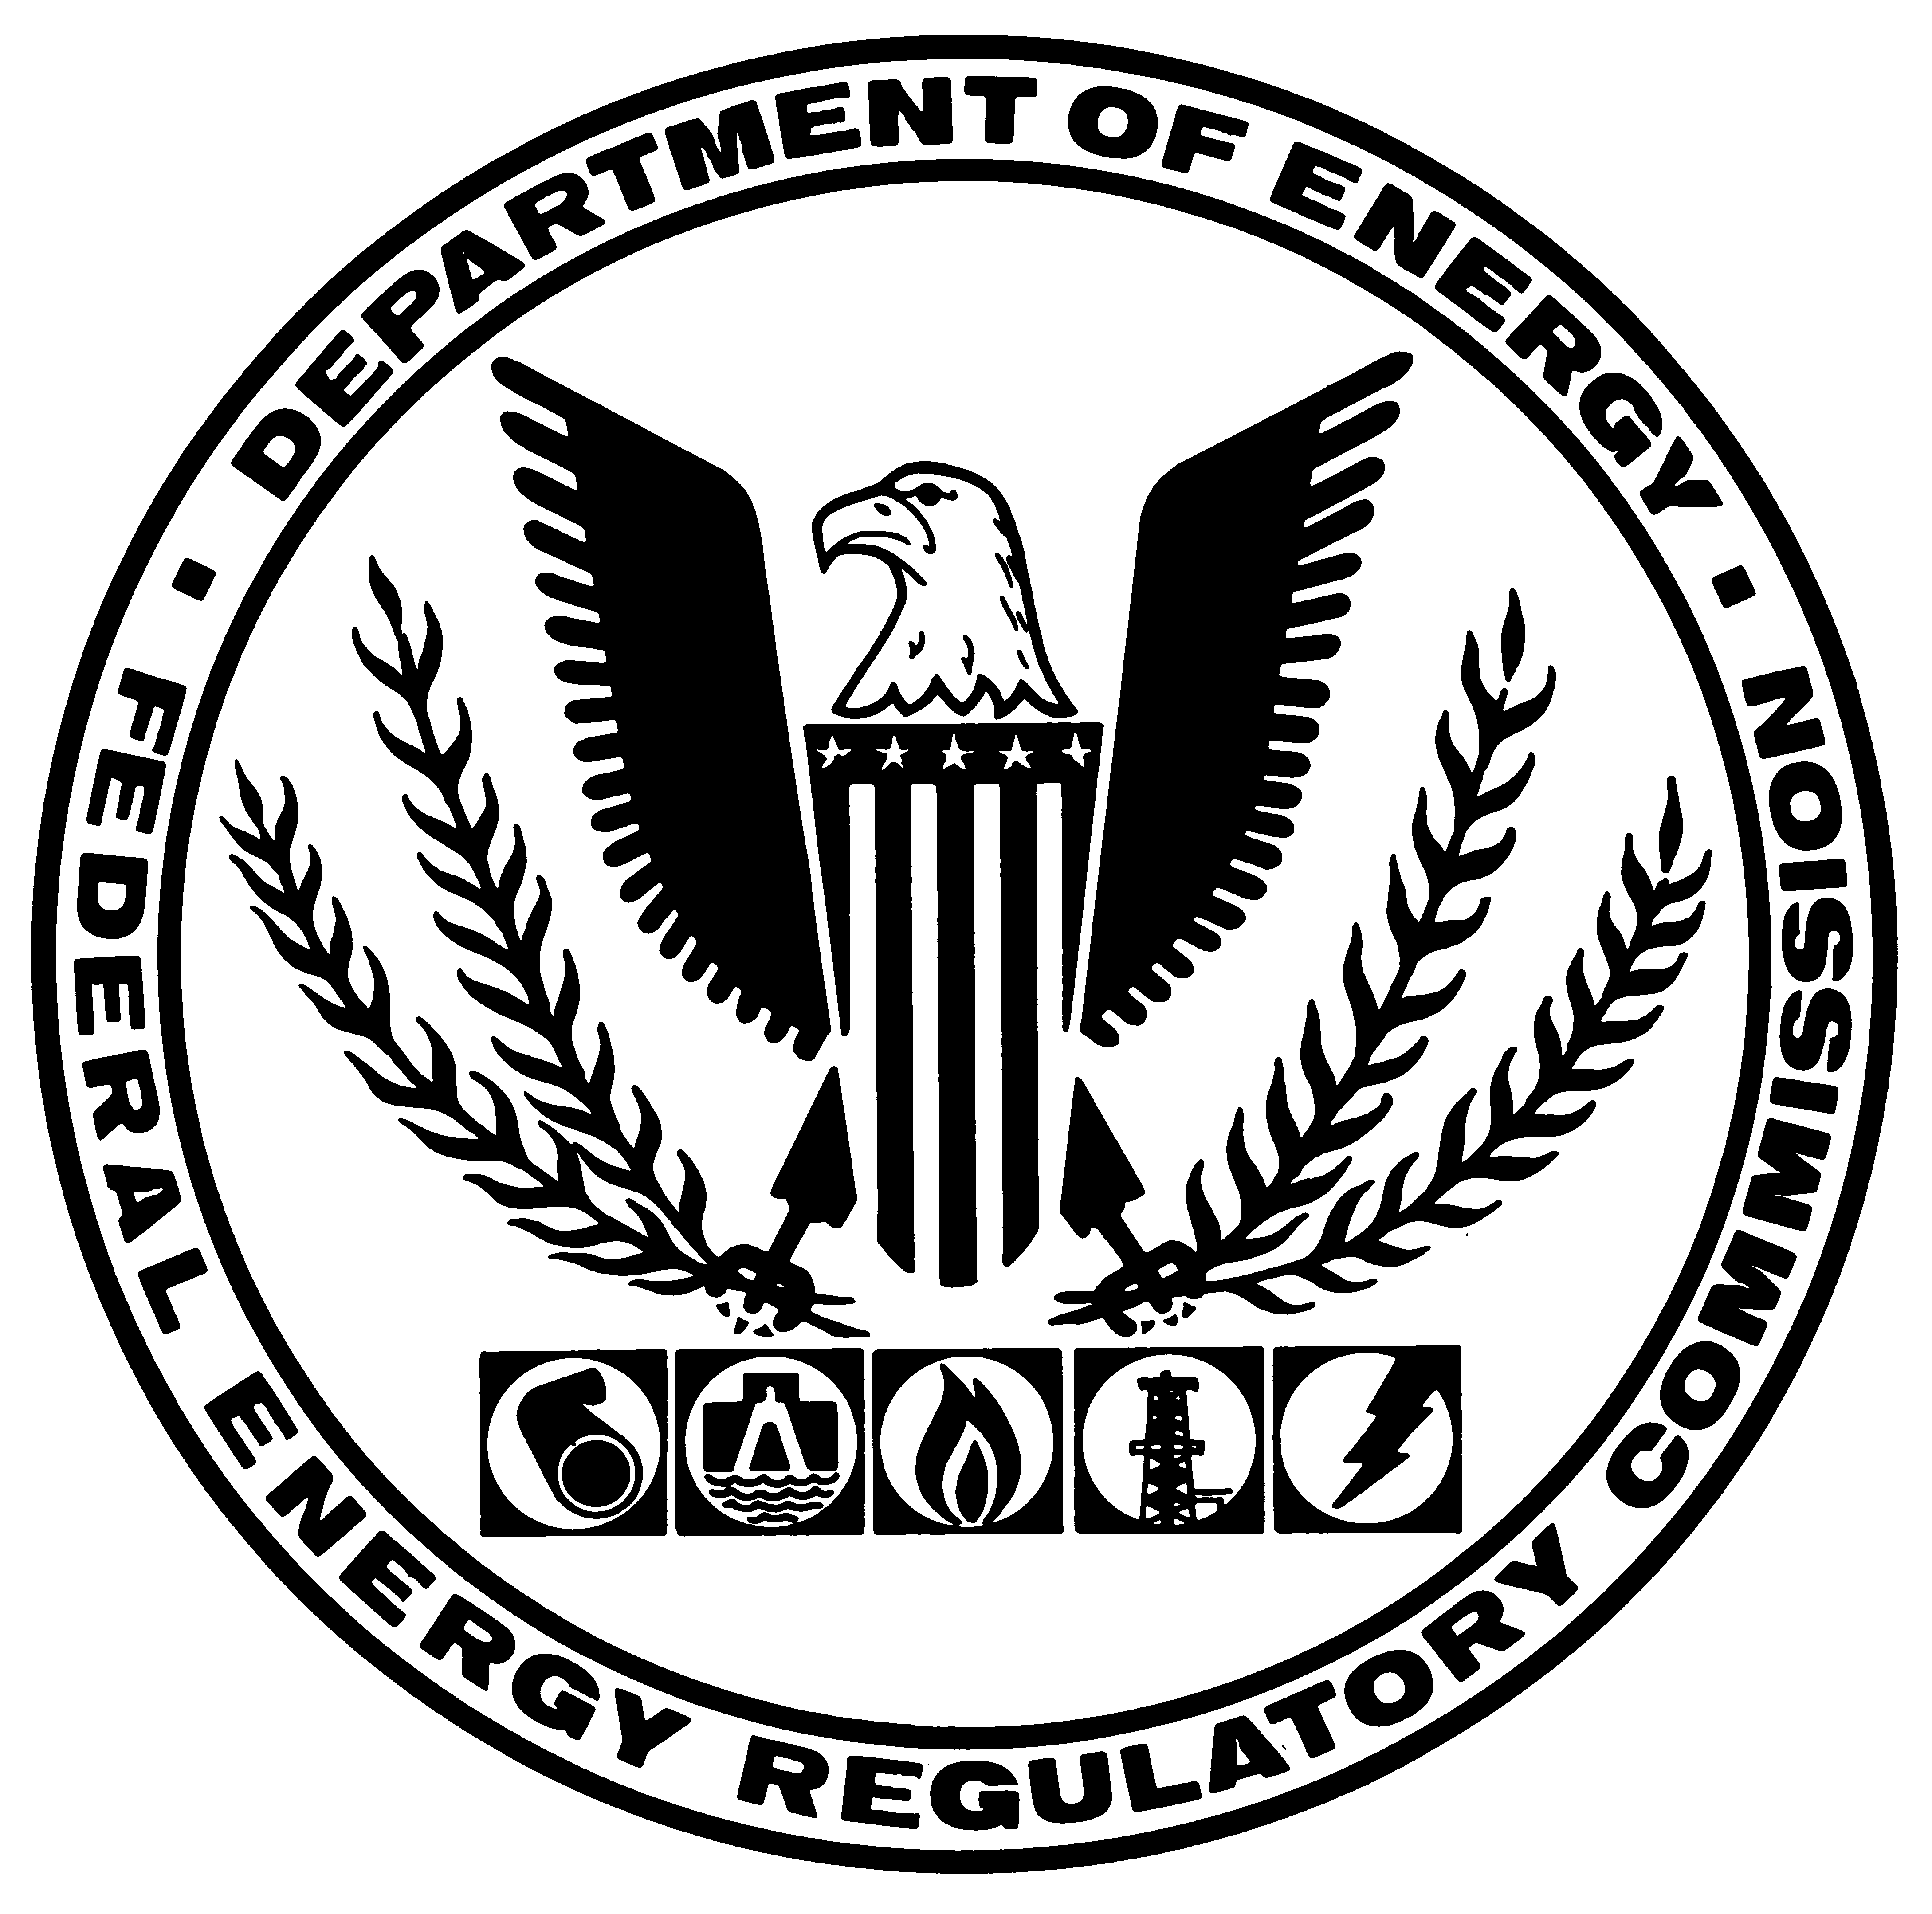
REGULATORY COMMISSION
WASHINGTON, D.C. 20426

NEWS RELEASE
NEWS MEDIA CONTACT: FOR IMMEDIATE RELEASE
Barbara A. Connors April 25, 2001
(202) 208-0680 Docket Nos. RT01-35-000 and RT01-15-000

COMMISSION ACCEPTS OUTLINE OF BROAD WESTERN RTO, ITC; NOTES IMPORTANCE OF INTERRELATED WESTERN ENERGY MARKET

The Federal Energy Regulatory Commission today accepted as a "first step" key parts of a proposal for a broad regional transmission organization (RTO) that will span eight western states. Today's order also accepts a proposal for an independent transmission company (ITC) within the RTO structure (RT01-15-000).

Noting the recent power market problems experienced in California and throughout the West, the Commission emphasized the regional nature of the electric marketplace and said these issues highlight the substantial benefits that an RTO will provide. RTO West can serve as an anchor for the ultimate formation of a West-wide RTO, the Commission said.

RTO West, a non-profit organization with an independent board that will act as the independent system operator, includes Avista Corporation, the federal utility Bonneville Power Administration, Idaho Power Company, Montana Power Company, Nevada Power Company, Pacificorp, Portland General Electric Company, Puget Sound Energy, Inc. and Sierra Pacific Power Company (RT01-35). RTO West will operate more than 90 percent of the high voltage transmission facilities from the U.S.-Canadian border to southern Nevada, the Commission noted. The RTO will not own transmission facilities, but will control each participating owners' transmission facilities.

In today's order, the Commission addressed RTO West's proposals on governance, scope and configuration, and liability issues.

R-01-21 (more)

(2)

Noting that no single class of owners can exercise control, the Commission accepted the RTO's governance structure and its code of conduct. The Commission deferred consideration of its market monitoring plan until further information is submitted.

In accepting the scope and configuration of the RTO, the Commission noted recent comments sent to the Commission by Secretary of Energy Spencer Abraham supporting seamless electricity markets. "[T]he best way to achieve the balance between a healthy Western electricity market and regional reliability needs is to create a strong, regional RTO...," Secretary Abraham said.

In addition to the RTO proposal, Avista, Montana Power, Nevada Power, Portland General Electric, Puget Sound and Sierra Pacific propose a for-profit, independent transmission company, TransConnect, LLC. The ITC would own and operate the interstate transmission facilities of these utilities, with TransConnect participating in RTO West as a single transmission owner. The Commission accepted TransConnect's proposed governance structure.

Since TransConnect will operate as an independent transmission company within RTO West, the Commission allowed TransConnect the flexibility to propose and file incentive rate mechanisms.

Under Order No. 2000, issued in December 1999, the Commission called for the voluntary formation of RTOs. By broadening the market for electric power transactions, RTOs help ensure comparability of service for users, reliability for consumers and efficient economic transactions for customers.

R-01-21 (30)

