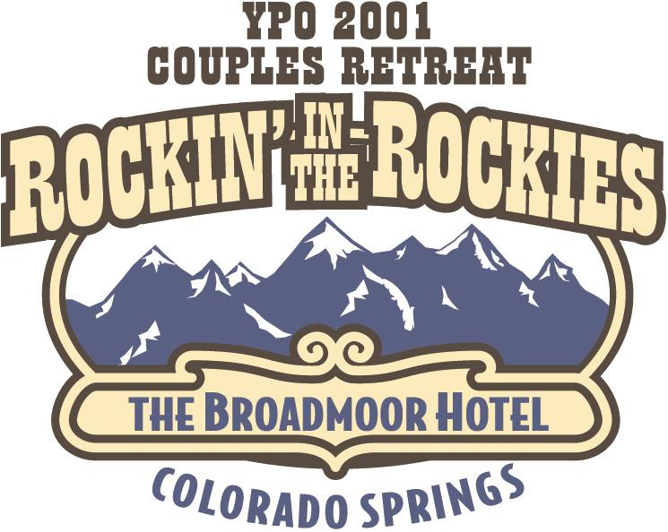

ROCKIN’ IN THE ROCKIES ITINERARY

September 13, 2001 (Thursday)

7:30 – 8:30 AM IAH – Continental Group Check In and Hospitality Room

Dress comfortably as we will be doing some walking at the Olympic Center.

9:40 AM Leave IAH on CO# 770

11:00 AM Arrive Colorado Springs (COS)

11:15 AM Buses to Olympic Center
(All transportation arranged by Mark & Jennifer Kuebler)

11:30 – 2:30 PM Lunch and Tour of Olympic Center

3:00 PM Check in Broadmoor
(Hosted by Blake & Shawn Hogan)

Hospitality Room Opens
(Hosted by Mike & Patti Morgan)

At your Leisure

5:45 PM Begin Shuttle Service to Evening at El Pomar
(Broadmoor West Entrance)
(Hosted by Roy & Kim Steinhagen)

5:45 – 7:00 PM Cocktails patio

7:00 PM Dinner - Buffet on Terrace

8:00 PM Entertainment

9:30 Begin Staggered Shuttle Departures

September 14, 2001 (Friday)

7:30 – 8:30 AM Breakfast Buffet in Rocky Mountain Ballroom Room AB

8:30 – 12:30 PM Resource Rocky Mountain Ballroom CD
(Hosted by David & Marcia Solomon)

1:00 – 4:30 PM Lunch & Competition – Colorado East Hall Parking Lot
(Hosted by Mike Holthouse)

6:30-6:45 PM Buses transport to Air Force Academy Dinner and Dancing
(Hosted by Greg & Ronda Brenneman)

9:30 PM Begin Staggered bus departures

10:30 PM Continue staggered departures

11:30 PM Final Bus Departure

September 15, 2001 (Saturday)

At your Leisure

Optional Activities – (Managed by Larry & Pam Del Papa)

Spa

Golf

7:30 PM Cocktails in Pompeian Room
(Evening hosted by John & Maureen Graf)

8:00 PM Dinner and Dancing in Main Ballroom

September 16, 2001 (Sunday)

9:00 AM Luggage Pull

10:00 AM Buses depart for Airport

11:45 AM CO # 771 to IAH

2:45 PM Arrive IAH

*All events are resort casual except Saturday evening when you will be in your most “Flapper - Dapper” attire.

** All hotel tips are included in your room charge. Additional tipping at your discretion.

*** For your convenience a Dollar Car Rental is located on premises at The Broadmoor. Please call to make your reservations. 719-471-6300 or 719-633-3147.

****The temperature in September typically ranges from 50° in the evenings to 75° during the day.

While you are away you can be reached:

The Broadmoor

PO BOX 1439
Colorado Springs, Colorado 80901
800-634-7711
719-634-7711
fax 719-577-5700

