QUICK START

⏐logging on⏐

- Point your Internet browser to http://www.EnronOnline.com .

- You may be prompted to download the Shockwave plug-in first – see Section xxx of this Guide for help.

- Enter your User ID and Password (these are case sensitive).

- Click on ‘GO’.

⏐electronic trading agreement⏐

- If this is your first time logging on with a Master User ID, you will be presented with the Electronic Trading Agreement (ETA). It must be read and accepted to proceed into the quotes screen. In order to accept the ETA after reading it, scroll through it and click on the “I accept” button at the end. The ETA together with Password Application (PA) set out the framework for electronic trading via EnronOnline.

- A list of products and prices will then appear on your web-page.

- The ETA will always be available for viewing and printing by clicking on the link in the bottom left hand corner of the quotes screen.

⏐filtering & creating composites⏐

- To view a choice of products and quotations, EnronOnline allows for composite screens to be created.

- To filter the products and quotations and create your own favorite pages, use the navigation bar on the left hand side of the quotes screen. Further instructions can be found in this Guide.

⏐submitting offers to buy or sell⏐

- After logging in, the quotes screen will appear. You will see a list of products together with their corresponding bid and offer quotes and volumes.

- To offer to Enron to buy or sell a particular product, simply move your mouse over the bid or offer price cell for that product and click on the price.

- A submission window will appear.

- Clicking on the ‘Submit’ button will send your offer to Enron (other features of the Submission Box are outlined in detail in the 'transacting' Section of this Guide).

- If a ‘Submit’ button is not visible, this will be replaced by a “Read GTC” button. This means that you will need to read and accept the General Terms & Conditions (GTC) for the product prior to submitting an offer to Enron.

- If your offer is successfully processed, you will see it appear at the top of the Transactions section on the lower part of the quotes screen.

⏐help⏐

- There is a comprehensive Help Guide, available on the quotes screen, which is accessible by clicking on the Help bar on the left hand side of the quotes screen.

- There are also HelpDesks available to answer personally your calls + 01 713 853 4357 for the Americas and +44 (0) 20 7783 7783 for other regions.

⏐master user functionality⏐

The Master User ID allows you to set up other Users within your company to transact via EnronOnline. This gives you considerable flexibility as you do not need to contact Enron to set up new Users and you can set up Users with different types of access to view or trade according to how your company is structured.
In order for your company to transact via EnronOnline, you need to have at least one Master User ID, but you may also have multiple Master User ID’s as required. The Master User ID is issued by Enron to your company once we have approved your Password Application (PA).

⏐setting up other Users⏐

Select “Administration” from the bottom of the quotes screen (only you and other Master Users in your company (legal entity) will be able to see or access this feature).The functionality allows you to:

- Add New Users (and Back Office Users)
- Update User Access Levels
- Add and Update User Passwords

Your Master User ID will allow you to create new Users or Back Office Users. You may also authorise trading access for a User. We have provided you with a Master User ID to let you be in control of your own Users. As a Master User, you control the access or view rights that a particular User in your company has, within the limits of your own rights as a Master User. You can create up to 10 Users or Back Office Users.
A Back Office User will only be able to view transactions which Users in your company have completed. Back Office Users will not have any rights to transact via EnronOnline.

⏐preferences⏐

Within the “Preferences” option at the bottom of the Quotes screen, you can select your preferred:

• Time zone – this sets the time zone for timestamping of transactions via EnronOnline and does not affect any of the times referenced in the product descriptions.

- Language – where the GTCs are available in the language you have selected, these will be made available to you.

- Notifications On/Off - notifications related to price, volume, and product changes can be activated or deactivated.

⏐contractual terms and conditions⏐

Each transaction concluded via EnronOnline is either governed by a GTC, which has been accepted by your company via EnronOnline, or by an existing master agreement between you and Enron relating to the particular product.

To see the GTC at any time for a particular product, click on a product short description and a link will be available to the GTC.

⏐clicking on the product short description⏐

By clicking on the relevant product short description on the quotes screen, you will be presented with a long description window containing the long description for the product together with additional product-specific information such as the trading hours, the minimum volume, and contact details within Enron for that specific product. From this window, you will also be able to access the GTC which governs the transactions in that particular product if you do not have an existing master agreement with Enron governing the particular product.

⏐transacting⏐

Provided your company is registered to transact via EnronOnline, you can offer to Enron to buy and sell particular products directly from the quotes screen.

In order to transact via EnronOnline, all you need to do is the following:

1. Click on the Price

Move your mouse over the product bid or offer price and click once. When your mouse rolls over a given price, the background color of the box surrounding the price is highlighted.

2. The Submission Window

- The “Submission” window will appear. You will be prompted to confirm your offer to Enron.

- Note that if you have not yet read and accepted the GTC for that product, or the transaction is not governed by an existing master agreement, you will be asked to read and accept the GTC via EnronOnline. You will see a window similar to the following:
- Once you have read and accepted the GTC the “Read GTC” button will now appear as a “Submit” button.
3. Reviewing your submission window options

- Prior to submitting your offer to Enron, you have several additional options as depicted above.

Option A – Volume

You can adjust the volume by decreasing the volume shown on the screen in those increments set by the Enron trader for that product.

Option B – Volume choices

There are two options, either “All or Nothing” or “Accept Partial Volume”. Prior to submitting your offer to Enron, you have two additional options as depicted above.

- The “All or Nothing” option allows you to specify that your offer may only be processed if the entire volume you require is available at the price you specify.

- Under the “Accept Partial Volume” option, the system will process your offer based on such volume up to the maximum available on the screen as is available at the price you specify.

Option C – Price Range

The “Price Range” option allows you to specify a range of prices at which your offer may be accepted by Enron. By specifying a range of prices, your offer could be filled if the requested price ceases to be available by the time your offer arrives, but another price is available which meets your range. This submission or offer does not act as an order in the EnronOnline system. Your offer will either be completed successfully or rejected.

4. Click the Submit button

To proceed in making the offer, click on the “Submit” button.

5. View Your Transaction

If your offer has been successfully processed, you will see the transaction appear at the top of the "Transactions" summary box near the bottom of the page.

If your offer has not been successful, you will receive a message indicating that this is the case.

⏐transaction search⏐

Transactions that have been concluded via EnronOnline can be viewed using the Transaction Search functionality accessed through the navigation at the bottom of the page.

Master Users and Back Office Users can search all transactions completed by the Users in your company. Users may only search their own transactions.

⏐filtering and composite pages⏐

EnronOnline covers hundreds of individual products. To help you organize this large volume of data, EnronOnline allows for products to be filtered and organized into user-specified “Composite Pages”.

Products can be filtered by country, region, deal type, commodity, currency or category. Once filters are created, the results can be saved into named sections within the Composite Pages, and the Composite Pages themselves can be named.

You can create up to eight sections within each of up to five Composite pages. You can also select individual products and add them to the Composite Pages. By combining the individual products and filters, products can be displayed in much smaller groups which are more tailored to your business requirements.

Selecting & Applying filters
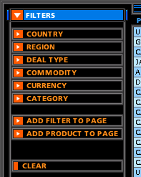

- You can create different filters to view only those products you need.

- Click on the “Filters” title in the navigation list on the left. This will show you a list of different filter types. A filter is simply a set of product attributes that are applied to the list of quotes to reduce the number of displayed quotes according to the chosen filter(s).

- You can apply any of the following six product attributes to filter the list of all the products available. Each of the six filters can be applied in isolation or in any combination.

2. Clearing Filters

In order to deactivate the filters chosen and view all the quotes again click on the “Clear” button on the navigational section on the left. You can then select a new set of filters to apply to the list of all quotes.

3. Putting your filtered products into a composite⏐

You can create up to five different Composite Pages, each of which may contain up to eight sections (a saved filter or an individual product). This gives you significant flexibility in setting up your customized quotes screens. You can also set any one of your Composite Pages as your default page so that each time you login to EnronOnline, that page appears first.

(i) To add a filtered section to a Composite Page

- Go to “Filters”, select the composite page to which the filter will be added.

- Click on the “Add Filter to Page” button. The saved filter becomes a “Section” in a new or existing Composite Page.

(ii) To add products to a Composite Page

- In addition to filters, you can also add individual products to your Composite Page. These will become another Section in your Composite Page once added.

- Click on the products you wish to add to the Section. Each product you select will then be highlighted in a different color to identify the items to be added. A tool tip box will inform you when you mouse over the short description of the product that you must click on it to add it to the Section.

- After you have selected all the products you wish to add to the Section click on the button labeled “Stop Adding”. Your Section will now be created within the composite selected and you will now be out of the “adding products mode”.

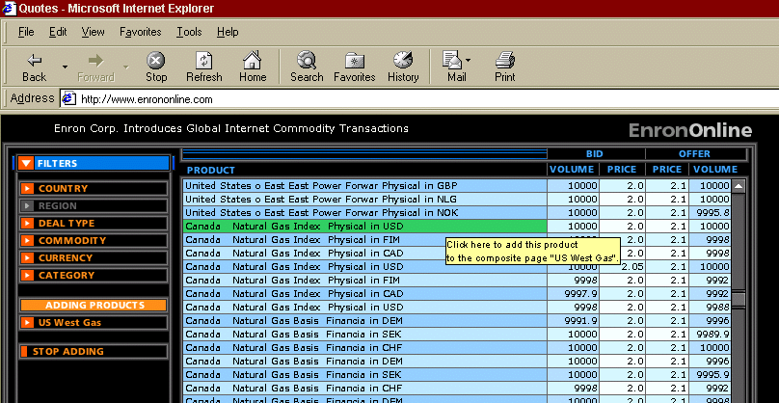

⏐system requirements⏐

For system requirements, all you need is an Internet connection, a Web browser (Microsoft® Internet Explorer 4.0 or Netscape Navigator® 4.0, or higher versions), and a Macromedia® Shockwave™ plug-in (freely available and may already be included in your browser). For your convenience, EnronOnline works with either a PC (Microsoft® Windows® 95 / Windows NT®) or an Apple Mac®.

If you do not currently have Shockwave installed on your computer, you should download it now from http://www.shockwave.com . This should enable you to see prices via EnronOnline in real time and benefit from all that EnronOnline has to offer.

⏐logging off from EnronOnline⏐

- To log off EnronOnline at any time, click on “Log off”. Your session will then be terminated.

