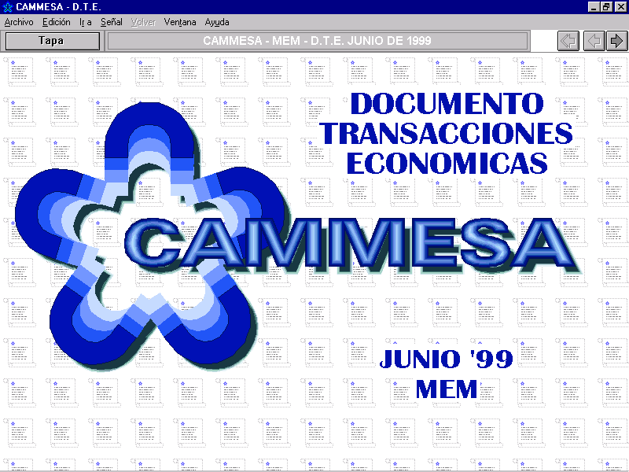

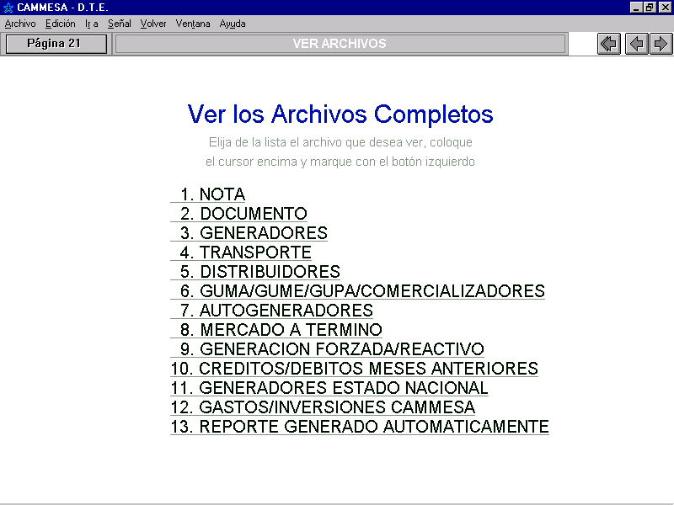
Under point 3 you can access Annex 1 “Generators”, and under point 1.7 “PRECIOS DEL MERCADO EN $/MWH”, you can find the index for energy for each hour the month
