Proposed RTO Update Outline

RTO Name: Desert STAR
Short-name: DSTAR

Region: Desert Southwest/Rocky Mountain
Major Filing Utilities included:
    - Arizona Public Service
    - El Paso Electric
    - Public Service New Mexico
    - Salt River Project
    - Tucson Electric Power
    - Western Area Power Administration (LC and CM)

Current Status:
The DSTAR Board will be meeting on May 22 and 23 to review Filing Utilities and Consultant Tariff documents to decide what to file with the FERC. According to information received there is a possibility of the Board filing one DSTAR RTO Tariff and the Filing Utilities filing their own. While the possibility of this occurring is unlikely, it could happen.

Number of Control Areas: DSTAR will operate as a single control area

Main Functions:
The October, 2000 filing to FERC contained a summary description of the DSTAR proposed rules of operation. In summary, the major DSTAR business functions will include, but not be limited to the following:

- Certification and registration of market participants
- Certification and registration of meters and meter-data systems
- Review, acceptance, and rejection of long-term and short-term generation-maintenance schedules and transmission-outage schedules
- Acceptance, processing, validation of schedules and bids from Scheduling Coordinators for the Day-Ahead (DA) and Schedule-Adjustment (SA) time periods, including both energy and ancillary services
- Conducting auctions and confirmations of trading in firm transmission rights (FTRs), recallable transmission rights (RTRs), non-converted rights (NCRs), and non-firm transmission rights (NTRs)
- Acceptance, processing, and validation of schedules from non-participants operating with converted and non-converted “existing contracts”
- Publishing, reporting, and updating specific market and transmission data, including operating transmission capacity (OTC) data, for the public and Market Participants (MP)
- Real-time regulation and control of the single DSTAR control area in conformance with the NERC operating Guidelines, including CPS1, CPS2, and DCS, with full archiving
- Performance of operations within the parameters of and in compliance with the market rules
- Planning, auctioning, and providing ancillary services in accordance with the market rules
- Performing long term, short term, and real-time system-security analyses, loss calculations, operations planning, (planned) outage scheduling, as well as grid resource-planning and forecasting
- Operating the Web-based market functions that support the scheduling and bidding transactions of the Market Participants
- Performing settlements and billing functions for DSTAR-related transactions and those transactions involving debiting or crediting parties for grid use.

Congestion Management:
DSTAR shall use a Congestion Zone-based approach to manage Congestion within the DSTAR Grid and to allocate use of the DSTAR Grid, including access to both FTR Interfaces and Scheduling Points

Products:
- Firm Transmission Rights (FTRs): Firm physical scheduling rights that will be auctioned on a periodic basis
- Recallable Transmission Rights (RTRs): Recallable physical scheduling rights, made available by the non-use of FTRs and the non-use of Non-Converted Rights (“NCRs”) in the Day-Ahead Scheduling Process, that can be recalled if the FTR or NCR is later scheduled in the Schedule Adjustment Process by the SC for the owner of the FTR or NCR
- Non-Firm Transmission Rights (NTRs): Non-firm physical scheduling rights made available by DSTAR that are subject to recall at any time
- Non-Converted Rights (NCRs): Physical transmission rights associated with an Existing Contract (“EC”) that have not been contractually converted to DSTAR Transmission Service

Ancillary Services:

Products:

Regulation and Frequency Response service;

Load Following Up service;

Load Following Down service;

Spinning Reserve service;

Non-spinning Reserve service;

Balancing Energy service;

Supplemental Energy service;

Energy Markets:
Will be operated independently from the RTO.

Settlements/Billing:

Miscellaneous Information:

Appendix A

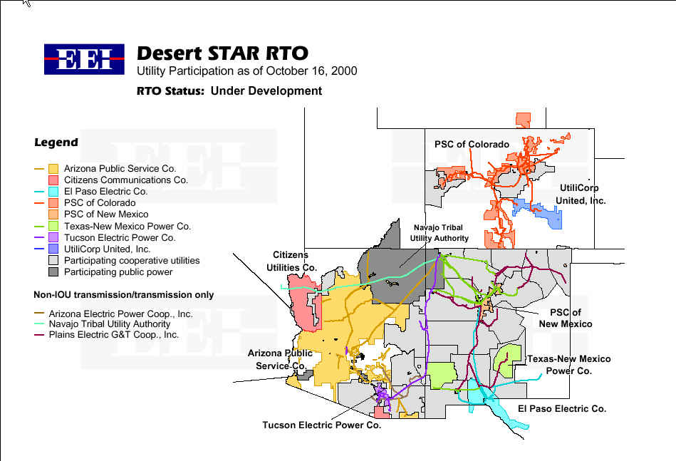

Appendix B
Electric Utility Name | Control-Area (CA) Now? | Transfer CA to DSTAR? | Transmission Owner (TO) Now? | Transfer Transmission Operation to DSTAR?
Arizona Electric Power Coop. | No | NA | Yes | Yes
Arizona Public Service | Yes | Yes | Yes | Yes
Arizona Utility Investors Association Inc. | No | N/A | Yes | Yes
Basin Electric | No | N/A | Yes | Yes
Black Hills Light & Power | No | N/A | Yes | Yes
El Paso Electric | Yes | Yes | Yes | Yes
Electrical District No. 1 of Pinal County | No | N/A | Yes | Yes
Electrical District No. 3 of Pinal County | No | N/A | Yes | Yes
Imperial Irrigation District | Yes | TBD | Yes | Yes
Mohave Electric Cooperative, Inc. | No | N/A | Yes | Yes
Plains Electric G&T | No | N/A | Yes | Yes
Platt River Power Authority | No | N/A | Yes | Yes
Public Service Colorado | Yes | Yes | Yes | Yes
Public Service New Mexico | Yes | Yes | Yes | Yes
Salt River Project | Yes | Yes | Yes | Yes
San Carlos Irrigation Project | No | N/A | Yes | Yes
Southwest Transmission Electric Power Coop, Inc. | No | N/A | Yes | Yes
Texas New Mexico Power | No | N/A | Yes | Yes
Tri-State Generation & Transmission Assoc., Inc. | No | N/A | Yes | Yes
Tucson Electric Power | Yes | Yes | Yes | Yes
Western Area Power Administration, LC | Yes | TBD | Yes | Yes
Western Area Power Administration, CM | Yes | TBD

Appendix C
DRAFT LIST OF FTR INTERFACES AND SCHEDULING POINTS

DSTAR Congestion Zones

- Arizona
- Northern New Mexico
- Southern New Mexico/West Texas
- Western Colorado
- Eastern Wyoming
- Four Corners
- Eastern Colorado

Import Limited Zones

I1. Phoenix
I2. Tucson
I3. Yuma

External Zones

E1. California
E2. North Texas
E3. Western Wyoming
E4. Eastern Utah
E5. Southern Utah
E6. Nebraska
E7. Southern Nevada
E8. Mexico

FTR Identifier

- A to I1 (Arizona to Phoenix)
- A to I2 (Arizona to Tucson)
- A to I3 (Arizona to Yuma)
4. A to C (Arizona to/from Southern New Mexico)
5. B to C (Northern New Mexico to/from Southern New Mexico/West Texas)
- F to A (Four Corners to Arizona)
- F to B (Four Corners to Northern New Mexico)
8. F to/from D (Four Corners to/from Western Colorado)
- D to G (Western Colorado to Eastern Colorado)
- E to G (Eastern Wyoming to Eastern Colorado)
11. A to/from E1 (Arizona to/from California)
12. B to/from E2 (Northern New Mexico to/from North Texas)
13. C to/from E2 (Southern New Mexico/West Texas to/from North Texas)
14. A to/from E5 (Arizona to/from Southern Utah)
15. E to/from E3 (Eastern Wyoming to/from Western Wyoming)
16. D to/from E4 (Western Colorado to/from Eastern Utah)
- E to/from E6 (Eastern Wyoming to/from Nebraska)
- A to/from E7 (Arizona to/from Southern Nevada)
- C to/from E8 (Southern New Mexico/West Texas to/from Mexico)
I3
E3
E1
E7
18
E8
A
F
C
I2
I1
G
E2
E4
E5
E6
7
5
4
2
1
6
9
10
X
IX
EX
DSTAR Congestion
Import Limited Zone
External Zone
XX
FTR Identifier
12

13

8

11

14

17
16

15
II
E
19

See Appendix A – Regional Map
These are the main drivers of forming DSTAR. A complete list of Transmission-Owner Entities is attached. See Appendix B
For Scheduling point identifications and Zone diagram see Appendix C

