Wholesale Power Supply Proposal

Prepared for:

Central Iowa Power Cooperative

Submitted by:

Enron North America Corp.
1400 Smith Street
Houston, TX 77002-7361

April 28, 2000

Trade Secret Information and Confidential

April 28, 2000

Mr. David K. Duncan
Manager Resource Planning
Central Iowa Power Cooperative
1400 Highway 13 SE
Cedar Rapids, IA 52403-9803

Re: Power Supply Proposal

Dear Mr. Duncan:

In response to Central Iowa Power Cooperative’s (“CIPCO”) Request For Porposal dated April 7, 2000, the attached proposal outlines the basic parameters for a transaction between Enron North America (“Enron”) and CIPCO.

The proposal is intended to initiate further discussion and demonstrate Enron’s willingness to partner with CIPCO. Key elements of the proposal include:

- The plant will be based on two General Electric 7EA’s in simple cycle mode.
- Commissioning the facility on 5/1/01, prior to CIPCO’s peaking capacity needs creates savings, decreases CIPCO’s all-in cost and reduces construction risk.
- The output of the plant is within the tolerance of the site and would require minimum transmission improvements.

Please note that Enron considers all information presented in this proposal as Trade Secret Information. I will call in a few days to follow-up on questions you may have.

Sincerely,

Oscar Dalton
Director

Power Supply Proposal
Overview | Enron North America Corp. (“Enron”) and Central Iowa Power Cooperative (“CIPCO”) will develop a simple-cycle power generating station (“the Plant”) to serve the needs of both companies. Enron will construct the plant and CIPCO will finance, own and operate.
Plant Description | The Plant will be based on 2 gas-fired General Electric 7EA combustion turbines installed in simple-cycle configuration. Construction will begin in September 2000, turbines will be delivered in November 2000 and the plant will be commissioned in May 2001.  Enron reserves the right to substitute technology (turbines) as long as the overall economics of the project are not impacted.
Operating  Characteristics  (90° F) | Output 152 Mw  Heat rate (HHV) 11,900 Btu/kWh  Emissions 25 PPM NO_{X}
EPC | Enron will be responsible for engineering, procurement and construction or as mutually negotiated.
Power Sales  Agreement  PSA Schedule  Project Economics | CIPCO will execute a power sales agreement (“PSA”) with Enron for the output of the Plant. The PSA will permit Enron to schedule all of the capacity of the Plant with typical scheduling requirements and operating constraints. Enron will be responsible for marketing all capacity and energy not contracted by CIPCO.  Start Date: May 1, 2001  End Date: October 31, 2007  Capacity: 152 MW’s  MW Output:  2001 2002 2003 2004 2005 2006 2007  Enron: 76 117 107 102 97 92 87  CIPCO: 0 35 45 50 55 60 65  Enron will guarantee overall project economics for CIPCO at $375/kW or $57,000,000 for the completely installed project (“Installed Project Cost”). The Installed Project Cost could be nominally decreased by approximately ??????? via the payment by ENA to CIPCO for a capacity charge pursuant to the negotiation of a PSA. An initial indication of the PSA value is ????? for the term May 1, 2001 through ?????? and is subject to change daily based on market conditions.

Financing  & Ownership  Site | CIPCO will finance and own the Plant through the term of the PSA and thereafter, thereby allowing CIPCO to consider attractive RUS financing.  It is contemplated that Plant will be constructed at a site currently being secured by CIPCO. As an alternative, Enron has secured development sites in Iowa including an existing site under option that would provide direct access to the CIPCO.Alliant 115 Kv system as well as the 345 Kv system of Mid-Am.
Electrical Interconnection | The Plant will be interconnected into the existing transmission system at the plant site described above.
Transmission  O&M | CIPCO agrees to negotiate transmission access across its system either directly or indirectly to provide ENA access to other wholesale markets.  CIPCO will be responsible for the daily operation of the plant, performance of routine maintenance, and coordination of major maintenance.
Permits | Air Construction (Non- PSD Permit)  Title IV Permit (acid rain)  Title V Operating Permit  Water Stormwater Construction Permit  Stormwater/Wastewater Permit for Industrial Activities  Other Risk Management Plan (ammonia handling if SCR)  Various local, zoning and land usage permits  Non-PSD Air Permit could be obtained instead of a PSD permit. A non-PSD permit would limit the Plant to 250 tons of NO_{X} emissions per year. With a non-PSD permit, the PSA would include a scheduling limitation of 1,000 hours per year.
Gas Supply | A new gas supply lateral will need to be constructed from the site to a mainline interconnect with an interstate natural gas pipeline company. Enron’s site is approximately ½ mile from Northern Natural Gas Pipeline Company which is an Enron affiliate. It is Enron’s understanding that the CIPCO site is also less than ½ mile from a major interstate pipeline company. Enron proposes to manage the construction of the gas supply lateral as well as manage the long-term fuel supply for the Plant. A detailed fuel supply proposal will be presented at a later date.
Assumptions | 900 annual run hours (approximately 5% annual use)  Gas pressure sufficient and no compression required

Respondent  Information | Name: Enron North America Corp.  1400 Smith Street  Houston, TX 77002-7361  Parent: Enron Corp.  1400 Smith Street  Houston, TX 77002-7361  Description:
Enron is one of the world's leading integrated electricity and natural gas companies. The company, which owns approximately $34 billion in energy related assets, produces electricity and natural gas, develops, constructs and operates energy and water facilities worldwide and delivers physical commodities and risk management and financial services to customers around the world. Enron's Internet address is www.enron.com, and the stock is traded under the ticker symbol, "ENE."

Contact:
Oscar Dalton
Director
Phone: 713-853-0361
Fax: 713-646-3421
E-Mail: oscar.dalton@enron.com

Ben Rogers
Associate
Phone: 713-853-7998
Fax: 713-646-3421
E-Mail: benjamin.rogers@enron.com

Enron Project  Team | Ozzie Pagan Vice President Origination 713-853-5429  Oscar Dalton Director Origination 713-853-0361  Ben Rogers Associate Origination 713-853-7998  Dan Williams Project Manager Enron Cont. 713-646-7958
Proposed Site:
 | 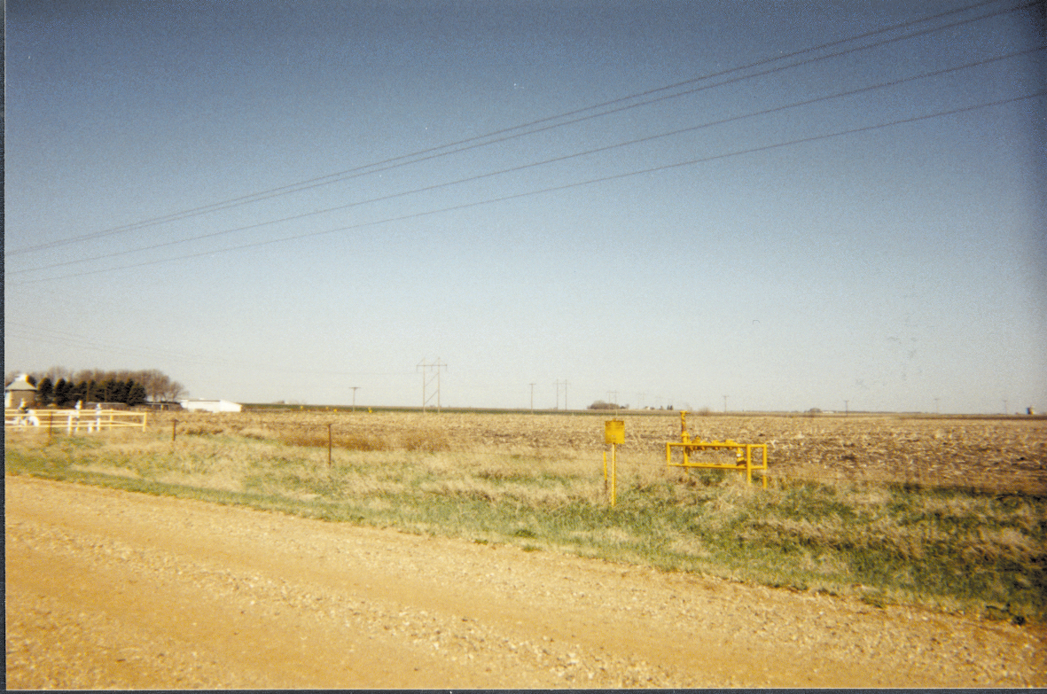

This Proposal is for discussion purposes only to facilitate the negotiation, preparation, and execution of definitive agreements relating to the Proposal. This Proposal is subject to, in all respects, Enron and its affiliates and CIPCO obtaining all requisite approvals and consents from all interested parties to consummate the Proposal. This Proposal is not intended to create a binding or enforceable contract or commitment by Enron, its affiliates or CIPCO. Consummation of any transaction is subject to, among other matters, the following conditions: (i) receipt of all necessary or advisable regulatory or other approvals or consents, (ii) approval by the Boards of Directors of Enron and, if applicable, its affiliates, and (iii) negotiation, execution and delivery of definitive agreements relating to all aspects of the Proposal. While Enron North America Corp. is submitting this Proposal, certain of its proposed obligations herein may be assigned to, and performed by, various Enron Corp. affiliates.

