Long Term Fixed Prices for Lumber Producers
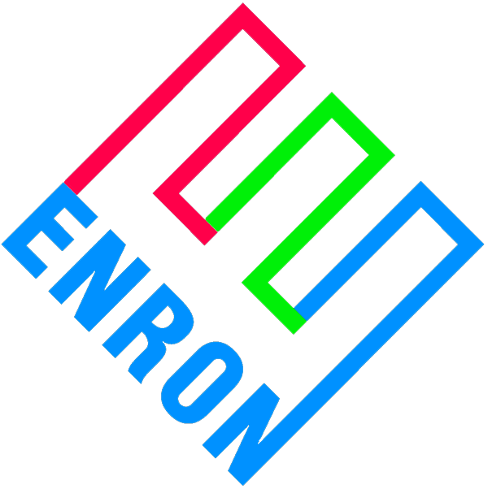
 |  |  | Long term Fixed Prices for Framing Lumber and OSB*
 |  |  | Volume I Number 32
 |  |  | Long-term prices as of September 24 – October 01 Start (U.S. Dollars)

Enron’s Bid Prices for Framing Lumber and OSB
 |  |  |  | 3 Months |  |  |  |  |  |  |  |  |  |  | 6 Months |  |  |  |  |  |  |  |  |  |  | 12 Months
Framing Lumber Composite Price /Mfbm |  |  |  | 315 |  |  |  |  |  |  |  |  |  |  | 315 |  |  |  |  |  |  |  |  |  |  | 315
 |  |  |  | SYP  Wst |  |  | S-P-F  Base |  | S-P-F  BOS |  |  | S-P-F  GL |  |  |  | SYP  Wst |  |  | S-P-F  Base |  | S-P-F  BOS |  | S-P-F  GL |  |  |  |  | SYP  Wst |  | S-P-F  Base |  |  | S-P-F  BOS | S-P-F  GL
2x4 Std & Btr K.D. R/L /Mfbm |  |  |  | 315 |  |  | 275 |  | 345 |  |  | 360 |  | 315 |  |  |  |  | 280 |  | 350 |  | 365 |  |  |  | 320 |  |  | 285 |  |  | 355 | 370
2x6 #2 & Btr K.D. R/L /Mfbm |  |  |  | 260 |  |  | 265 |  | 335 |  |  | 350 |  | 270 |  |  |  |  | 270 |  | 340 |  | 355 |  |  |  | 285 |  |  | 275 |  |  | 345 | 360
2x8 #2 & Btr K.D. R/L /Mfbm |  |  |  | 300 |  |  | 290 |  | 360 |  |  | 375 |  | 305 |  |  |  |  | 285 |  | 355 |  | 370 |  |  |  | 310 |  |  | 285 |  |  | 355 | 370
OSB 7/16” 24/16 NC /Msqft |  |  |  | 155 |  |  |  |  |  |  |  |  |  |  | 155 |  |  |  |  |  |  |  |  |  |  | 160
OSB 15/32” NC /Msqft |  |  |  | 170 |  |  |  |  |  |  |  |  |  |  | 170 |  |  |  |  |  |  |  |  |  |  | 175
OSB 19/32” T&G NC /Msqft |  |  |  | 235 |  |  |  |  |  |  |  |  |  |  | 235 |  |  |  |  |  |  |  |  |  |  | 245
OSB 23/32” T&G NC /Msqft |  |  |  | 273 |  |  |  |  |  |  |  |  |  |  | 273 |  |  |  |  |  |  |  |  |  |  | 280

Commentary
Keep an eye out for an upcoming news-letter detailing various initiatives Enron Forest Products will be rolling out over the next few months and how Enron will play a leading role in creating a more transparent and efficient Lumber Marketplace.
www.clickpaper.com
Please click or call us for details.
Enron has started a physical solid wood products business recently, buying and selling dimensional lumber and structural panels.

Our Goal:
To Become the Leading Provider of
Financial Risk Management Services to the Lumber Industry

For general & contracting information please contact (U.S.):
Please call 1-888-ENRON41 for details.

This document does not create and is not intended to create a binding and enforceable contract between the parties or a duty on the part of either party to negotiate in good faith toward a binding contract, and may not be relied upon by either party as the basis for a contract by estoppel or otherwise, but rather evidence a non-binding expression of good faith understanding to endeavor, without obligation, to negotiate mutually agreeable definitive agreements. Any transaction is conditioned upon (i) Enron board of director and senior management approval, (ii) the results of a due diligence review to EIM’s satisfaction, which due diligence review has not yet been conducted, and (iii) the negotiation and execution of mutually acceptable definitive documentation. The pricing proposals set forth in this document are subject to change based upon commodity price movements.

