Objectives

Add the ability for customers to place price limit orders on standard products currently offered on EOL.

Overview

The customer places a Price Limit Order via the transaction screen. All orders for each product are queued by price and by time stamp. When the EOL price is at the level of any “Limit Order” the system will automatically fill them in the order they were received.

Functional Requirements

The Customer Application

Placing Orders

- Price Limit Orders will be placed via the current transaction screen.
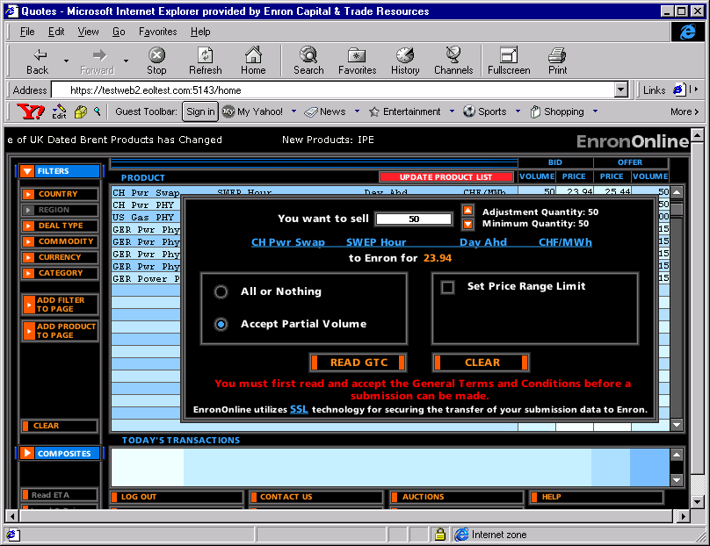
- Clicking on the product bid or offer takes customer into the transaction submission screen.

- It is proposed to remove the “ Set Price Range Limit” functionality in Phase 2 (need to check if it is currently being used) This section will be used to
- Provide spaces where the customer may enter the limit price and volume.
- Display the minimum, maximum and adjustment quantity applicable to Limit Orders.
- The customer will need to
- Check the Price Limit Order box. If the Price Limit Order box is checked the system should
- Blank out the current Bid or Offer price and Volume in the main area of the submission box. For E.g. in the screen above when “Price Limit Order is checked, the main part of the submission box would read, “You want to sell CH Pwr Swap SWEP Hour Day Ahd CHF/Mwh to Enron”
- Select the “ Accept Partial Fill” option and lock down the “All or Nothing” option. The “All or Nothing” option will not be available with Price Limit Orders. The customer will have to accept partial fills on any orders placed.
- Enter the price and volume desired. The volume cannot exceed the maximum limit set by the trader.

- Click Submit. The system should
- Ensure that the order price is not worse than the existing bid or offer. If it is the system needs to display a message to that effect.
- Display a message “You have requested to place a price limit order for aaa mmbtus of yyyyy at a price of xxx. If the price you specified becomes available on EnronOnline, the system will automatically try to fill your order and a transaction may result. Your order maybe filled partially or completely depending on the volume available. This order will remain active till you cancel it, or the expiration of the product whichever is earlier. It will not be withdrawn when you log off.” The customers choices are
- Proceed. Selecting Proceed submits the order.
- Cancel. Clicking Cancel takes the customer back to the previous screen.
- All open Price Limit Orders will be displayed on the Quotes screen in a section below the Today’s Transactions section. The system should display the order number, order date, order time, product details, volume, and the limit price.

Order Cancellation
- To cancel an order before it is filled,
- Select the order to be modified from the Price Limit Orders section.
- Click on the Order number.
- Click the ‘Cancel Order’ button. This should prompt a message “Cancel Order” the customers choices are,
- Yes. Selecting Yes submits the order for cancellation.
- No. Selecting No returns the customer to the previous screen.
- If the order is submitted for cancellation the system should
- Check to see if the order has been filled. If it has been filled display a message to that effect.
- If it has not been filled then
- Remove the order from the list.
- Send a confirmation of the order cancellation to the customer.

Order Completion.
- When an order is filled the system should
- Send a message to the customer that effect.
- Remove the order from the list.
- Display the trade in the Today’s Transaction section.

Order Constraints
- One Price Limit Order per price per product per user
- Orders expire at the end of each day unless cancelled
- Five price limit orders per Product per user.

The Trader Application

- The trader will be able to view limit orders via the stack manager. The space currently below the Dependencies window will be used to display the Price Limit Orders.
- Traders will not be able to move their prices through a Price Limit Order level – they will only be able to move their prices to the price specified in the nearest Price Limit Order. Once that order is filled, they will be able to move their prices in any increment until reaching the next Price Limit Order price level, etc.
Placing Orders
- If the customer places an order the system needs to
- Display a message that an order has been received. E.g. “New Order 23456” in the Stack Manager message window.
- Q orders based on price and time stamp.
- Display the order in the Price Limit Order window. The system should display the order number, order date, order time, counterparty, product details, volume, the limit price, and the order status. Orders should be sorted first by product then by price. The system should clearly identify whether it is a bid or offer limit order. The trader should have the option of viewing a summary of the orders by product by price.
- All Price limit orders should have a user invisible field which is either ‘Active’ or ‘Inactive’. Each night the system should check to see if there are any orders associated with products that have tokenised reference periods, and if there are such orders should be set to inactive. All orders must be maintained in the database till they are filled, cancelled or expire.

Modifying Orders
- If an open order is modified the system should
- Display a message in the Stack Manager message window.
- Change the placement of the order in the Q based on the new time stamp.

Order Cancellation
- If an open order is cancelled the system should
- Display a message in the Stack Manager message window.
- Remove the order from the order list.
Order Completion
- If price changes made by the trader causes the EOL price to reach the level of any limit order the system should ensure that the customer has sufficient credit. If the customer credit is good the system should automatically fill those orders. The rules for filling the orders are as follows:
- Orders will be filled on a ‘First Come First Serve’ basis, based on the time stamp.
- If the volume at the limit price is not sufficient to cover an order completely it will be partially filled. The order will remain open for the remainder of the volume. A message to this effect should be sent to the customer.
- If a customer submits an order just as the trader is changing his price, and the trader’s price is better than the order price, the customer will get the better price.
- If an open order is filled the system should
- Display a message in the Stack Manager message window.
- Remove the order from the list.
- Display the trade in the transaction list.

