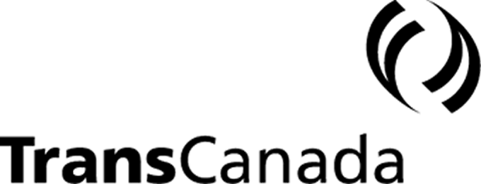

NewsRelease

TransCanada and Stakeholders Reach a Settlement for

2001 and 2002 Canadian Mainline System Services and Pricing

CALGARY, Alberta – February 22, 2001 – (TSE: TRP) (NYSE: TRP) – TransCanada PipeLines Limited today announced it has reached a settlement regarding 2001 and 2002 services and pricing on its Canadian Mainline natural gas transmission system that resolves all issues other than cost of capital. The parties agreed that the issue of cost of capital would be determined in a different forum. The settlement is the result of broad industry negotiations and represents a balance of interests among most of the negotiating parties.

“We are pleased to have reached this settlement, which will assist in meeting the needs of TransCanada’s customers and shareholders,” said Doug Baldwin, TransCanada’s President and Chief Executive Officer. “The settlement provides the foundation for further discussions to ensure the Canadian Mainline System continues to compete effectively for market demand and natural gas supplies. It’s also another example of what can be accomplished by working collaboratively with industry stakeholders.”

Highlights of the Settlement

Revenue Requirement:
The settlement establishes the Canadian Mainline System’s fixed operating, maintenance and administration; post employment benefits; and regulatory commission (OM&A) costs for the next two years. All other elements of the 2001 and 2002 revenue requirements will be treated on a flow through basis. OM&A variances between actual costs and those agreed to in the settlement will accrue to TransCanada’s account.

OM&A costs for 2001, commencing January 1, 2001, are fixed at $223 million. Commencing January1, 2002, the OM&A costs for 2002 are fixed at $216.5 million. These amounts are subject to adjustments from the final 2000 Merger and Cost Benefit Agreement account.

Depreciation is based on a composite rate of 2.75 per cent in 2001, compared to 2.65 per cent in 2000. In 2002, the composite depreciation rate will increase to 2.90 per cent.

Contract Demand:
Contract demand will be estimated each year. Variance between forecast and actual contract demand will be deferred and recovered in the following test year.

Incentives:
The settlement includes various incentive programs to assist in balancing the cost
incentive provided by the fixed OM&A agreement. Specific incentive programs include:

Fuel Gas and Power Incentive - to minimize total delivered costs. Details of this incentive are to be determined by April 30, 2001.

Foreign Exchange Program - to reduce foreign exchange costs on Interest and Transportation by Others in foreign currencies. Savings, to a benchmark, are shared equally between TransCanada and its shippers. This program will terminate December 31, 2002.

Interest Rate Management Program - to reduce interest costs by managing fix/floating rates. Savings are shared equally between TransCanada and shippers. This program will terminate December 31, 2002.

Revenue /Asset Management Mechanism:
Revenue/Asset Management Mechanism - a commission to TransCanada of varying percentages to provide an incentive to reduce asset costs and generate incremental revenue. Revenue to TransCanada from this mechanism is capped at $5 million.

Services:
Firm Service (FT) - will be provided with Make-up and Authorized Overrun Service (AOS) rights as described below:

FT Make-up - the Demand Charge associated with each FT shipper’s unutilized FT Demand rights in each month will be credited towards that FT shipper’s Interruptible Service (IT) invoice at the end of each month. This service will terminate December 31, 2002.

AOS - four per cent of each FT shipper’s monthly contract demand charges will be credited to that shipper’s IT invoice each month. This service will terminate December 31, 2002.

Short Term Firm Service (STFT) – there is no change to the existing STFT offering. STFT will remain as a biddable service with a floor price of 100 per cent of the FT toll.

IT – will remain as a biddable service. The price is based on a proxy for marginal fuel, plus commodity toll, plus a contribution to fixed costs. The floor price for IT can vary between 80 per cent of the FT toll and 120 per cent of the FT toll.

Future Business Model:
The parties acknowledged that a competitive pipeline system is in the interest of all stakeholders and will enable TransCanada to meet its needs and those of its customers, supporting the long-term viability of the TransCanada system. By the end of August 2001, TransCanada will work to present to the stakeholders, a specific business and regulatory model for the future that will allow it to compete effectively for market demand and gas supplies. Discussions with stakeholders regarding any new model, including a code of conduct, will be initiated on or before September 17, 2001 and completed by February 28, 2002.

This settlement will form the basis of a formal agreement between the parties. Once TransCanada and the parties have completed the agreement (anticipated by the end of this March), TransCanada will apply to the National Energy Board for approval of the agreement.

TransCanada is a leading North American energy company. It is focused on natural gas transmission, power, and gas marketing services, complemented by employees who are expert in these businesses. The company's network of approximately 38,000 kilometres of pipeline transports the majority of western Canada's natural gas production to the fastest growing markets in Canada and the United States. TransCanada's common shares trade under the symbol TRP on the Toronto and New York stock exchanges. Visit us on the internet at www.transcanada.com for more information.

Note: All dollar amounts are expressed in Canadian funds, unless otherwise indicated.

(For a complete version of the Settlement, please visit TransCanada’s web site at
www. transcanada.com and follow the links to this news release.)

– 30 –

Media Inquiries: Glenn Herchak/Kurt Kadatz (403) 267-3309

Analyst Inquiries: David Moneta (403) 267-8521

