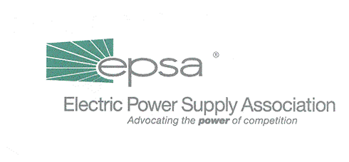
1401 New York Avenue, NW 11th Floor
Washington, DC 20005
202/628-8200
202/628-8260 fax
www.epsa.org
Memorandum
TO: | Board of Directors  Public Affairs Committee
FROM: | Jana Martin, Public Affairs Committee Chair  Mark Stultz, Vice President, Public Affairs & Marketing
DATE: | May 9, 2001
RE: | Pro-competition media campaign  - Voluntary contributions requested

As previously discussed at the recent EPSA Board of Directors meeting, we are seeking your voluntary support for a 13-week, third-party, pro-competition media campaign to run in targeted states, and perhaps with selected messages directed at Capitol Hill.

We are beginning phase one with a solicitation to cover creative development and initial production costs. We anticipate that this component of the campaign could cost as much as $250,000 -- but as soon as we get about $125,000 in the bank, we can begin developing at least one electronic and one print ad, which will then serve as demos (along with additional story boards) for the rest of the campaign.

Here is how that $125,000 breaks down:
Creative fee: $50,000 (includes one produced commercial & 3-4 story boards)
Production: $35,000 (includes pre- and post-production, studio and editing)
Talent: $ 5,000
Print: $10,000 (layout and design of three print ads)
Contingency : $25,000
While this budget is an estimate, these items will be supported by invoices. Public Strategies Inc. will work at the vendor invoice cost with no markup.

With that in mind, we are seeking an initial voluntary payment of $10,000 from industry participants, both members and other interested stakeholders. These payments are not tax deductible as charitable contributions, and we estimate that all of these payments will be used for direct thought-leader advocacy. Checks should be made payable to: "Joint Venture for a Powerful Future," c/o of EPSA, 1401 New York Ave. NW, 11th floor, Washington, D.C. 20005.

At the appropriate time, we will do a phase-two solicitation for placements and re-evaluate the targeted placements as directed by the campaign funders. We also anticipate that EPSA members will have access to the creative deliverables for potential additional placements among their own target audiences.

If you have any additional questions, please don't hesitate to contact Mark Stultz at (202) 628-8200, or mstultz@epsa.org.

