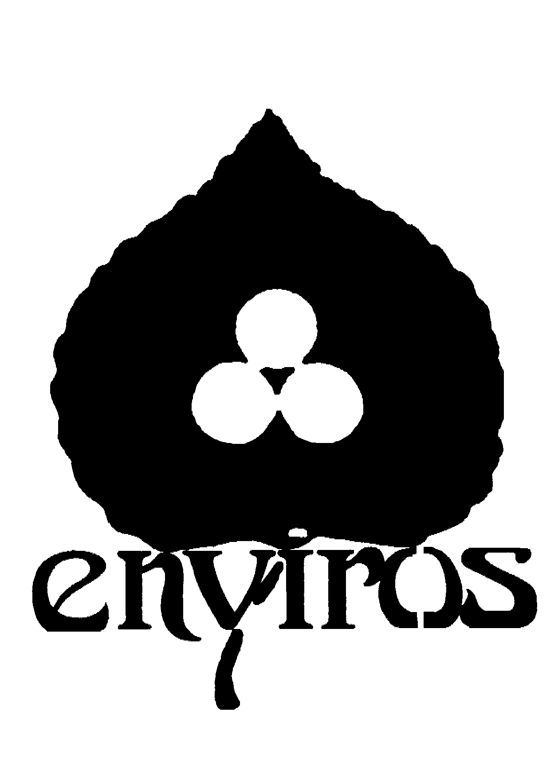
The Order of Good Cheer 11th Annual Charity Fundraiser

Pledge Form

We have five categories of sponsors (please check one):

Partner - $10,000

Platinum - $5,000

Gold - $3,000

Silver - $2,000

Bronze - $1,000

Donor Name: _____________________________ Address: __________________________

___________________________

___________________________

Cheques should be made payable to “Enviros” and sent to _______________. A 1999 tax receipt for the full amount of the donation will be provided by this registered charity, provided your donation is received in the 1999 calendar year. Enviros will also accept securities as donations including flow-through shares


