3-A-VI. Lincoln Energy Center - Will County, Illinois

MAIN Region

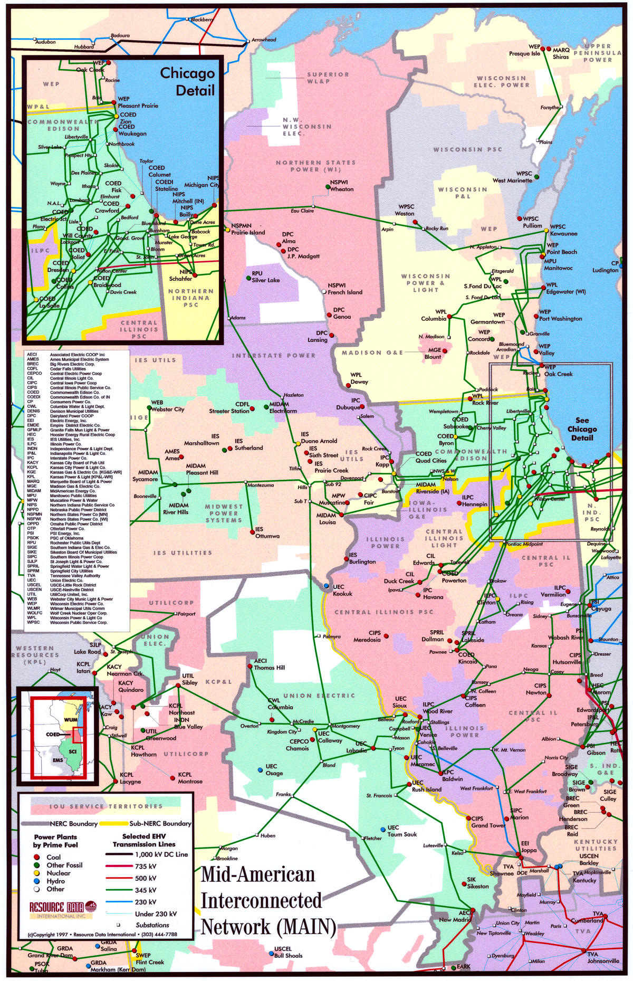
Lincoln Energy Center
Lincoln Energy Center

Overview - Lincoln Energy Center

Description: 656 MW (nominal) natural gas-fired, simple cycle power generation facility (the “Lincoln Energy Center”) owned by Des Plaines Green Land Development, L.L.C., an indirect wholly owned subsidiary of Enron North America. The Lincoln Energy Center consists of eight General Electric Model 7EA gas turbines, each rated at approximately 82 MW (nominal).

Location: The Lincoln Energy Center is located on 50 acres of land at 27155 South Kankakee Street in Manhattan, Illinois, directly across from the Commonwealth Edison Wilton Center substation (“ComEd Substation”).

Constructor: NEPCO, an indirect wholly owned subsidiary of Enron Corp.

NERC Region: MAIN-ComEd

Control Area: ENLC. The Lincoln Energy Center has been designated a control area in accordance with NERC policy.

Power Purchase Agreement: The Lincoln Energy Center has a limited term commitment for the plant’s capacity and energy.

Transmission: The Lincoln Energy Center is interconnected directly to the ComEd Substation at the 345 kV level. The ComEd Substation has five transmission lines to which it is connected: three 345 kV lines and two 765 kV lines. Each of the 765 kV lines has significant available transmission capacity during periods of peak load. In addition to the direct access to Commonwealth Edison's service territory, the ComEd Substation has direct access to eastern markets (such as AEP) via the 765 kV line.

Fuel: The Lincoln Energy Center is permitted to use natural gas as its sole fuel source. The plant is interconnected to a natural gas pipeline system owned by Northern Border Pipeline Company (“Northern Border”). Des Plaines Greenland Development, L.L.C. and Northern Border each own, operate and maintain specified portions of the interconnection facilities as defined in the interconnect agreement. Natural gas transport delivery to the Lincoln Energy Center is achieved through Northern Border’s pipeline pursuant to an interruptible gas transportation agreement with Northern Border. The term of the interruptible gas transportation agreement began on March 1, 2000 and continues until February 28, 2002.

Zoning: To develop the Lincoln Energy Center, the plant site was re-zoned as industrial.

Air Permit: The Lincoln Energy Center received its PSD air permit in September 1999.

Baseload Emission Information
NO_{x} Cap (Per Unit): < 9 PPM
CO (Per Unit): < 25 PPM

Commercial Ops: June 2000

Ops Hours: The Lincoln Energy Center is permitted for 3,250 hours of annual operation at full load.

Heat Rate: At 90 degrees Fahrenheit and at full operation, the plant is able to achieve a net heat rate of approximately 11,900 Btu/kWh (HHV).

Peaking Capacity: At 90 degrees Fahrenheit and at full operation, the capacity of the plant is approximately 632 MW.

Expansion Potential: The Lincoln Energy Center has been designed to facilitate a future expansion or conversion to combined-cycle.

Anticipated Water Usage: 175 gpm during operation.

Water Supply: On-site wells.

LINCOLN CENTER
ENLC
G4
G5
G6
G3
G7
G8
G1
G2
B
B
B
B
B
B
B
B
GSU T34
GSU T33
GSU T32
GSU T31
B
Summer
Nominal
Winter
Unit MW Rating:
79
82
88
Gas Transporter:
Northern Border
Gas Daily Index:
Chicago LDC's
B
B
B
B = Breaker
GSU = Generator Step-up Unit
345 kV
345 kV line to:
ComEd
Substation

Site Pictures - Lincoln Energy Center

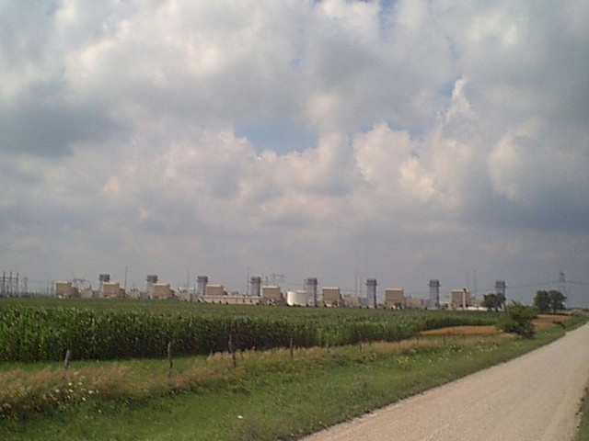

Plant View (7/17/00)

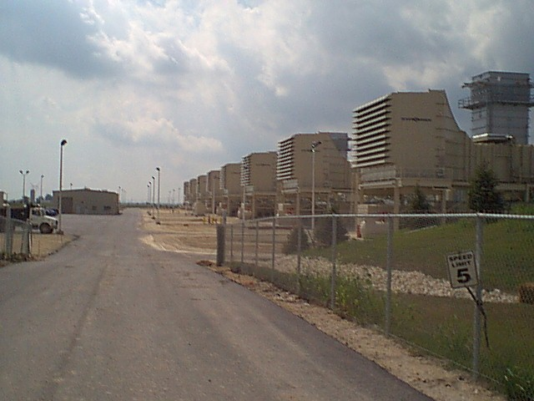

Turbine Air Inlets (7/17/00)

