3-A. The Peaker Plants

3-A-I. Investment Merits of the Peaker Plants

First Mover Advantage in Midwest and Southeast Markets
- 1,710 MW (nominal) of new gas-fired generation located in Illinois, Indiana, and Tennessee
- Commercial operation June 2000; combustion turbines are still under OEM warranty
- Conventional technologies with proven track record

Portfolio of Assets with Extensive Market Reach
- The plants provide geographic diversification with critical mass
- Direct access to three major markets: SERC, ECAR, MAIN
- Well-positioned interconnections enable access to 55% of US electricity demand within one wheel

Attractive Power Market Fundamentals
- Target markets have historically experienced extreme power price volatility due to tight reserve margins, transmission constraints, and susceptibility to outages of large scale units
- Regions are ideally suited for peaking capacity due to low variable cost of installed plants and declining reserve margins

Each Plant is its own Control Area
- Gleason, Wheatland and Lincoln Energy Center are each Control Areas as designated by NERC
- Control Area designation is valuable for point-to-point power sales, scheduling of power, and parking and hubbing

Peaking Plants Ideal for Power Marketing
- “Virtual electricity storage”
- Ability to ramp-up plants quickly
- Can cycle plant to capture intra-day price spikes
- Flexible portfolio with ability to sell multiple products and services including capacity, energy, ancillary services, financial options, etc.
- Ideally suited to capitalize on gas/power arbitrage opportunities
- Provides a hedge for market positions

Favorable Gas Market Dynamics
- Plants situated on major interstate gas pipeline corridor with access to multiple supply basins
- Favorable gas transportation arrangements for all the plants
- Flexible gas arrangements in Chicago area allow access to ANR and Northern Border

Significant Upside Potential
- Expansion potential at existing sites
- Conversion capability to combined cycle at all sites
- Accelerated utility plant retirements would enhance capacity values
- Increasing environmental regulation favors gas-fired plants relative to coal plants

3-A-II. Location of Peakers

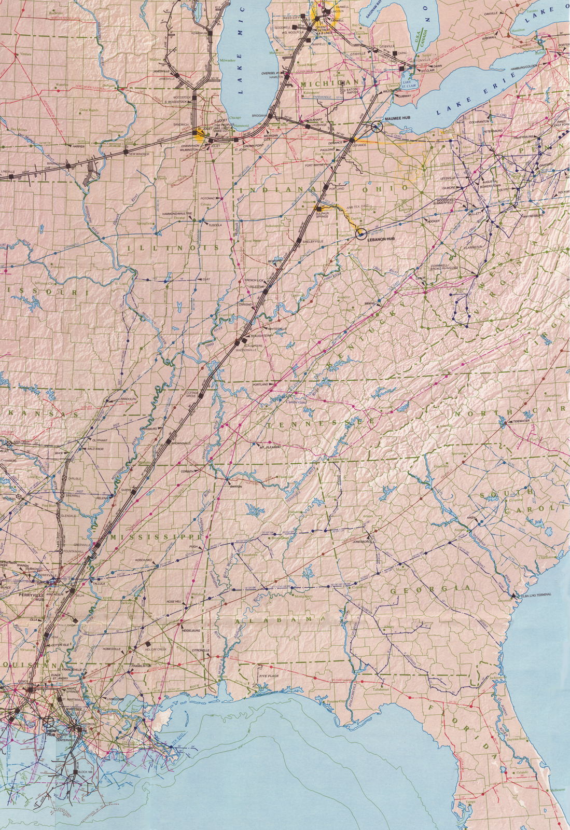
Manhattan, IL
Wheatland, IN
Gleason, TN

3-A-III. Operating Information

Summary of Key Data

 | Gleason Plant | Wheatland Plant | Lincoln Energy Center
Region | SERC | ECAR | MAIN
Interconnected Area | TVA (500 kV) | IPL/CIN (345 kV) | CE (345 kV)
Control Area Name | ENGL | ENWI/ENWC | ENLC
Turbine No./Type | 1 x W 501 FC 2 x W 501 FD | 4 x W 501 D5A | 8 x GE 7EA
NO_{x} Compliance Technology | Water Injected | Water Injected | DLN
NO_{x} (Per Unit) | < 25 PPM | < 25 PPM | < 9 PPM
CO (Per Unit) | < 30 PPM | < 25 PPM | < 25 PPM
Capacity @ 90⁰ degrees (MW) | 535 | 480 | 632
Heat Rate @ 90⁰ (HHV, Btu/KWh) | 10,900 | 11,500 | 11,900
Gas Interconnect | ANR | Midwestern Gas | Northern Border
Approximate Maximum Annual MWh | 532,992 | 461,313 | 2,002,000
Normal Unit Ramp from Cold  to Full Load (Min) | 30 | 30 | 30
Operating Expenses
Estimated Variable O&M ($/MWh) | 1.50 | 3.00 | 2.00
Estimated Fixed O&M ($000) | 1,242 | 1,516 | 1,449
Major Maintenance ($/Start/Turbine) | 3,000 | 1,500 | 1,000
Owner’s Expense ($000) | 322 | 306 | 401
Property Tax Liability ($000) | 92 | 203 | 334
Tax Rates
State Income Tax Rate | 6.00% | 4.50% | 7.18%
Adjusted Gross Income Tax | N/A | 3.40% | N/A
Gross Receipts Tax Rate | N/A | 1.20% | N/A
Franchise Tax Rate | 0.25% | N/A | 0.15% yr 1,  0.10% yr 2-20

Operating Expenses

- Variable O&M: Variable O&M expenses include water costs and variable maintenance expenditures.

- Fixed O&M: Fixed O&M includes payroll expenses and other fixed O&M expenses.

- Major Maintenance: Includes accrual for future major maintenance on a start per turbine basis, assuming 100 starts/year.

- Owner’s Expense: Owner’s expense includes insurance, utilities, interconnection fees, gas pipeline metering cost and miscellaneous expenses.

- Property Tax Liability: Property tax varies based on abatement programs and other local issues.

Tax Rates

- State Income Tax Rates: The applicable local state income tax rates are listed in the Summary of Key Data table.

- Adjusted Gross Income Tax: Indiana income is subject to the greater of a 3.4% adjusted gross income tax or a 1.2% gross income tax. The adjusted gross income tax is based on federal net income, adjusted for specific Indiana additions and subtractions. The gross income tax base is total gross receipt, without any deductions for expenses or related cost.

- Franchise Tax: Franchise tax is calculated for Gleason Plant and Lincoln Energy Center. For Gleason Plant, Tennessee imposes a 0.25% tax on the higher of (1) capital stock less treasury stock or stock held in other Tennessee corporations, retained earnings, indebtedness to, or guaranteed by, affiliated corporations and all reserves that do not represent legal liabilities, or, (2) the cost of all property owned less book (GAAP) accumulated depreciation. For Lincoln Energy Center, Illinois imposes a franchise tax, which is the product of the computed paid-in capital multiplied by a 0.15% (drops to 0.10% after first year) rate. The computed paid-in capital is comprised of consideration paid for stock, any other consideration contributed to the corporations by a shareholder.

3-A-IV. Gleason Plant - Weakley County, Tennessee

SERC-TVA Subregion

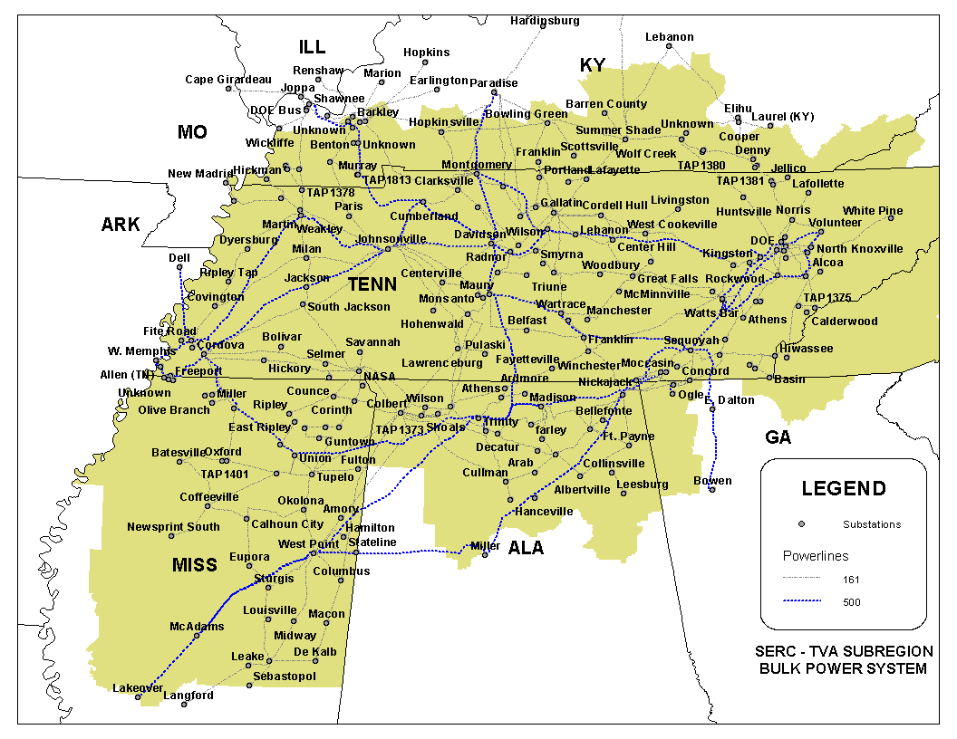
Gleason Plant

Overview - Gleason Plant

Description: 546 MW (nominal) natural gas-fired, simple cycle power generation facility (the “Gleason Plant”) owned by Gleason Power I, L.L.C., an indirect wholly owned subsidiary of Enron North America. The Gleason Plant consists of one Westinghouse Model 501 FC gas turbine and two Westinghouse Model 501 FD gas turbines, rated at 182 MW and 182 MW, respectively (nominal).

Location: The Gleason Plant is located on an approximate 60 acre tract of land at 1156 James Mill road in Gleason, Tennessee.

Constructor: NEPCO, an indirect wholly owned subsidiary of Enron Corp.

NERC Region: SERC-TVA

Control Area: ENGL. The Gleason Plant has been designated a control area in accordance with NERC policy.

Power Purchase Agreement: None

Transmission: The Gleason Plant is interconnected to a 500 kV TVA line that traverses the site.

Fuel: The Gleason Plant is permitted to use natural gas as its fuel source. The plant is interconnected to a natural gas pipeline system which traverses the site and is owned and operated by ANR Pipeline Company (“ANR”). Gleason Power I, L.L.C. and ANR each own, operate and maintain specified portions of the interconnection facilities as defined in the facilities agreement. ANR transports and delivers natural gas and provides gas parking and lending services to the Gleason Plant, pursuant to an interruptible transportation service agreement and an interruptible parking and lending service agreement. The term of each of these agreements ends on February 28, 2010. The interruptible transportation service agreement and the interruptible gas parking and lending service agreement will continue on a month-to-month basis after February 28, 2010, until terminated by either party.

Zoning: Not applicable; no local zoning requirements.

Air Permit: The Gleason Plant site is located in an attainment area for air permitting purposes.

Baseload Emission Information
NO_{x} (Per Unit): < 25 PPM
CO (Per Unit): < 30 PPM

Commercial Ops: June 2000

Ops Hours: The Gleason Plant is permitted to operate for approximately 915 hours per year at full load.

Heat Rate: At 90 degrees Fahrenheit and at full operation, the Gleason Plant is able to achieve a net heat rate of approximately 10,900 Btu/kWh (HHV).

Peaking Capacity: At 90 degrees Fahrenheit and at full operation, the net capacity of the plant is approximately 535 MW.

Expansion Potential: The Gleason Plant has been designed to facilitate a future plant expansion or conversion to combined-cycle. An interconnect request for conversion has been filed with TVA.

Water Usage: Approximately 400 gpm during operation.

Water Supply: On-site wells.

GLEASON
ENGL
G3
G2
G1
B
Summer
Nominal
Winter
Unit MW Rating:
175
182
182
180
182
182
Gas Transporter:
ANR
Gas Daily Index:
ANR (LA Onshore)
Between Chicago LDC & ANR
B = Breaker
GSU = Generator Step-up Unit
B
GSU1A,1B,1C
B
GSU2
B
B
B
B
B
500 kV
TVA
Johnsonville
Switchyard
TVA Weakley
Substation

Site Pictures - Gleason Plant

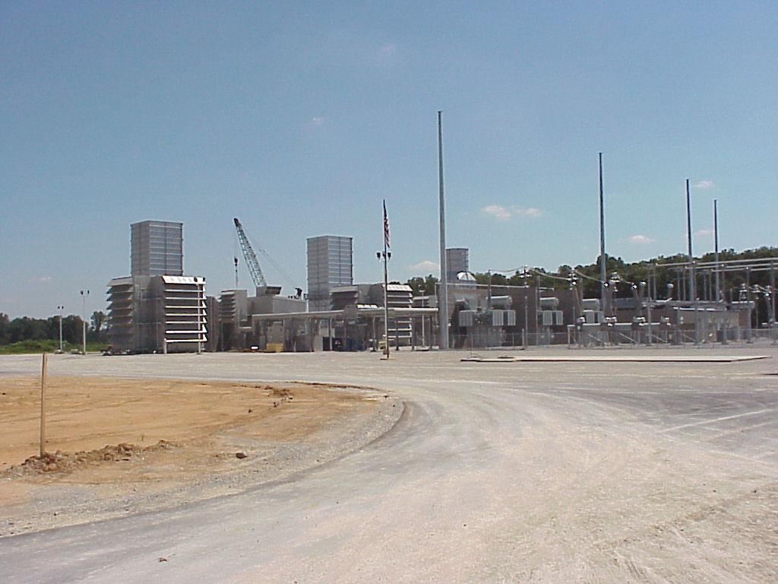

Plant View (7/17/00)

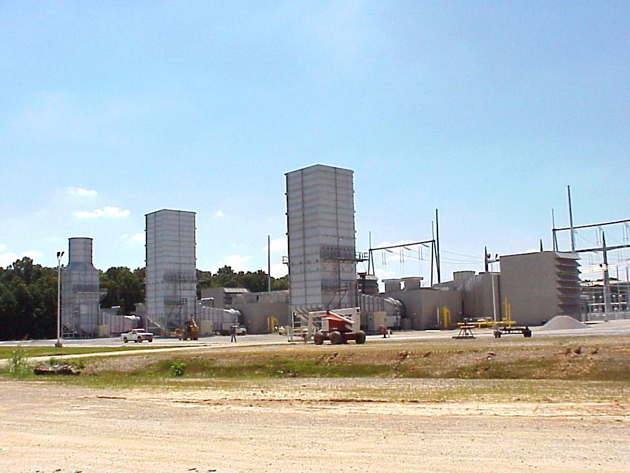

Exhaust Stacks (7/17/00)

