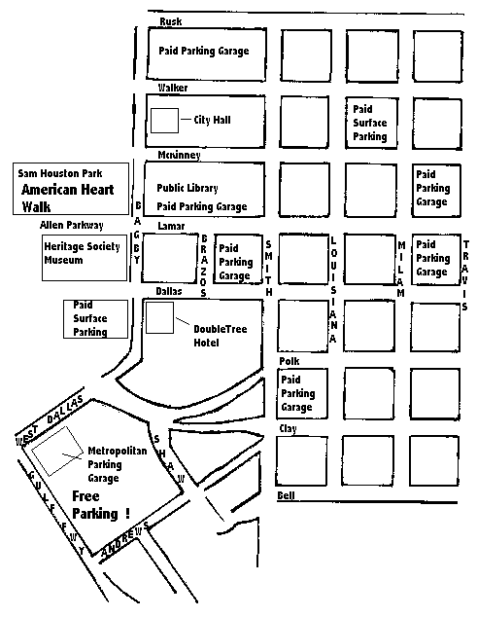

Free Parking will be available on Walk Day

TrizecHahn is once again donating parking for this year’s American Heart Walk. They will open the Metropolitan Racquet Club Garage (only two blocks from Sam Houston Park) for all Heart Walk participants early Saturday morning.

You can enter the garage from two streets:
“Gulf Freeway” or “West Dallas”

The Metropolitan Racquet Club Garage is different than the Allen Center Garage, which is adjacent. The Allen Center Garage will not be open.

