

PROPOSED TRANSMISSION PROJECT:
PARIS - ANNA 345 KV LINE

April 10, 2001
Issue: Proposed Transmission Project: Paris – Anna 345 kV Line
Background/History: The 345 kV transmission system in the northeast Texas portion of ERCOT was originally developed to transport energy from the Valley and Monticello generation facilities to the load in the Dallas – Fort Worth area. Energy transfers in that area exceeded the original design limits of the 345 kV facilities when the 600 MW East HVDC tie was placed in service. The Monticello – Farmersville – Anna Switch 345 kV transmission project is currently underway to increase the transfer levels for the Monticello – DC Tie area.
The installation of the 1,100 MW Lamar Power Project (LPP) near Paris further increased the transmission constraints in the Northeast Region. Several single and double circuit contingency conditions result in thermal overloading of the 345 kV and/or the 138 kV circuits in the northeast ERCOT area. Counting the East HVDC import capability, this area represents a generation resource of about 4,950 MW.
In addition, with LPP generation, there is a serious system stability concern for the northeast area. There are several short circuit faults that result in instability at the Valley, Monticello and Lamar generation plants and may cause these plant(s) to trip off line.
The four-county DFW area (Collin, Dallas, Denton and Tarrant) has been designated by the Environmental Protection Agency (EPA) and Texas Natural Resources Conservation Commission (TNRCC) as a non-attainment area for ground-level ozone, which is produced in part by nitrogen oxide (NOx) emissions from fossil fuel burning. A recently approved EPA State Implementation Plan (SIP) mandates specific actions to reduce emissions of NOx from various sources within the area by 2003, with additional reductions required by 2005. To conform to the new SIP, DFW power plants will be required either to retrofit generation units with new NOx reduction devices, or to reduce or cease operation.
Key Factors Influencing Issue: Without the additional transmission there is a reliability risk for the Northeast ERCOT area that may lead to transmission loading above ratings, generation unit trips, transmission congestion limiting generation capacity and possible cascading outages. The existing 345 kV transmission system outside the DFW region has inadequate transfer capability to allow full replacement generation to be provided to the DFW area from remote locations.
Discussion: Until new transmission can be built, the Lamar Power Project has been equipped with a special protection system (SPS) that will rapidly trip three of the six Lamar generation units in the event that a transmission disturbance results in overloads on the Paris-Valley 138 kV or 345 kV circuits. An SPS refers to an automated action triggered by a change in system conditions that requires an immediate response to restore system security. Normally, it is desirable that the transmission service provider (TSP) construct transmission facilities adequate to eliminate the need for an SPS. Use of an SPS is limited to the time required to construct replacement transmission facilities unless replacement transmission facilities have been determined by the ERCOT to be unnecessary. SPS can be a liability to reliability and have been a factor in blackouts in the WSCC system.
Alternatives Considered:
- Do Nothing
- Add second 345 kV circuit from Paris to Valley and Valley to Anna
- Construct a 345 kV Line from Paris to Royse
- Construct a 345 kV Line from Paris to the Monticello-Royse 345 kV Line
Conclusion/Recommendation: It is proposed to construct a new 70 mile 345 kV line from Paris to Anna.

PROPOSED TRANSMISSION CONSTRAINT PROJECT:

Proposed Project: Paris–Anna 345 kV Line
Projected In Service Date: To Be Determined (estimate 2004 to 2005)
Estimated Cost: $38,000,000

DESCRIPTION OF FACILITIES:

Construct 70 miles of 345 kV transmission line from Paris to Anna switching station via Valley Junction. About 50 miles of bundled 1590 MCM ACSR conductor on double circuit structures with new right of way from Paris to Valley Junction. About 20 miles of bundled 1590 MCM ACSR conductor on existing structures and right of way from Valley Junction to Anna. Install 345 kV terminal equipment at Paris and Anna. All terminal equipment should meet or exceed winter long term emergency rating of conductor.

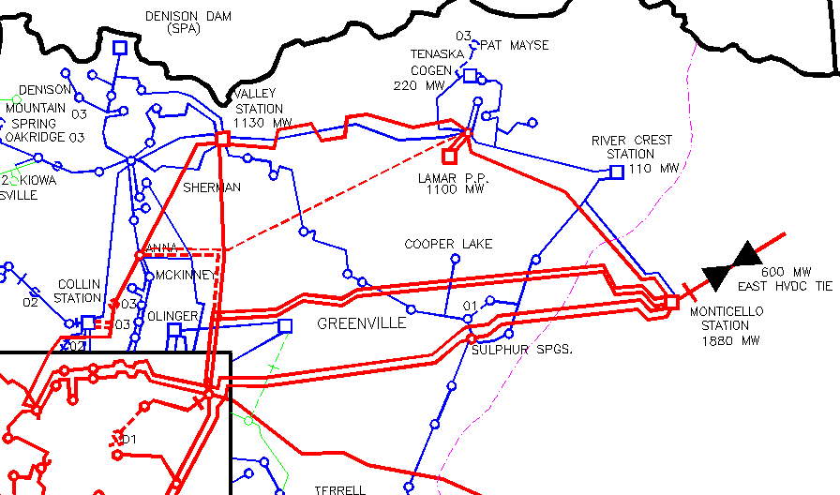

INTERRELATED FACILITIES:

- Farmersville Switching Station (in service 2001)
- Monticello – Farmersville 345 kV Line (in service 2001)
- Farmersville – Anna 345 kV line (in service 2002)
- Lamar Power Project 1,000 MW Plant
- Monticello 1,880 MW Plant
- Valley 1,130 MW Plant
- Tenaska Cogen 220 MW Plant
- Rivercrest 110 MW Plant
ALTERNATIVES CONSIDERED:

ERCOT has considered and studied a variety of other alternatives in the course of performing studies. This is not intended to be a complete listing but rather to demonstrate that a large class of alternatives has been examined.

Alternative One: Do Nothing

Does not meet the ERCOT Planning Criteria for thermal and stability. Generation and East HVDC tie capability will be limited. SPS will continue to be needed at Monticello, Lamar and Valley.

Even after completion of the Monticello-Farmersville-Anna Sw. line in December of 2002, a Special Protection Scheme (SPS) will still be required at Lamar Power to sequentially trip generation to prevent overloading the Paris-Valley 345 kV and 138 kV Lines when certain contingencies occur and the generation at Lamar, Valley and Monticello along with import on the East DC Tie is at maximum. The SPS at Lamar will trip up to 500 MW of generation for several local and remote contingencies. The Paris Sw-Valley 138 kV Line will overload to approximately 110% of the conductor rating for an outage of the Paris Sw-Valley 345 kV Line. The Paris Sw-Valley 345 kV Line will overload to approximately 109% to 113% of the conductor rating for an outage of the Monticello-Farmersville Sw 345 kV double circuit Line or the Monticello-Sulphur Springs/Monticello-Allen double circuit Line. Completion of the proposed Paris Sw-Anna 345 kV Line will add the transmission capacity needed to allow removal of the SPS at Lamar and allow full generation from resources in the Northeast region of ERCOT.

Alternative Two: Add second 345 kV circuit from Paris to Valley and Valley to Anna

Does not meet the ERCOT Planning Criteria for loss of double circuit outage of Paris-Valley line for thermal and stability. Generation and East HVDC tie capability may be limited. SPS may continue to be needed at Monticello, Lamar and Valley.

Alternative Three: Construct a 345 kV Line from Paris to Royse or a 345 kV Line from Paris to Farmersville

Aggregates loading in the Farmersville-Royse Area. Does not meet the ERCOT Planning Criteria thermal. Generation and East HVDC tie capability may continue to be limited.

Alternative Four: Construct a 345 kV Line from Paris to the Monticello-Royse 345 kV Line

Aggregates loading in the Farmersville-Royse Area. Does not meet the ERCOT Planning Criteria thermal. Generation and East HVDC tie capability may continue to be limited.

