STATE OF CALIFORNIA – THE RESOURCES AGENCY GRAY DAVIS, Governor
CALIFORNIA ENERGY COMMISSION
1516 NINTH STREET
SACRAMENTO, CA 95814-5512
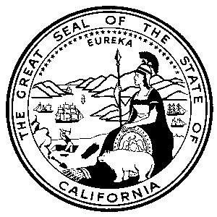

April 13, 2001

Docket Office
California Public Utilities Commission
505 Van Ness Avenue, Room 2001
San Francisco, California 94102

Re: A.00-11-038

Dear Docket Clerk:

Enclosed for filing in the above-entitled matter are the original and five copies of the “TESTIMONY OF MICHAEL R. JASKE CALIFORNIA ENERGY COMMISSION REGARDING RATE DESIGN” This filing has been served to all parties on the service list for these proceedings, as well as the Presiding Commissioner, President Loretta M. Lynch, and Administrative Law Judge Linda R. Bytof. We request that the extra copy of this document be file-stamped and returned for our records. Enclosed is a stamped, self-addressed envelope for your convenience.

Thank you for your attention to this matter.

Very truly yours,

JENNIFER TACHERA
Attorney for the
California Energy Commission
1516 Ninth Street, MS-14
Sacramento, CA 95814
Tel. No.: (916) 654-3870
Fax No.: (916) 654-3843
E-mail: jtachera@energy.state.ca.us

Enclosures

cc: Service List A.00-11-038

