STATE OF CALIFORNIA – THE RESOURCES AGENCY GRAY DAVIS, Governor
CALIFORNIA ENERGY COMMISSION
1516 NINTH STREET
SACRAMENTO, CA 95814-5512
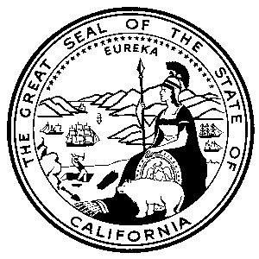

July 26, 2001

Docket Office
California Public Utilities Commission
505 Van Ness Avenue, Room 2001
San Francisco, California 94102

Re: A.00-11-038
Dear Docket Clerk:

Enclosed for filing in the above-entitled matter are the original and five copies of the
"COMMENTS OF THE CALIFORNIA ENERGY COMMISSION ON THE DRAFT DECISION OF ADMINISTRATIVE LAW JUDGE WALWYN RELATIVE TO REAL-TIME PRICING" This filing has been served to all parties on the service list for these proceedings. We request that the extra copy of this document be file-stamped and returned for our records. Enclosed is a stamped, self-addressed envelope for your convenience. Thank you for your attention to this matter.

Very truly yours,

JENNIFER TACHERA
Attorney for the
California Energy Commission
1516 Ninth Street, MS-14
Sacramento, CA 95814
Tel. No.: (916) 654-3870
Fax No.: (916) 654-3843
E-mail: jtachera@energy.state.ca.us

Enclosures

cc: Service List A.00-11-038

